Record Note of SME Awareness Session for Women Entrepreneur
Name of BSC Office: | SBP BSC Faisalabad
Event Category: | Awareness Session
Program Title: | SME Awareness Session for Women Entrepreneurs
Main Responsibility & Cluster (Name of Organizing Association/Chamber) | SBP BSC Faisalabad in collaboration with Zunnurain Welfare Society (NGO)
Event Date: | 12-01-2022
Event Time: | 10:00 AM to 01:00 PM
Event Location (Venue & City): | ZUNNURAIN Foundation/Welfare Society Faisalabad
Presentations made By: | Mr. Tahir Abbas (ACM-AFU SBP BSC Faisalabad)
Total no. of participants: | 60
Summary of Discussion:
SBP BSC Faisalabad conducted an SME Awareness Session for Women Entrepreneurs of ZUNNURAIN Foundation. Session was attended by women members of Zunnurain Foundation.
Ms. Quratulain Shahid-CEO/Founder of Zunnurain Welfare Society welcomed the audience and stated that Faisalabad is an industrial city and a large number of women are employed in various known industries as well as running their own small business set up. There are 200 active members of Zunnurain Foundation. Zunnurain Foundation is continuously putting efforts to promote the women led initiatives in the region and to facilitate them to run their own business smoothly. Yet lack of financing is a major constraint faced by the business. She further appreciated the recent steps taken by SBP including targets of women financing and expansion of scope of refinance scheme to Faisalabad & its relevant districts.
Afterwards, Mr. Tahir Abbas-ACM AFU shared a brief overview of recent policy measures taken by SBP to promote Women Entrepreneurs. He discussed in detail the SBP’s role of extending financing to unbanked or underbanked sectors of the societies.
Going forward, Mr. Tahir Abbas delivered presentation on SBP refinance schemes. Special focus was given to Refinance schemes for women entrepreneurs. All its features, requirements were discussed and questions were asked to the satisfaction of the participants.
Session ended with word of thanks from Ms. Quratulain Shahid-CEO/Founder of Zunnurain Welfare Society.
Action Plans/Agreement Points: [What, Why, Impacts, Task, Assigned to, Timeline]
N/A
Suggestions/ Queries/Issues or any other discussion points other than the agenda of program:
Deferred Items [Describe any items that may have been deferred for a later discussion]
N/A

Annexure A
List of Attendees
Note:
S. No. | Name | Designation | Organization
1 | 60 Members from Zunnurain Welfare Society

Annexure B
Photographs of the Event
Photographs
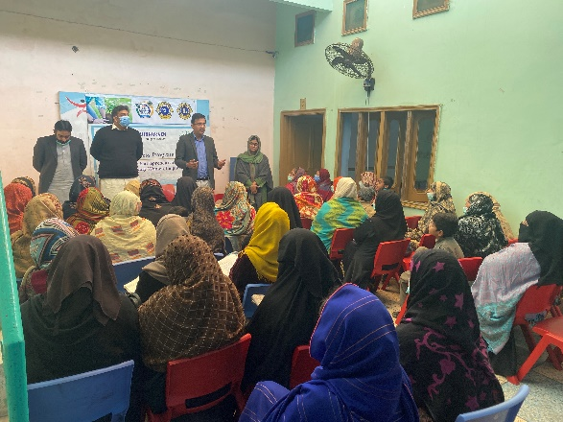 | 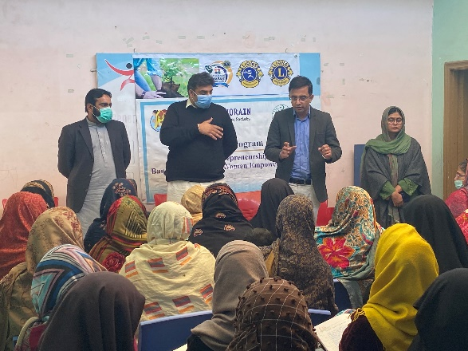
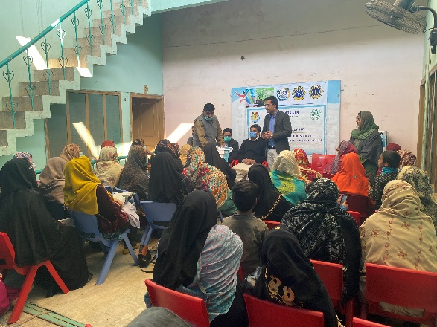 | 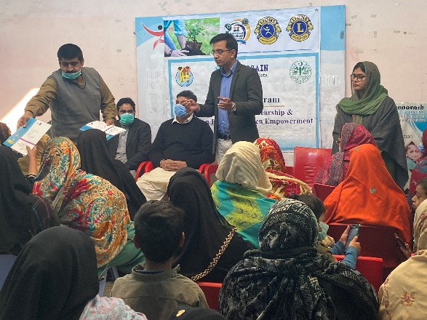
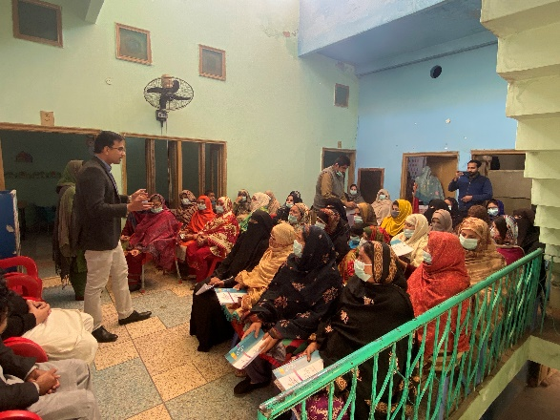 | 