Record Note for 1st Biannual Meeting of Regional Focus Group
For Microfinance
Name of BSC Office: | SBP BSC FAISALABAD
Event Category: | Focus Group Meeting (Online via Zoom)
Program Title: | Online 1st Biannual Meeting of Regional Focus Group  For Microfinance
Main Responsibility & Cluster (Name of Organizing Association) | Program was arranged by SBP BSC Faisalabad
Event Date: | February 08, 2022
Event Time: | 11:00 AM – 12:30 PM
Event Location (Venue & City): | Via Zoom Application, SBPBSC Bank Faisalabad
Presentations made By: | - AFU Officials, SBP BSC Faisalabad  - Regional Heads of Banks
Total no. of participants: | 15
Summary of Discussion:
Proceedings of the session commenced with Tilawat e Quran e Pak.

Mr. Sarfraz Ahmed Nadeem, Chief Manager-SBP BSC Faisalabad in his welcome address highlighted the importance and key role of Microfinance and Microfinance Banks in our economy. A special focus was given to Banking on Equality policy, relaxation for classification of loans and updation of Prudential Regulations for microfinance banks. In his discussion, he devised post COVID-19 scenario in our region and asked Microfinance Banks to observe process of collection with due norms of the sector in order to revamp financing portfolio of respective banks. At conclusion participants were encouraged to provide real time feedback for policy updation.

After this, Mr. Tahir Abbas, ACM-AFU, SBP BSC Faisalabad carried on discussion of agenda points submitted by Banks earlier and the responses of DFSD and State Bank respectively.

He, in pursuance to procession of the meeting, discussed one by one agenda points/issues/suggestions with Regional Heads of different banks.

Some highlights are as following:

- FINCA Microfinance Bank Limited. has submitted it’s point regarding Increasing Trends of stay Orders and Legal Cases., which was addressed by suggesting various options i.e. to review its recovery strategy, so that less no of borrowers opt for court proceedings.
- FINCA Microfinance Bank Limited. has submitted another point regarding Poor Trends of collection particularly of the portfolio deferment and restructured cases. It was responded as SBP is closely monitoring the situation in collaboration with the MFBs and the larger industry. Where necessary, relaxations deemed are being awarded.
- FINCA Microfinance Bank Limited. has also submitted their point on Collection and recovery challenges against Agriculture Portfolio. It was responded as MFBs should focus to revisit and alter their product offering besides credit underwriting standards. This will not only improve the overall portfolio quality, but will also make recovery easy.
- Khushhali Bank. had asked to refer the cases to special courts instead of ordinary courts. As this does not fall in the ambit of SBP-BSC but bank was asked to come up with the specific proposal to refer to the concerned authorities.
- Khushhali Bank. had also asked to Review in microfinance PR of NPLS classification as there is change in loan amount and tenure of loan in Housing and MSME and SME. They were responded by recent updates in PRs.
- Performance of participating banks under MPMG was also discussed, Khushali bank presented their performance in form of 50 cases amounting Rs. 90 million.
- NRSP apprised that they have disbursed 75 cases and they also have engaged 10 officials especially for this scheme.
- U Bank apprised the participants that they have disbursed 5 cases under MPMG

Later, worthy CM asked Deputy Chief Manager – DFD, Mr. Asif Jabbar to discuss comments of DFSD and State Bank among participants of the meeting. Which were deliberately devised and feedback was called from such dealing banks on post COVID-19 scenario, their strategies and plans for future.

He expressed his hope that banks operating in the region would actively be participating in meetings towards smooth functioning of Microfinance keeping in view its overall significance in economy.

Concluding the meeting, Mr. Sarfraz Ahmad Nadeem Chief Manager SBP-BSC Faisalabad thanked participating banks and they ensured their cooperation in future.

There being no other point, the meeting ended with a vote of thanks to the chair.

Action Plans/Agreement Points: [What, Why, Impacts, Task, Assigned to, Timeline]
N/A

Suggestions/ Queries/Issues or any other discussion points other than the agenda of program:
N/A
Deferred Items [Describe any items that may have been deferred for a later discussion]
[Nil]

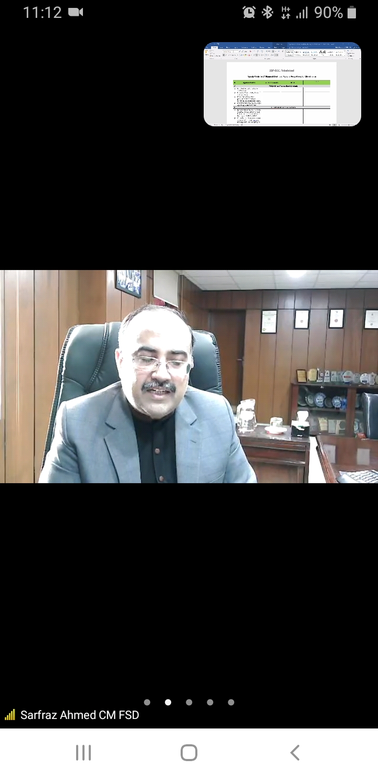
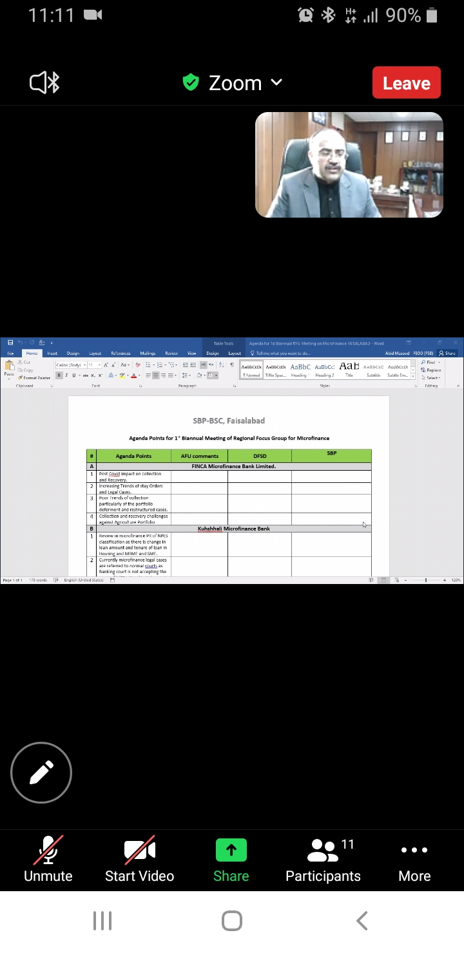
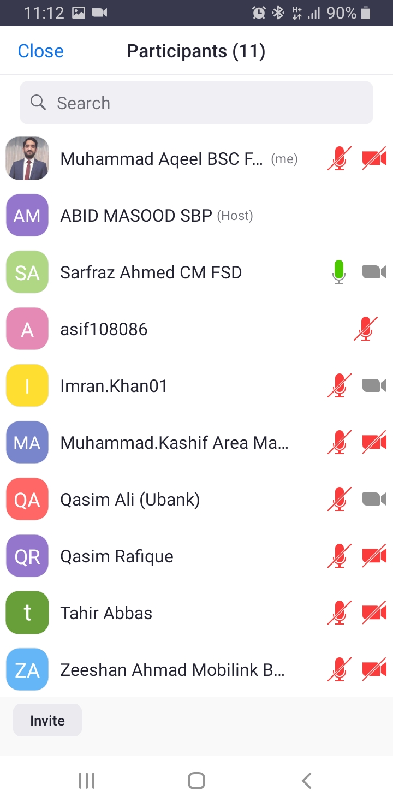
Screenshots of Meeting

