RECORD NOTE
“WINTER CHALLENGE- REMODELING OF LADIES COMMON ROOM”
Name of BSC Office: | SBP BSC FAISALABAD
Event Category: | Winter Challenge
Program Title: | “Remodeling of Ladies’ Common Room”
Main Responsibility | State Bank of Pakistan – BSC (Bank), Faisalabad
Event Date: | March 18, 2022
Event Time: | 04:00 PM
Event Location (Venue & City): | 5th Floor, SBP-BSC, Faisalabad
Summary of Event:
Winter Challenge was a step taken by Chief Manager SBP-BSC, Faisalabad in February 2022, intended to transform existing revolting areas of office to offer an appealing look, wherein two teams of each gender were formed to perform this task for remodeling of designated areas i.e. Hostel Mess by boys team and Ladies Common Room by Girls team. Each team entails five members including a team leader constraints to any employee (permanent/temporary/ contractual) upto OG3 could be a member/leader. An evaluation committee was formed consisting of the three participants for appraising the work of both teams based on predefined criteria.

Keeping in view the designated area for renovation, the Girl’s team approached female staff of the office and acquired their requirements and suggestions about new look of Ladies Common Room (LCR). After obtaining valuable suggestions from female staff, team itself performed a feasibility analysis of all the suggested needs and discussed list of proposed items with GSU/ENGG in order to check the expediency of recommended items as per procurement rules.

Based on the suggestions of female staff, team decided to divide common room into four parts, i.e. Dining Area, Study Area, Prayer Area and Living Area. Each member was given a particular area for remodeling under the guidance of team leader. Furthermore, a special attention was also given to each area’s aesthetics.

Throughout the time of LCR’s transformation, the Girls’ team focused on elegant look within their budget limits as per procurement rules. Team explored bank’s store room with GSU officials in search of old furniture and equipment which could be reused after proper repairing and polishing. Intending to cut down the expenses, girls’ team transformed old calendars, newspaper cuttings into decorative and informative frames/ pieces and whole furniture in newly renovated room is completely recycled. Further, new curtains and carpet was placed in LCR being significant items. All the items placed in common room are durable and easy to maintain with an aim to make them long lasting.

The Winter Challenge Task was completed within given timeline and inauguration ceremony of Ladies Common Room was held on 18th March, 2022. Worthy managing director SBP-BSC inaugurated Common room and applauded the efforts of team and office management. Mr. Sarfraz Ahmed Nadeem, Chief Manager Faisalabad office, briefed Worthy MD-BSC and Regional Head South about the whole activity and shed light on the efforts inputted and obstacles faced by the team and GSU/ ENGG unit. At the end of inauguration ceremony, all the dignitaries and office management commended the exertions of both teams, hence as per the decision of evaluation committee, girls’ team was announced winner of the challenge with an advice to make the facility upto mark and keep a regular check on its maintenance. A winning trophy with certificate of appreciation were awarded to both teams.

Pictures of before and after remodel look of common room are given below:

Pictures of the Old and New/Remodel Look of LCR
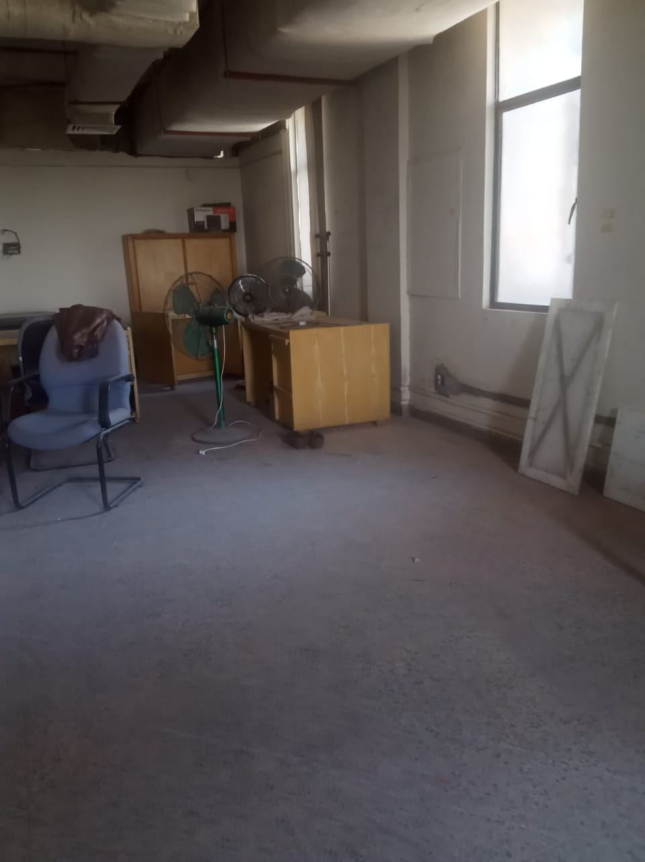
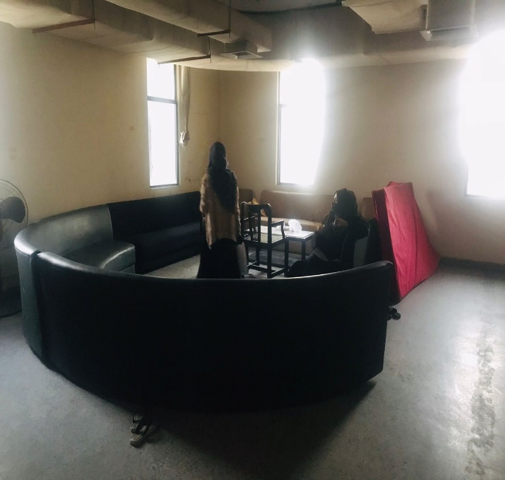
Before
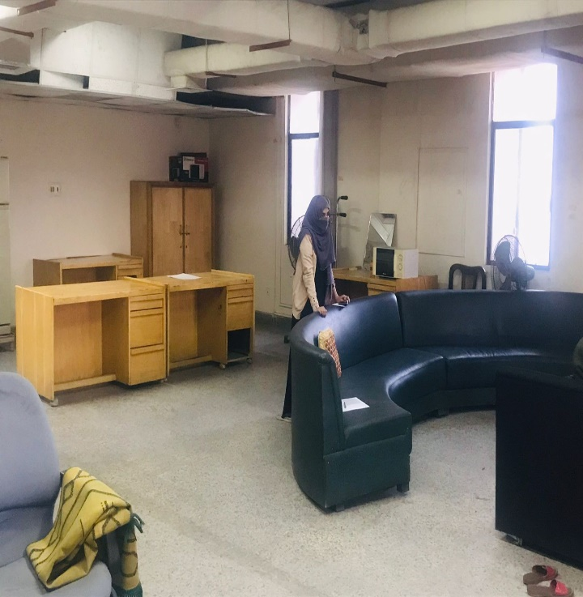
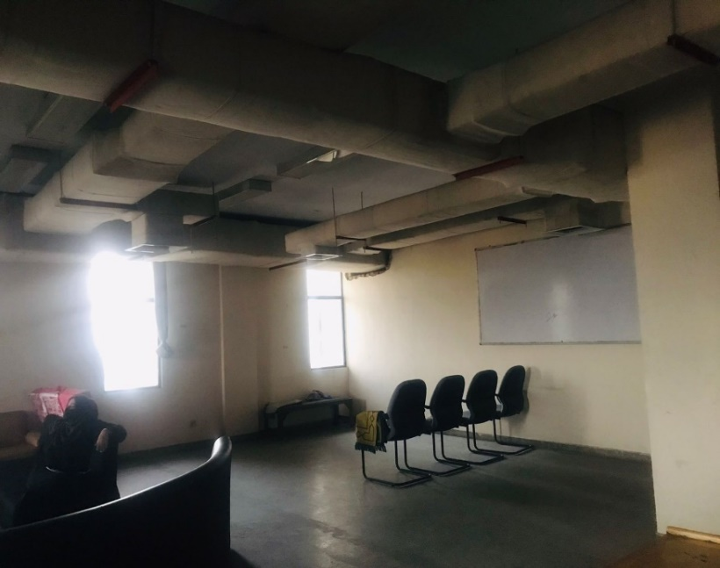

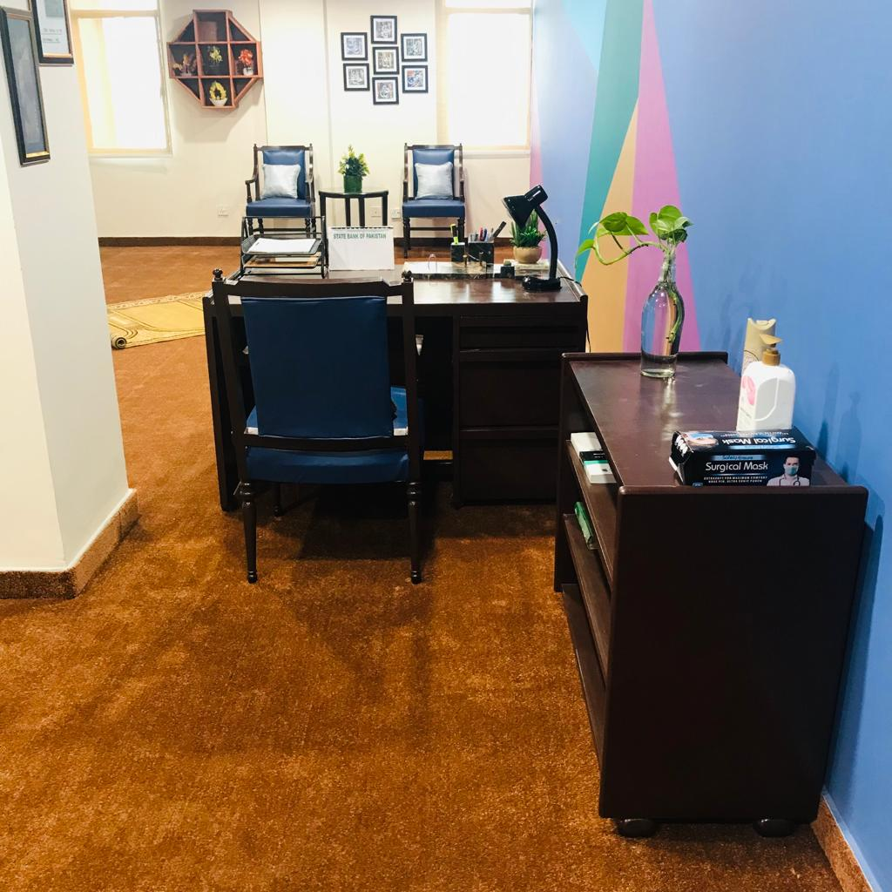
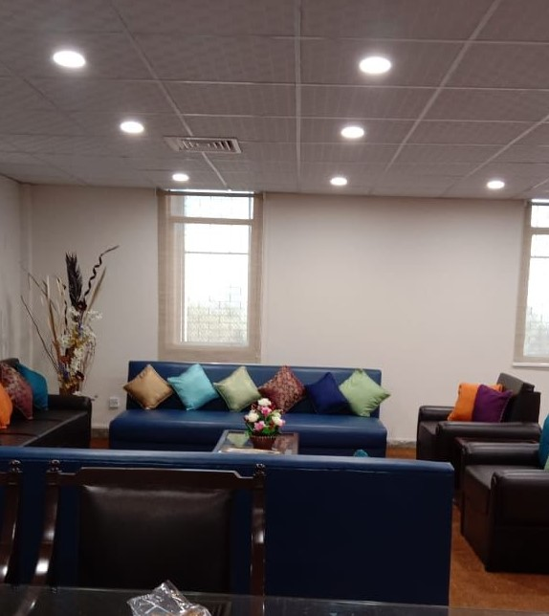
After
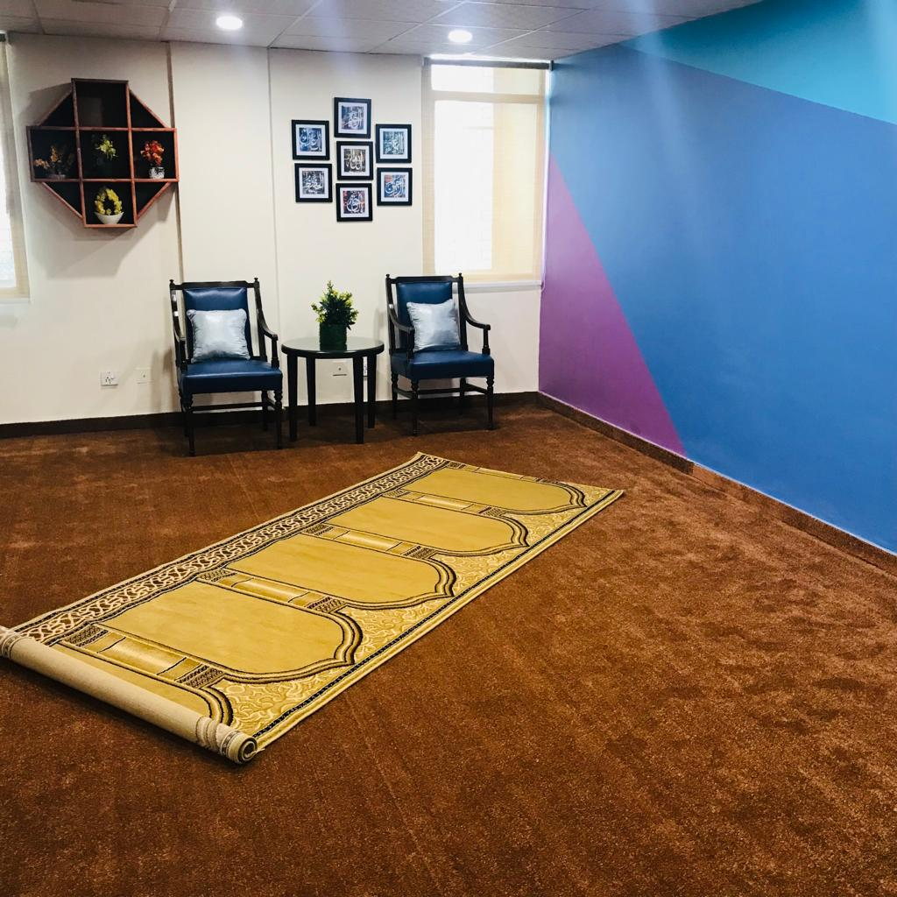
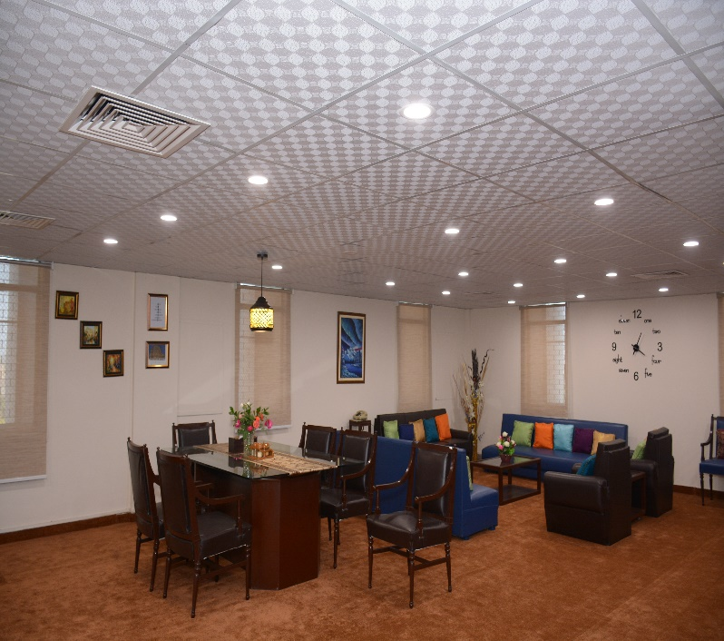

Pictures of Inauguration Ceremony
