Record Note: “Meeting on MPMG Mela and Case Processing”
Name of BSC Office: | Faisalabad
Event Category: | Meeting
Program Title: | “Meeting on MPMG Mela and Case processing”
Main Responsibility | SBP-BSC Office Faisalabad
Event Date: | 18-March-2022
Event Time: | 11:30 PM to 01:00 PM
Event Location (Venue & City): | 6th Floor SBP-BSC Faisalabad
Presentations made By: | N/A
Total no. of participants: | 50
Summary of Discussion
A meeting with Regional heads of commercial banks was arranged to discuss the strategy for successful conduct of MPMG Mela and Case processing Under MPMG Scheme in Faisalabad region, on 18-March-2022.
Mr. Muhammad Ashraf Khan, Managing Director, SBP-BSC welcomed the participants. In his welcome remarks, He briefed the participants regarding the vision of honorable Governor State Bank of Pakistan (SBP) on Mera Pakistan Mera Ghar (MPMG) Scheme and sensitized the role of Participating Financial Institutions (PFIs) in successful implementation of this public benefiting scheme. He further added that SBP and SBP-BSC in coordination with commercial Banks are organizing MPMG Mela at Circle Club Faisalabad on March 19-20, to facilitate the masses under MPMG scheme.
In order to make these endeavors efficacious, he invited the participants to submit their suggestions for successful conduct of MPMG-Mela and prioritized processing of cases referred through SBP-BSC intervention.
Following action items consented in the meeting:
- Regional heads of commercial banks will ensure display of steamers outside their branches for promotion of MPMG-Mela.
- For smooth facilitation of visitors at MPMG-Mela, Banks will depute relevant trained staff at the stalls.
- At least one female staff member will be deputed at stall for facilitation of prospect women borrowers.
- All Banks will mobilize their customers for Mela through SMS marketing.
- HBL, BAHL and Meezan banks were advised to expedite the processing of logged in cases in cases.
Later, Mr. Muhammad Ashraf Khan, Managing Director, SBP-BSC expressed his hope that banks operating in the region will actively participate in MPMG Mela.

Concluding the meeting, Mr. Sarfraz Ahmad Nadeem, Chief Manager SBP-BSC Faisalabad, thanked participating banks and they ensured their cooperation in future as well.

There being no other point, the meeting ended with a vote of thanks to the chair.
Suggestions:
- Regional Head of Meezan Bank suggested that considering the change in weather water, Fans and canopies are necessary for public at Mela.
Action Plans/Agreement Points: [What, Why, Impacts, Task, Assigned to, Timeline]
As mentioned above in details
Suggestions/ Queries/Issues or any other discussion points other than the agenda of program:
As stated above in detail
Suggestions:
- Nil
Deferred Items [Describe any items that may have been deferred for a later discussion]
Nil

Annexure A
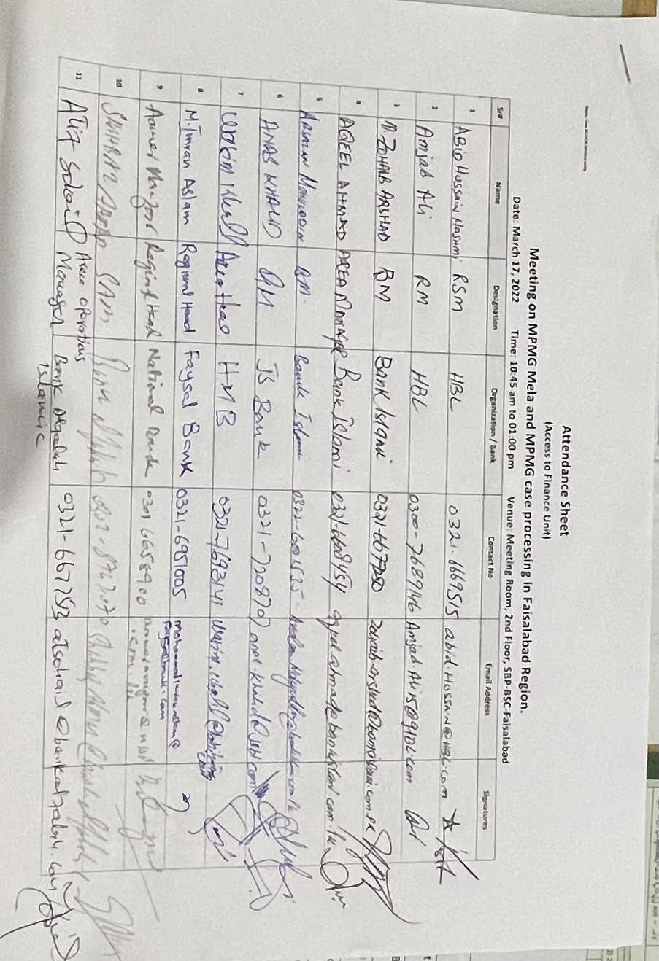
List of Attendees
Name | Designation | Bank
Muhammad Ashraf Khan | Managing Director | SBP-BSC
Qazi Shoaib Ahmad | Regional Head South | SBP-BSC
Sarfraz Ahmad Nadeem | Chief Manager | SBP-BSC Faisalabad
Tahir Abbas | Asst. Chief Manager | SBP-BSC Faisalabad
Hafiz Muhammad Aqeel | Sr. Officer | SBP-BSC Faisalabad
Abid Masood | Officer | SBP-BSC Faisalabad
Laiba Asif | Officer | SBP-BSC Faisalabad
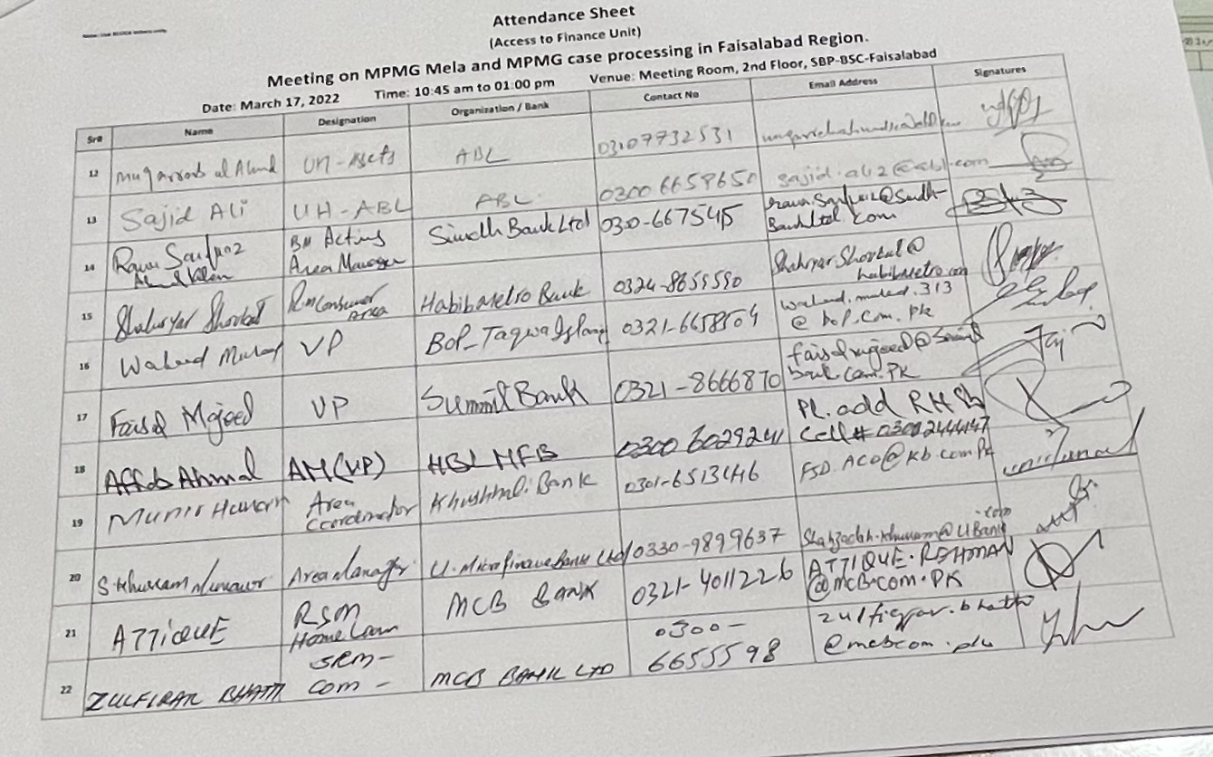
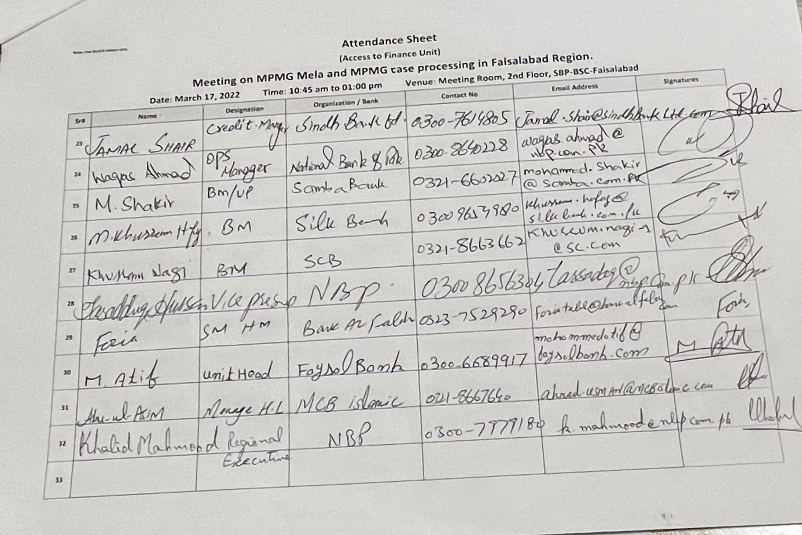
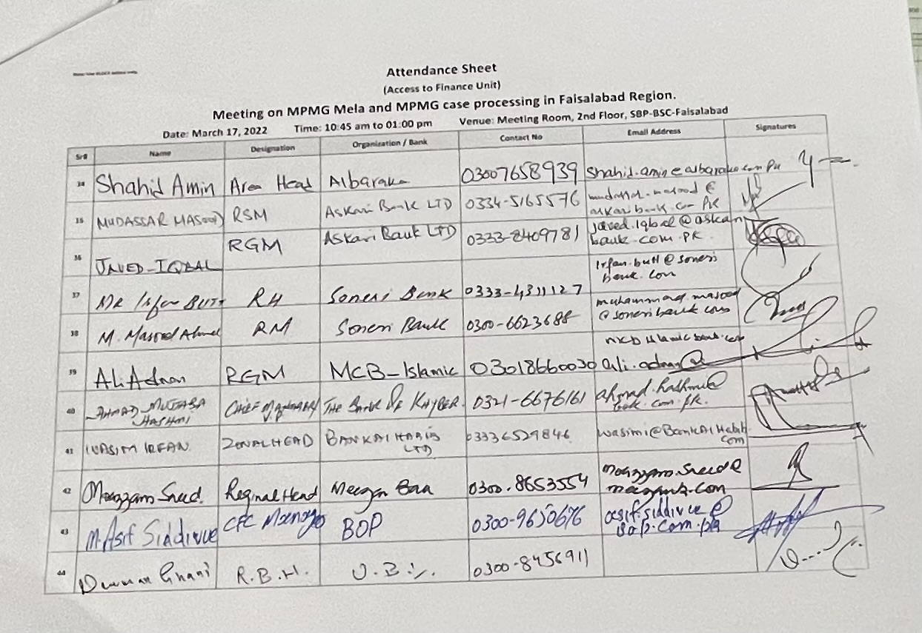

Pictures of the Meeting
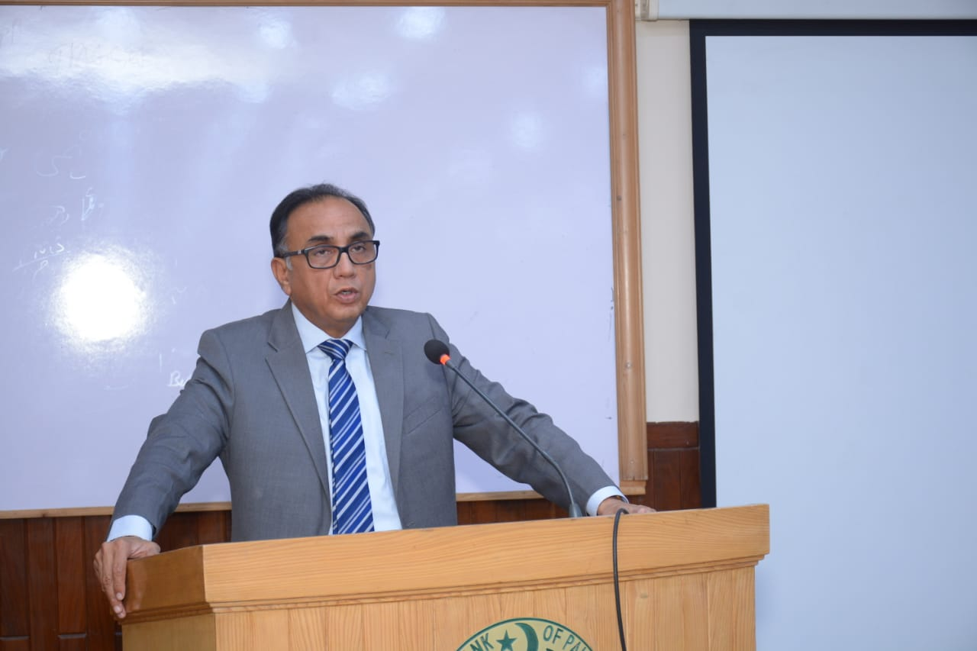 | 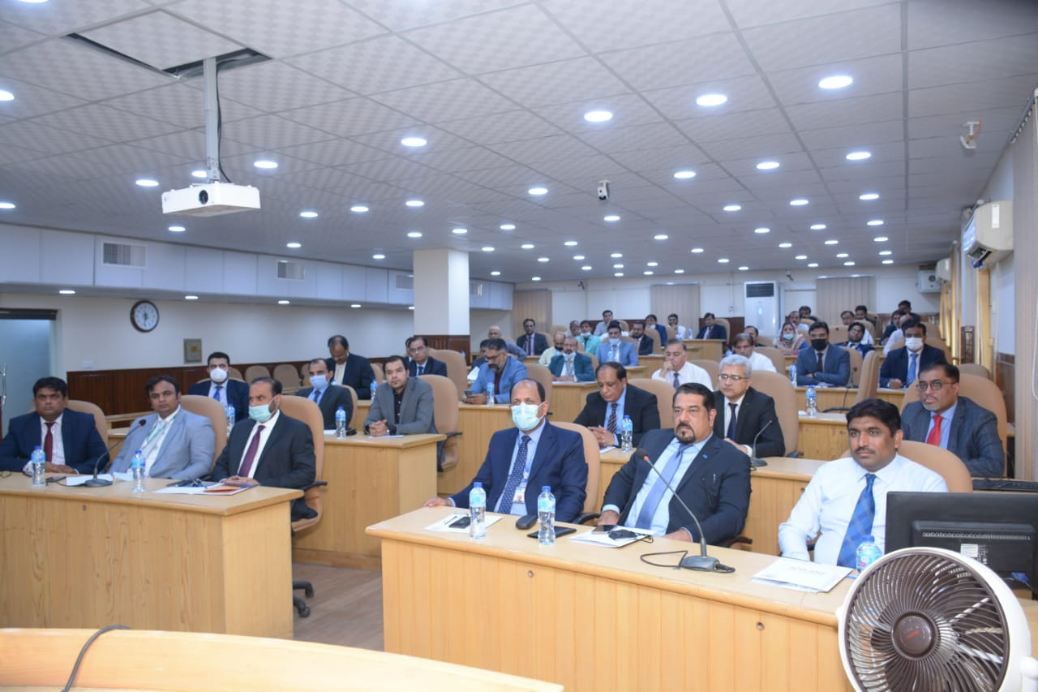
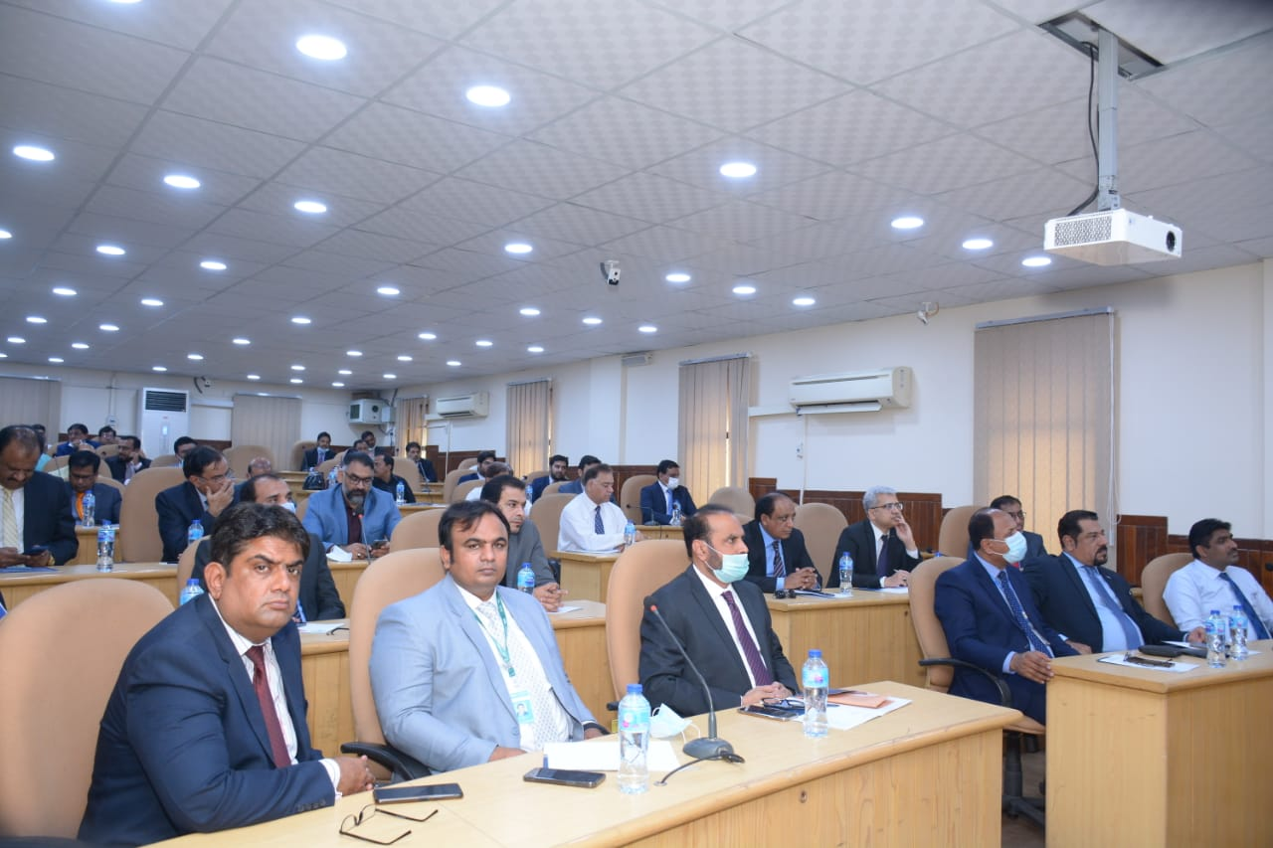 | 