Record Note
SBP BSC Managing Director’s visit to Faisalabad Office

Name of BSC Office: | SBP BSC FAISALABAD
Event Category: | Official Visit
Program Title: | Visit of Managing Director SBP BSC to Faisalabad Office
Event Date: | 17-20 March, 2022
Event Location (Venue & City): | SBP-BSC, Faisalabad
Summary of Visit:
Honorable Managing Director, Mr. Muhammad Ashraf Khan and Mr. Qazi Shoaib Ahmed, Regional Head South visited Faisalabad office on March 17-20, 2022. During this visit, Managing Director conducted meetings/sessions with various stakeholders i.e. an interactive session with the office management team and a town hall meeting with employees of Faisalabad office. Besides that, he also planted a tree in office garden, inaugurated recently renovated Hostel Mess and BPAS hall.

Meeting with Office Management Team:
The Initial session was held with the office management team i.e. Unit In-charges, Divisional Heads, and Chief Manager. The session began with tilawat-e-Quran-e-Pak. In opening remarks, Mr. Sarfraz Ahmed Nadeem, Chief Manager- Faisalabad Office, welcomed the honorable MD and stated that the session will have a long-lasting impact on the management of Faisalabad Office as they had an opportunity of face to face interaction after a long time with senior management of SBP-BSC.

At the outset, MD emphasized participants to improve their skill set and knowledge to familiarize themselves with rapid procedural, functional and technological changes being taken place in the organization continuously so that employees can play their diligent role towards accomplishment of organizational goals. He suggested the audience to go through the recently issued Annual Performance Review to keep themselves aware of recent developments and achievements regarding our organization.

MD apprised the audience about the automation processes underway in BSC, especially RAAST, Pakistan’s instant micropayment gateway for digital payment system. RAAST’s transaction up to Rs. 200,000/- will be free of cost and it will be a great game changer in the field of financial transactions being carried out daily as it will more swift and reliable. RAAST is expected to play a key role in the digitalization of payment systems in Pakistan.

He informed the audience about SBP’s working on digital banks framework which focused on smart branches of commercial banks providing facilities to customers at their doorsteps as well as opening of bank account at one click through applications.

Another significant achievement underway is the promotion of paperless environment at the State Bank of Pakistan through implementation of Knowledge Management (KM) program at all 16 field offices.

In the end, honorable Managing Director advised all the participants to enhance their knowledge base and remain up-to-date with current advancements. He also advised all participants to follow instructions and SOPs while working. He strictly advised the audience to always remain alert while using IT systems in order to avoid any suspected cyber-attack and avoid sharing of passwords.

Town-Hall Meeting with Staff of Faisalabad Office:
Moving ahead, a town hall meeting was arranged on 6th floor, in which all officials of SBP BSC Faisalabad were present. The meeting commenced with the recitation of Holy Quran followed by the opening remarks of Chief Manager. In his opening remarks, Chief Manager appreciated the efforts of SBP BSC Faisalabad officials and briefed worthy MD and Regional Head South regarding key achievements and recent highlights of office operations. Subsequently CM encouraged all officials to discuss freely their thoughts, issues if any, and proposals etc. with Managing Director.
Worthy MD shared with participants, the discussions held in previous session with ACMs and. Furthermore, he discussed latest developments made under inflation adjustment package. He elaborated following developments in SBP/SBP-BSC:
- RAAST in Banking
- Digitalization of EFS
- Digital Prize Bonds
- Automation of Notes Processing Mechanism
- Paperless environment under Knowledge Management System
- Idea of smart BSC Offices
- Inauguration of new BSC Office in Gilgit Baltistan
- Construction of new office building in Sialkot
- New BSC Organogram under consideration.

Following this fruitful exchange of information, a Q&A session was held in which MD sb endorsed the suggestion to increase mileage allowance from Rs.10/km and apprised participants to discuss this with concerned authorities.

Responding to the question of fresh hiring, MD sb shared that after implementation of BPRs and automation processes in business operations, the need for new employees has to be considered accordingly. However the organization will recruit new HR as and when required.

Responding to the criteria of promotions, MD reiterated that SBP BSC’s promotion and grading system is totally transparent and purely based on merit.

A young female employee asked about the possibility of provision of medical facility to the parents of employees but MD responded that the monetary adjustment for parent’s medical facility has already been embedded into the package offered to them.

MD inquired about difficulties and issues for outstation female employees in response to which no such issue was raised. Further CM added that in accordance with guidelines of senior management, all outstation employees especially females are taken well care at this office. This includes provision of necessary items in hostel, upgrading mess area and transforming lawn in front of old building into a recreational park equipped with lush green grass, fancy lights and fountain. MD sb appreciated efforts of office and further disclosed that construction of women hostel has started in a very posh area of Karachi for the facilitation of female employees.

Chief Manager asked Mr. Qazi Shoaib (RH-South) to give his closing remarks. After his concluding remarks, the meeting ended with vote of thanks.

Tree Planation:
Afterwards, MD also took part in tree planation campaign and planted a tree in the garden of office building. He highlighted the significance of green environment and urged all officials to take part in such activities and play their due role in improving environment around their vicinity.

Inauguration of BPAS Hall:
MD also inaugurated BPAS hall where the state of the art notes processing machines installed. He guided the officers that BPAS machines have been purchased as a part of SBP BSC’s vision to automate currency related functions. While discussing the main features of BPAS machine, he highlighted that BPAS machine is the latest and most effective machine currently available in the global market for processing of notes with least HR. He also stressed that officers should come up with more innovative ideas that aligned with overall vision and mission of SBP and SBP/BSC.

Inauguration of Hostel Mess:
Lastly, MD inaugurated recently renovated SBP BSC Faisalabad’s hostel Mess and appreciated the efforts of all employees who took part in this beautification drive. He showed his pleasure over the facilities being provided to the residents of hostel at this office.

Pictures

Meeting with Office Management Team:

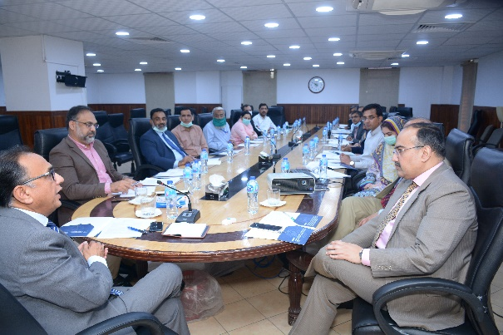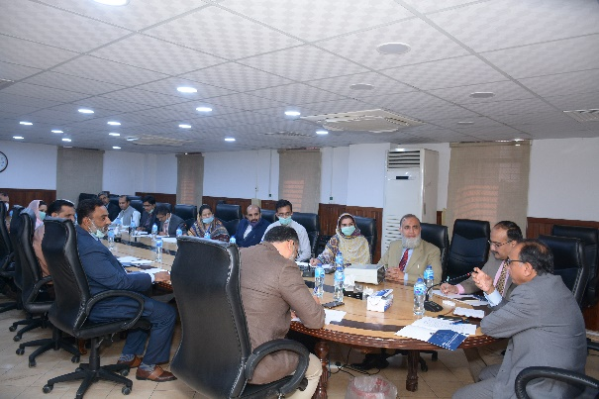

Town-Hall Meeting with Staff of Faisalabad Office:

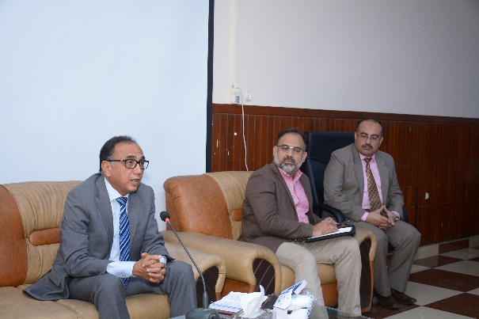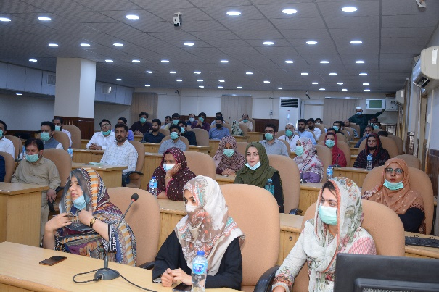

Tree Planation:

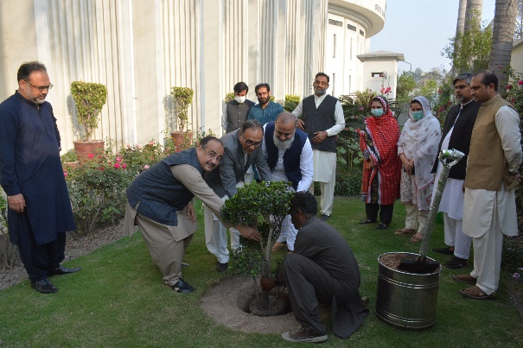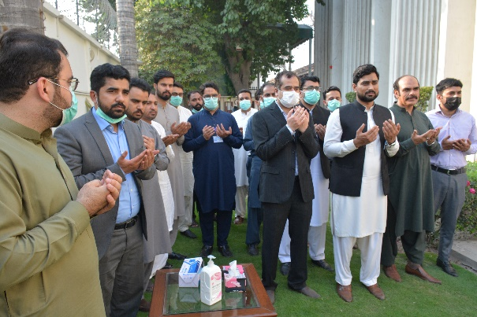

Inauguration of BPAS Hall:

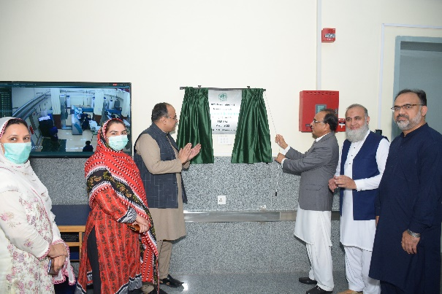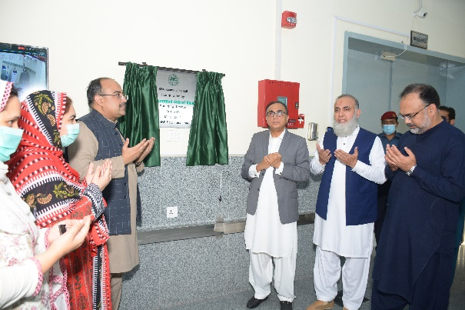

Inauguration of Hostel Mess:

