Record Note: “4th SME Clinic FY 2021-22”
Name of BSC Office: | Faisalabad
Event Category: | Awareness Session
Program Title: | 4th SME Clinic
Main Responsibility | SBP-BSC (Bank), Faisalabad
Event Date: | April 1, 2022
Event Time: | 10:30 AM to 01:30 PM
Event Location (Venue & City): | Canal Palace Marquee, Canal Road Faisalabad
Presentations made By: | Mr. Tahir Abbas ACM-AFU, SBP-BSC, Faisalabad
Total no. of participants: | 70
Summary of Discussion
Description of the Session:
State Bank of Pakistan-BSC Faisalabad arranged “4th SME Clinic” session to further strengthen Access to Finance Mechanism for promotion of SMEs with a special focus on SBP Refinance Schemes for Renewable Energy Sources. SME clinic was organized in collaboration with:

- Pakistan Textile Exporters Association (PTEA)
- Pakistan Hosiery Exporters & Manufactures Association (PHMA)
- All Pakistan Bedsheets & Upholstery Manufacturers Association (APBUMA)

Following stakeholders were invited to ensure the efficacy of the event:
- 06 partner Banks to Showcase their Products
  - 01 Islamic Bank (Meezan Bank)
  - 01 Public Sector Banks (NBP)
  - 04 Best Performing Commercial Banks of the Region in SME Finance (HBL, BAHL,BAFL and JSBL)
- Around 50 Existing & Potential SMEs, other industrialists, traders, businessmen, Regional Heads /SME Heads of commercial banks, media representatives and local notables

Proceedings of the Session:
Session started with Tilawat-e-Quran-e-Paak.
On behalf of members of APBUMA, Mr. Arif Ehsan Malik-Chairman (APBUMA) had welcome address. He thanked State Bank of Pakistan BSC Faisalabad especially DFD team working under leadership of CM-Faisalabad Office for taking such an initiative for betterment of SMEs in line with directions of SBP and SBP-BSC HOK. He applauded the extraordinarily prompt responses of DFD team and higher management of the bank for resolution of different complaints and concerns of SMEs. He put light upon the current issues faced by business community, specially the small and medium enterprises and auspicious response of Government and SBP thereof. He concluded by thanking the organizers for such an interactive session and facilitation for establishing connection between prospect borrowers and lending institutions.
Mr. Ameer Ahmad Vice Chairman-PTEA, in his address esteemed the role of SBP in promotion of subsidized Renewable Energy Financing with special focus on SMEs. Moreover he acknowledged the role of SBP-BSC Faisalabad in facilitation of exporters by ensuring open communication channels to address their concerns.
Mr. Sarfraz Ahmed Nadeem, Chief Manager SBP-BSC Faisalabad, welcomed guests in the session and highlighted the importance and significance of SME Clinics towards enhancing awareness of available financial services on concessional rates for underserved sectors and stressed that such clinics will encourage these segments to channelize and fulfill their financial needs through participating institutions, which will ultimately grow economic activities in the country. He emphasized upon the importance of this neglected segment of economy and exhorted supply side stakeholders i.e. SBP-BSC Faisalabad officials and commercial banks to go extra miles to facilitate the SMEs.
He gave a special focus on newly launched “SME Asaan Finance (SAAF) Scheme”, he apprised the audience that it is a revolutionary initiative taken by SBP in collaboration with 8 participating banks to satisfy the financial needs of those sectors of economy which lacks in provision of collateral against their requisite financing.
Participants were apprised that Pakistan has been facing a dual challenge of high cost energy sources and environmental deterioration. Immoderate energy sources result in high cost of doing business that leads to adverse competitiveness of our business community in global competition. On the other hand, carbon emission by our industrial production not only pollutes the environment but also causes loss of export business due to sanctions by environment protection agencies. In these circumstances, use of renewable energy sources is inevitable. In order to provide financial assistance to prospect consumers, SBP is offering concessionary Refinance Scheme for Renewable Energy production. These schemes provide concessionary financing for uninterrupted, low cost, green energy through large renewable energy power projects as well as for small scale renewable energy solutions.
A special focus was given to “RAAST” digital payment system, participants were encouraged to use this digital payment gateway for bulk payments as well as P2P payments and P2B payments subsequently. This is a revolutionary initiative by SBP in collaboration with other stakeholders for promotion of digital payments in line with demands of modern financial system. He concluded by assuring their office support to the stakeholders in resolving their concerns with banks.
After his remarks, Mr. Tahir Abbas ACM-AFU SBP-BSC Faisalabad delivered the presentation on SME schemes offered by State Bank of Pakistan on low markup rates for promotion of SMEs Sector. A special focus was given to SBP’s Refinance schemes available for renewable energy sources. SMEs raised various queries regarding these schemes and responded satisfactorily thereof.
Hafiz Rashid Mehmood Executive Member-PHMA presented the vote of thanks and acknowledged the role of SBP-BSC in assuring the facilitation of SMEs at every point of time.
This formal segment of the session led to the interactive segment wherein all of the existing and potential SMEs were requested to visit stalls of different banks and get themselves familiarized with the process of SME lending. They were guided by the commercial bankers in detail.
Chief Manager SBP BSC Faisalabad along with AFU team and senior executives of participating associations visited the stalls personally and made the session more interactive by answering the questions of SME’s members by themselves in presence of commercial bankers.
Afterwards, participants were requested to move for concluding formalities i.e. souvenir presentation, refreshments and group photo etc...
Suggestions:
- Nil
Deferred Items [Describe any items that may have been deferred for a later discussion]
Nil

Annexure A
List of Attendees
Officials from SBP-BSC Faisalabad
Office bearers as well as members from PTEA,APBUMA,PHMA
Existing and potential SMEs
Regional Head & Concerned Officials from HBL.
Regional Head & Concerned Officials from Bank Al Habib.
Regional Head & Concerned Officials from NBP
Regional Head & Concerned Officials from Bank Alfalah.
Regional Head & Concerned Officials from JS bank Ltd.
Regional Head & Concerned Officials from Meezan Bank Ltd.

Pictures of Session
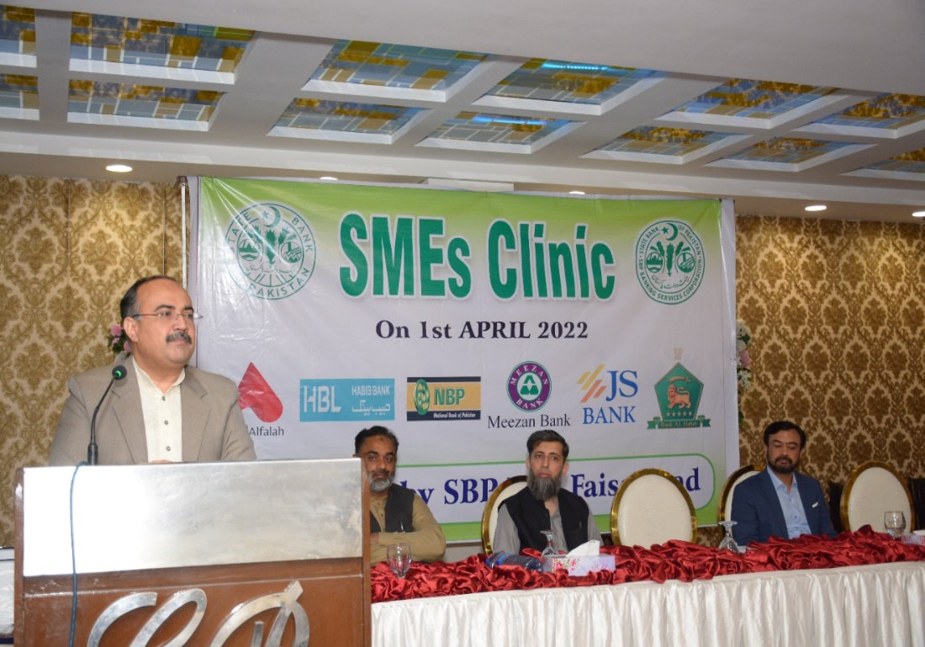
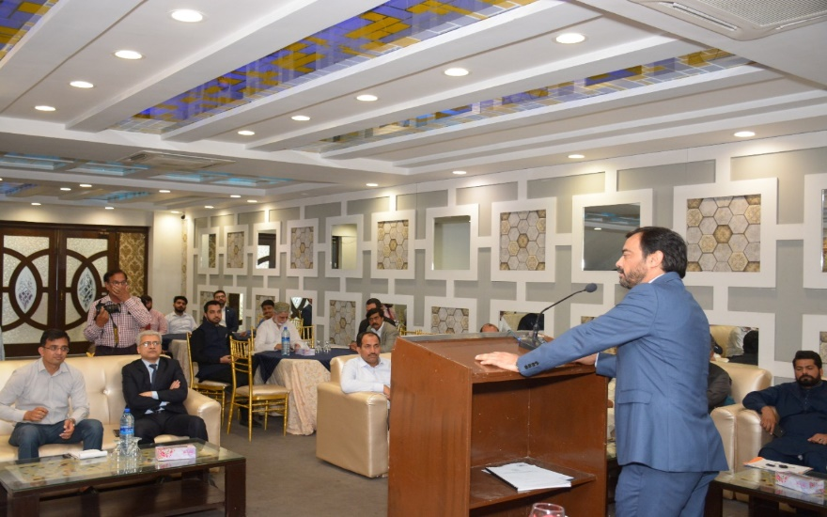 | 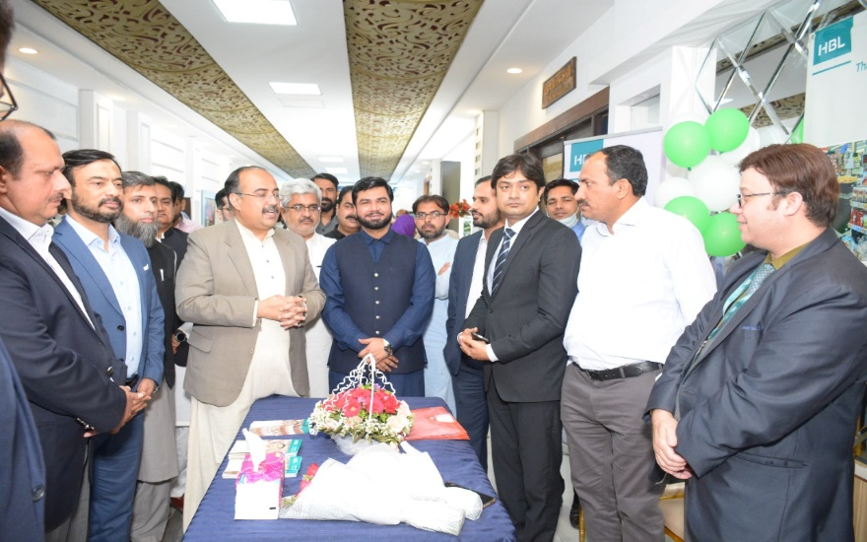
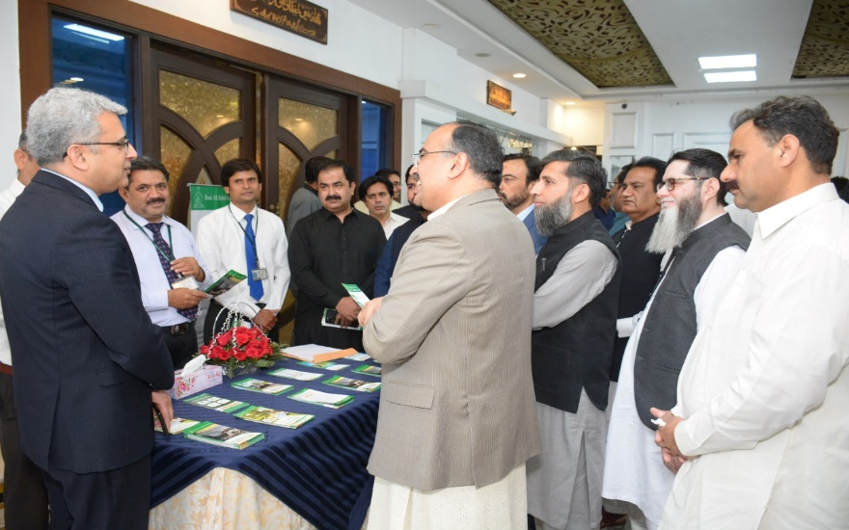 | 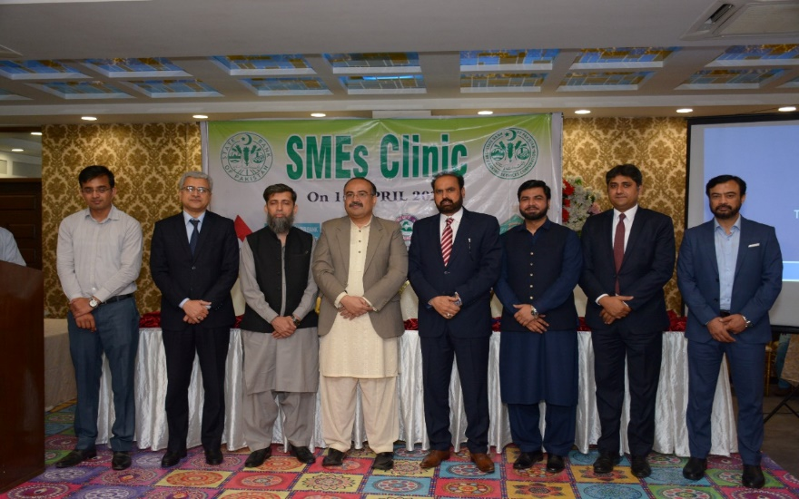
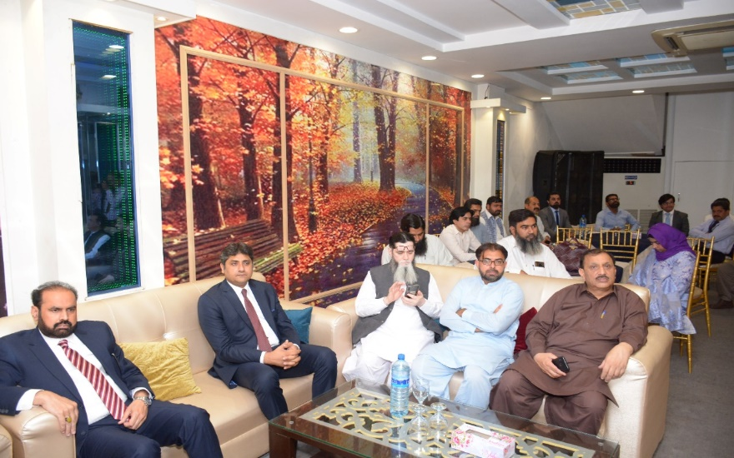 | 