Record Note: “2nd SME Clinic FY 2021-22”
Name of BSC Office: | Faisalabad
Event Category: | Awareness Session
Program Title: | 2nd SME Clinic
Main Responsibility | SBP-BSC Office Faisalabad
Event Date: | December 09, 2021
Event Time: | 11:00 AM to 02:00 PM
Event Location (Venue & City): | Sheraton Marquee Faisalabad
Presentations made By: | Mr. Tahir Abbas (SBP-BSC Faisalabad)
Total no. of participants: | 60
Summary of Discussion
Description of the Session:
State Bank of Pakistan-BSC Faisalabad arranged “2nd SME Clinic” session to further strengthen “Access to Finance Mechanism” for promotion of SMEs in general and Made ups sector in particular. SME clinic was organized in collaboration with All Pakistan Bedsheets and Upholstery Manufactures Association (APBUMA)

Following stakeholders were invited to ensure the efficacy of the event:

- 06 Banks to Showcase their Products
  - 01 Islamic Bank i.e. Meezan Bank
  - 01 Public Sector Banks i.e. BOP
  - 04 Best Performing Commercial Banks of the Region in SME Finance i.e. ACBL, HMBL, ABL and JSBL
- Around 30 Existing & Potential SMEs

Proceedings of the Session:
Session started with Tilawat-e-Quran-e-Paak and Naat-e-Rasool-Maqbool.
On behalf of existing and potential SMEs, Mr. Arif Ehsan Malik Chairman APBUMA thanked State Bank of Pakistan BSC Faisalabad especially DFD team working under leadership of CM-Faisalabad Office for taking such an initiative for betterment of SMEs in line with directions of SBP and SBP-BSC HOK. He applauded the extraordinarily prompt responses of DFD team and higher management of the bank for resolution of different complaints and concerns of SMEs. He put light upon the current issues faced by business community, specially the small and medium enterprises and auspicious response of Government and SBP thereof. He concluded by thanking the organizers for such an interactive session and facilitation for establishing connection between prospect borrowers and lending institutions.
Mr. Sarfraz Ahmed Nadeem, Chief Manager SBP-BSC Faisalabad, welcomed guests in the session and highlighted the importance and significance of SME Clinics in enhancing awareness of available financial services on concessional rates for underserved sectors and stressed that such clinics will encourage these segments to channelize and fulfill their financial needs through participating institutions, which will ultimately grow economic activities in the country. He emphasized upon the importance of this neglected segment of economy and exhorted supply side stakeholders i.e. SBPBSC Faisalabad officials and commercial banks to go extra miles to facilitate the SMEs. He gave a special focus on newly launched “SME Asaan Finance (SAAF) Scheme”, he apprised the audience that it is a revolutionary initiative taken by SBP in collaboration with 8 participating banks to satisfy the financial needs of those sectors of economy which lacks in provision of collateral against their requisite financing. He concluded by assuring their office support to the stakeholders in resolving their concerns with banks.
Mr. Atif Munir Sheikh, President Faisalabad Chamber of Commerce & Industry esteemed the role of SBP in addressing the problems of business community by establishing close interaction and harmony with the stakeholders. He discussed the issues being faced in the form of high cost of doing business and other barriers in ease of doing business. He apprised the audience about the close interaction with relevant ministries and other stakeholders regarding the formulation of formal policy for promoting SME sector of the country. He concluded by recognizing SBP-BSC management’s active role for taking business community point of view in consideration while formulating latest developments in banking industry specially for promoting SME sector financing.
After his remarks, Mr. Tahir Abbas ACM-AFU SBP-BSC Faisalabad delivered the presentation on SME schemes offered by State Bank of Pakistan on low markup rates for promotion of SMEs Sector. SMEs raised various queries regarding these schemes and responded satisfactorily thereof.
Representatives from BOP and Meezan Bank presented details of SME products available under conventional and Islamic banking respectively. Participants were responded against their queries and concerns.
Engineer Bilal Jameel Awan-Ex-Senior Vice Chairman-APBUMA presented the vote of thanks and acknowledged the role of SBP-BSC in assuring the facilitation of SMEs at every point of time.
This formal segment of the session led to the interactive segment wherein all of the existing and potential SMEs were requested to visit stalls of different banks and get themselves familiarized with the process of SME lending. They were guided by commercial bankers in detail.
Chief Manager SBP BSC Faisalabad along with AFU-team and senior executives of APBUMA visited the stalls personally and made the session more interactive by answering the questions of SMEs members by themselves in presence of commercial bankers.
Afterwards, participants were requested to move for concluding formalities i.e. souvenir presentation, refreshments and group photo etc...
Suggestions:
- N/A
Action Plans/Agreement Points: [What, Why, Impacts, Task, Assigned to, Timeline]
- SBPBSC Faisalabad will keep track of all participants’ loan applications and ensure financing to all eligible borrowers.
Suggestions/ Queries/Issues or any other discussion points other than the agenda of program:
As stated above in detail
Suggestions:
- Nil
Deferred Items [Describe any items that may have been deferred for a later discussion]
Nil

Annexure A
List of Attendees
Officials from SBP-BSC Faisalabad
Officials as well as members from APBUMA and FCC&I
Existing and potential SMEs
Regional Head & Concerned Officials from Bank of Punjab.
Regional Head & Concerned Officials from Askari Bank Ltd.
Regional Head & Concerned Officials from Habib Metropolitan Bank
Regional Head & Concerned Officials from Allied bank Ltd.
Regional Head & Concerned Officials from JS bank Ltd.
Regional Head & Concerned Officials from Meezan Bank Ltd.

Pictures of Session
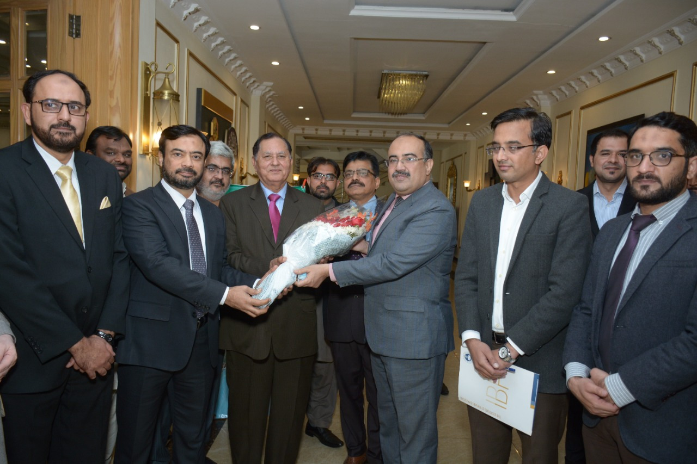
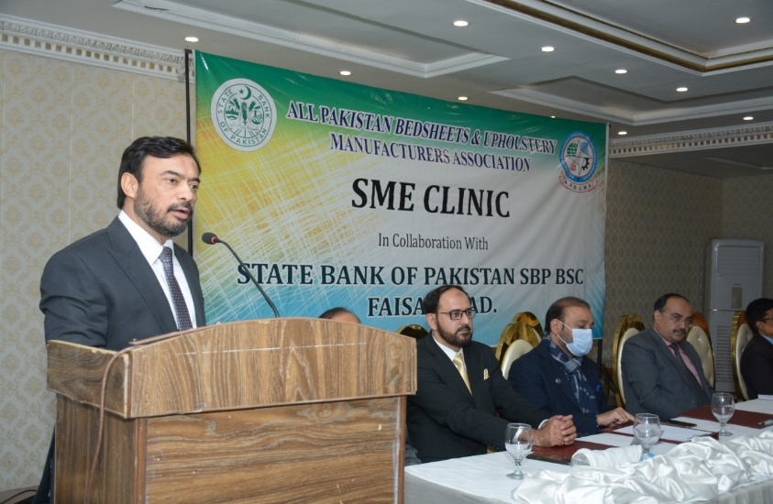
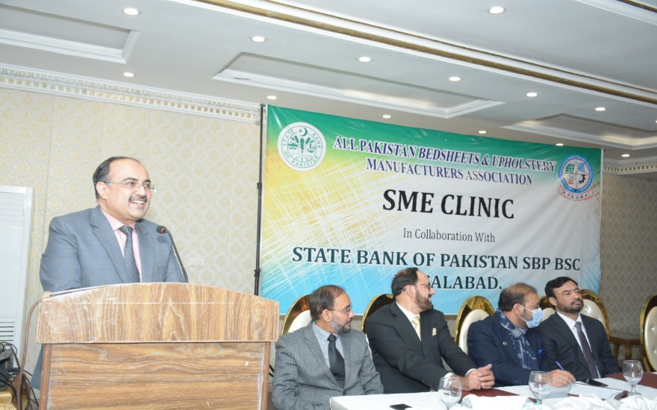
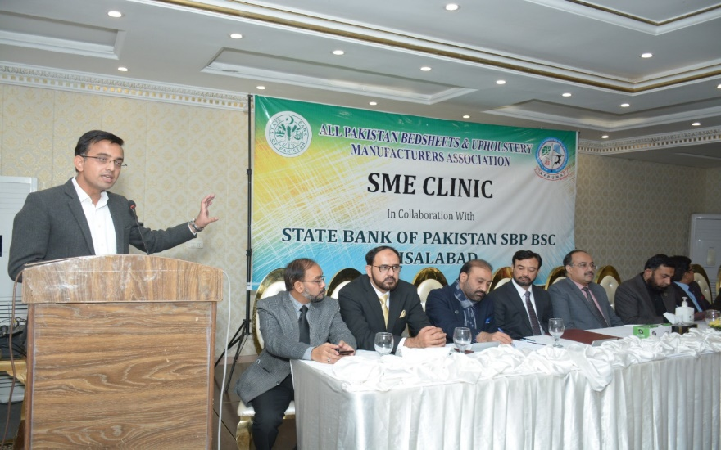 | 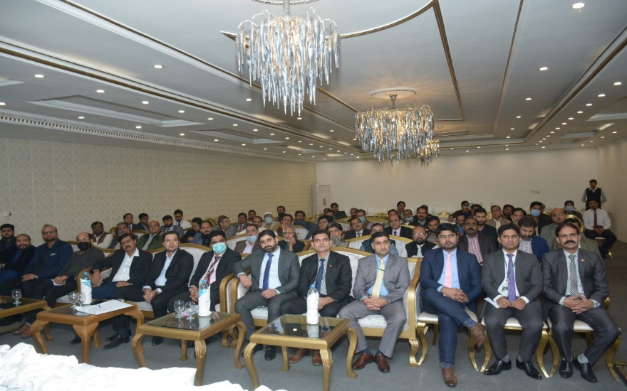
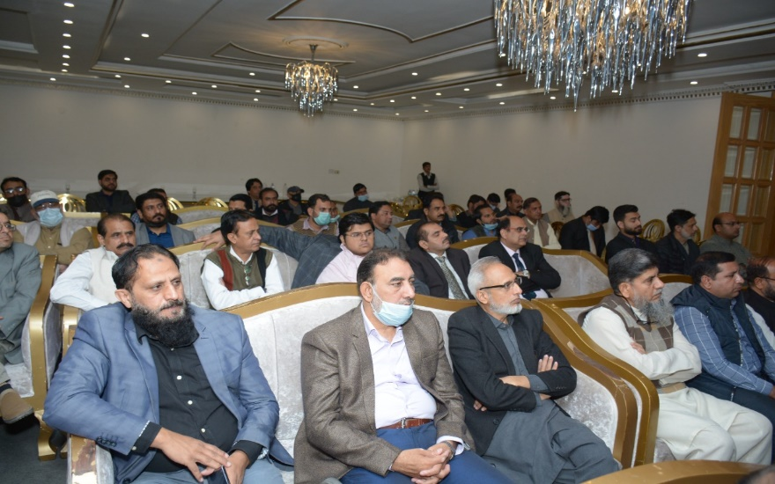 | 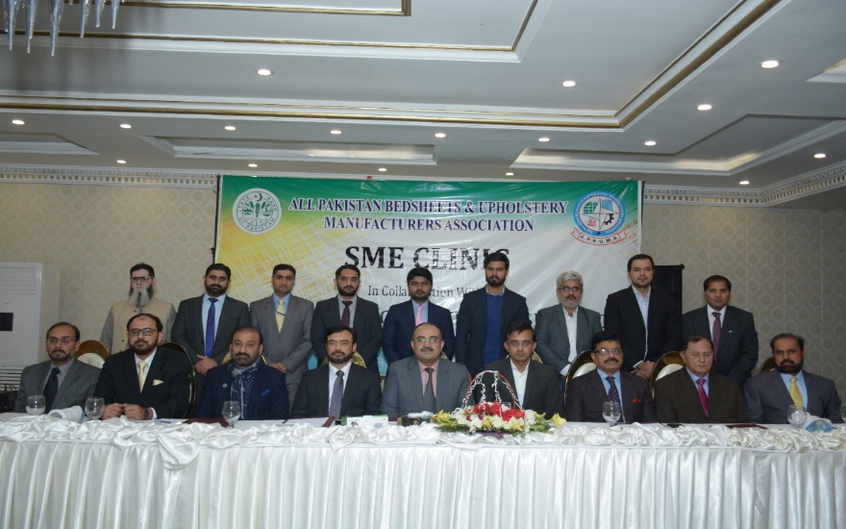
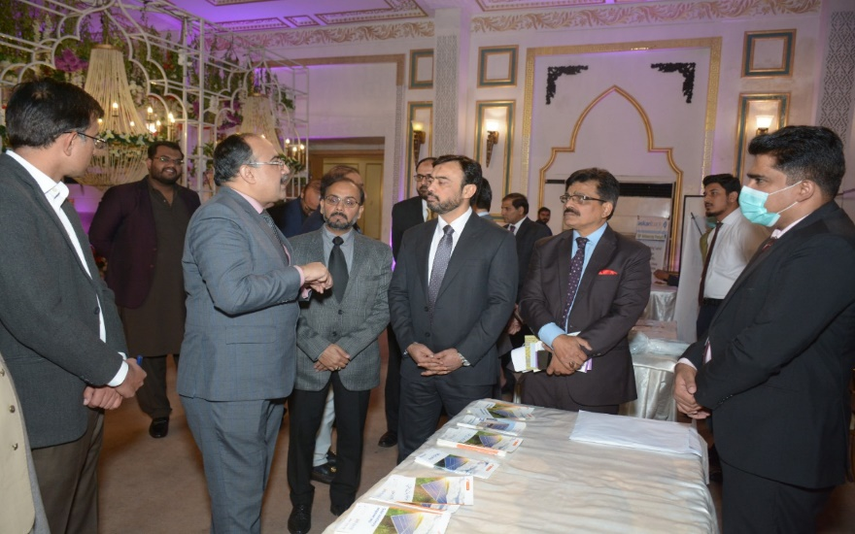 | 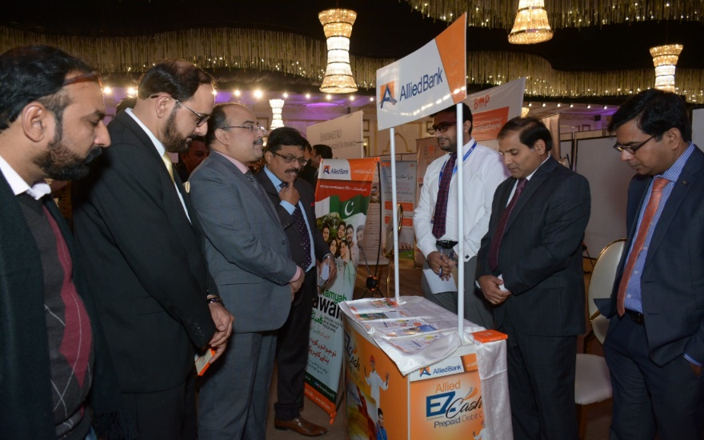
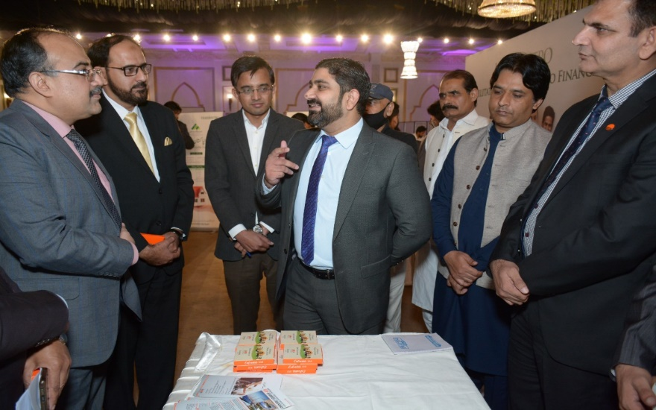 | 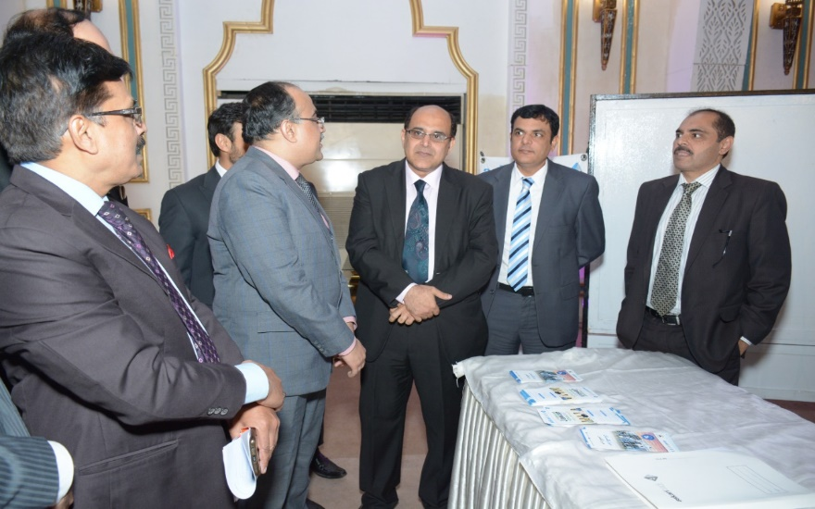
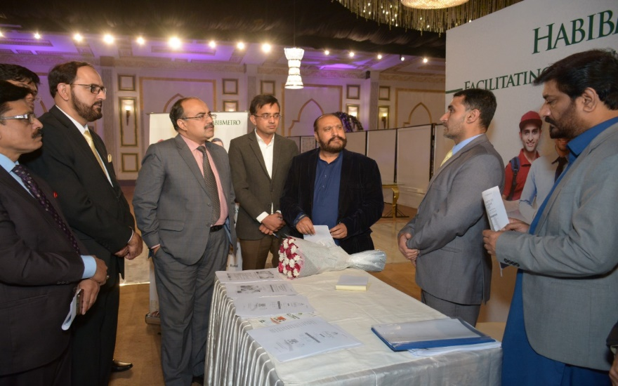 | 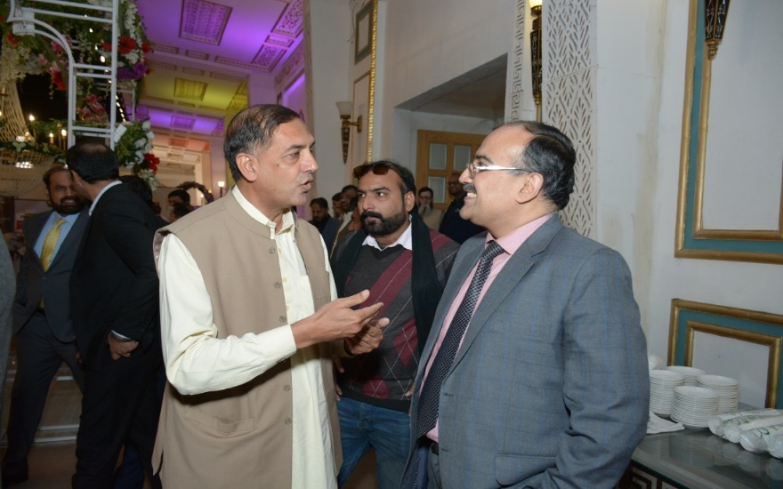
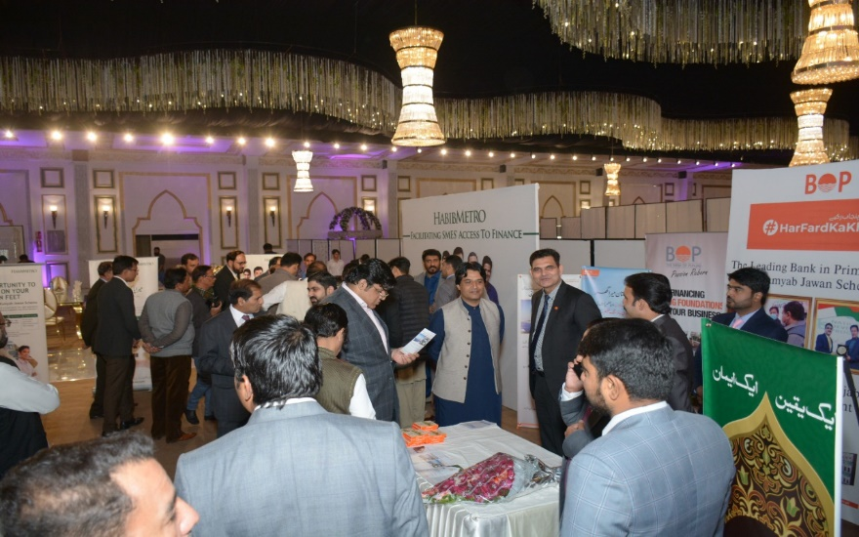 | 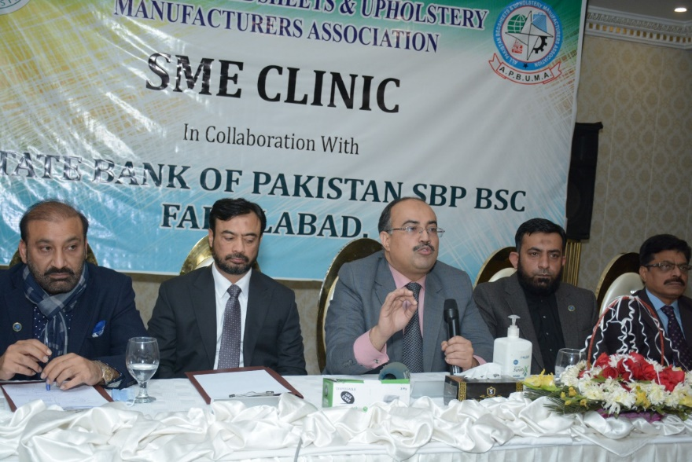
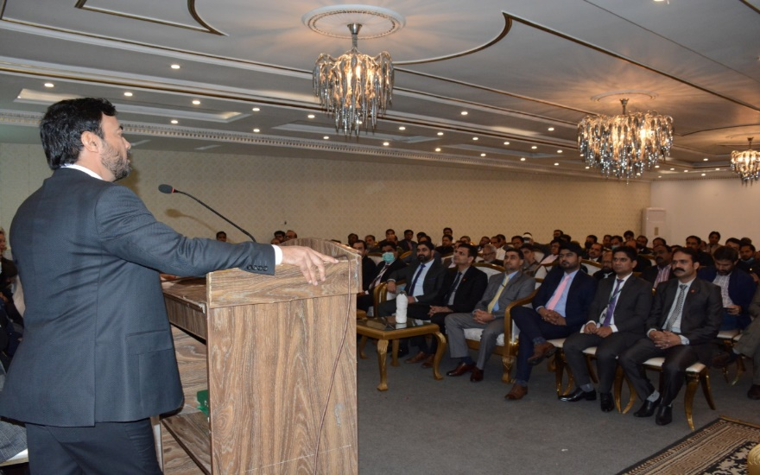 | 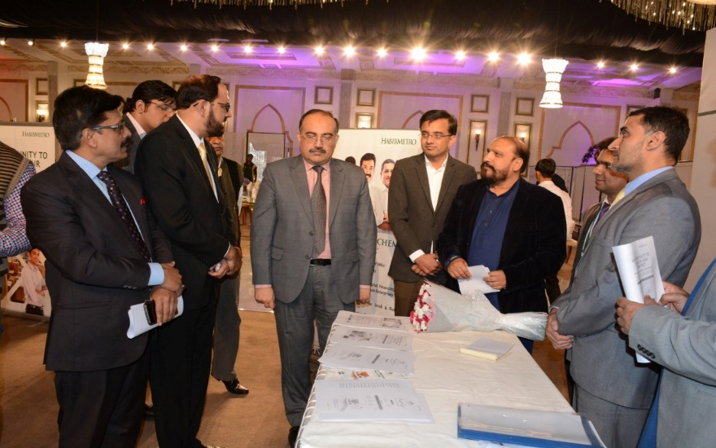
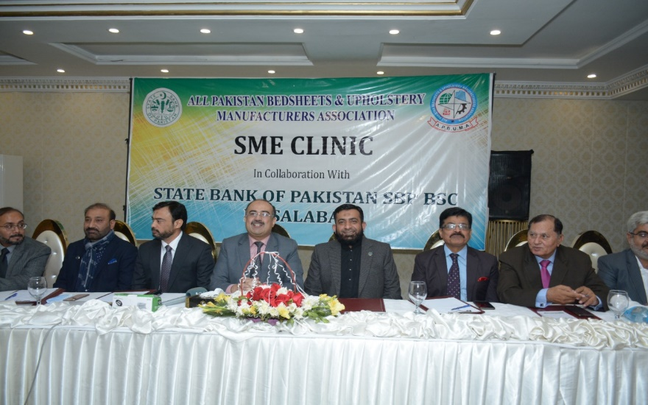 | 