7.1 KSE 100 & All Share Index
(As per last working day)
Sector Name | Jun-10 | Jun-11 | 2010 | 2011
Sector Name | Jun-10 | Jun-11 | Dec. | Jan | Feb | Mar | Apr
KSE 100 Index (1991 = 1,000) | 9,721.91 | 12,496.03 | 12,022.46 | 12,359.36 | 11,289.23 | 11,809.54 | 12,057.54
KSE General Index (1995 = 1,000) | 6,809.60 | 8,663.10 | 8,359.31 | 8,569.04 | 7,855.24 | 8,225.74 | 8,397.81
1. Oil & Gas | 11,526.64 | 13,077.44 | 13,915.19 | 14,025.07 | 12,309.74 | 12,166.44 | 12,719.80
2. Chemicals | 10,710.60 | 12,955.86 | 12,716.31 | 14,037.25 | 12,923.02 | 13,342.84 | 13,100.45
3. Forestry & Paper | 9,627.97 | 9,181.25 | 10,130.99 | 9,069.45 | 8,208.44 | 9,092.83 | 8,935.67
4. Industrial Metals & Mining | 8,232.44 | 7,569.61 | 8,772.19 | 8,190.50 | 7,490.00 | 8,064.56 | 8,017.34
5. Construction & Materials | 7,900.91 | 7,738.12 | 9,195.83 | 8,469.22 | 7,340.61 | 7,852.85 | 8,290.25
6. General Industrials | 8,123.49 | 8,873.13 | 9,401.79 | 9,320.24 | 8,138.96 | 8,728.86 | 8,723.76
7. Electronic & Electrical Equipment | 10,921.26 | 9,250.52 | 11,111.68 | 11,035.05 | 10,437.36 | 10,668.98 | 10,269.26
8. Industrial Engineering | 9,844.56 | 11,113.24 | 10,378.73 | 10,786.20 | 9,965.06 | 9,856.91 | 9,929.23
9. Industrial Transportation | 7,344.90 | 6,580.87 | 7,070.52 | 6,899.54 | 6,196.75 | 6,612.91 | 6,225.33
10. Support Services | 15,158.22 | 9,441.63 | 13,166.64 | 11,802.04 | 8,999.06 | 11,101.31 | 9,699.79
11. Automobile & Parts | 10,691.24 | 9,724.07 | 10,528.83 | 11,489.86 | 9,905.78 | 10,039.23 | 10,351.14
12. Beverages | 8,368.48 | 11,067.49 | 9,217.71 | 10,566.08 | 10,011.64 | 10,118.58 | 10,944.07
13. Food Producers | 11,987.59 | 27,076.67 | 15,922.99 | 19,342.35 | 19,788.91 | 19,823.70 | 20,594.99
14. Household Goods | 8,056.03 | 8,416.83 | 8,735.49 | 8,633.40 | 8,096.37 | 8,183.74 | 7,133.27
15. Leisure Goods | 9,424.37 | 6,610.48 | 7,898.16 | 7,504.74 | 7,555.30 | 7,256.69 | 6,604.17
16. Personal Goods | 8,475.13 | 9,793.32 | 10,723.92 | 11,115.21 | 10,307.80 | 10,440.86 | 10,152.87
17. Tobacco | 9,092.22 | 8,374.42 | 10,950.24 | 10,788.49 | 9,330.91 | 9,372.21 | 9,358.79
18. Health Care Equipment & Services | 14,315.97 | 17,999.14 | 15,920.14 | 16,482.31 | 16,625.53 | 15,548.88 | 16,837.66
19. Pharma & Bio-Tech | 8,190.02 | 8,013.90 | 8,935.65 | 8,224.50 | 7,249.58 | 8,327.25 | 7,891.21
20. Media | 10,912.10 | 3,638.07 | 9,708.30 | 4,001.83 | 4,164.74 | 4,179.01 | 3,598.24
21. Travel & Leisure | 8,416.04 | 9,156.95 | 9,938.45 | 9,808.46 | 9,593.02 | 9,620.52 | 9,519.13
22. Fixed Line Telecommunication | 9,141.51 | 6,985.01 | 9,642.15 | 9,244.12 | 8,735.15 | 8,391.82 | 8,270.88
23. Electricity | 9,316.18 | 10,085.46 | 10,311.56 | 10,647.99 | 10,391.56 | 10,204.39 | 10,438.75
24. Gas, Water & Multi-utilities | 10,716.06 | 10,794.54 | 12,105.06 | 12,228.83 | 11,890.20 | 11,546.47 | 10,298.83
25. Banks | 8,149.14 | 7,893.87 | 9,409.36 | 9,213.94 | 8,287.89 | 8,015.31 | 8,189.60
26. Non-Life Insurance | 6,655.13 | 6,106.79 | 7,083.27 | 7,082.68 | 6,533.25 | 7,045.85 | 6,067.32
27. Life Insurance | 6,159.97 | 6,391.39 | 6,372.01 | 5,889.31 | 5,032.63 | 5,581.53 | 5,466.04
28. Real Estate Investment & Services | 5,187.65 | 3,379.11 | 4,273.28 | 4,594.41 | 3,928.99 | 4,710.45 | 4,569.92
29. Financial Services | 4,635.74 | 2,674.91 | 3,849.56 | 3,803.10 | 3,201.25 | 3,178.58 | 2,633.97
30. Equity Investment Instruments | 8,341.80 | 6,416.82 | 7,839.74 | 8,099.81 | 7,924.00 | 8,076.20 | 8,466.72
31. Software & Computer Services | 7,838.72 | 6,412.62 | 5,995.78 | 8,092.58 | 6,647.70 | 7,528.41 | 7,061.41
32. Technology Hardware & Equipment | 8,626.56 | 9,242.77 | 6,581.92 | 6,581.93 | 4,425.31 | 4,117.23 | 7,251.18
Sector classification has been revised by KSE w.e.f. Jan 2010.

7.1 KSE 100 & All Share Index
(As per last working day)
Sector Name | 2011
Sector Name | May | Jun. | Jul. | Aug. | Sep. | Oct. | Nov. | Dec.
KSE 100 Index (1991 = 1,000) | 12,123.15 | 12,496.03 | 12,190.37 | 10,903.88 | 11,761.97 | 11,868.88 | 11,532.83 | 11,347.66
KSE General Index (1995 = 1,000) | 8,439.75 | 8,663.10 | 8,449.87 | 7,582.42 | 8,159.12 | 8,215.84 | 7,984.53 | 7,856.82
1. Oil & Gas | 13,030.98 | 13,077.44 | 13,110.35 | 11,341.27 | 11,805.73 | 12,212.45 | 12,402.73 | 12,164.66
2. Chemicals | 12,887.92 | 12,955.86 | 12,814.05 | 11,655.02 | 13,283.30 | 14,196.94 | 12,803.54 | 11,491.71
3. Forestry & Paper | 9,628.22 | 9,181.25 | 9,613.75 | 7,945.41 | 7,928.47 | 8,537.19 | 7,911.58 | 7,835.49
4. Industrial Metals & Mining | 7,865.05 | 7,569.61 | 7,649.03 | 6,766.10 | 6,516.43 | 5,886.73 | 5,224.67 | 5,984.48
5. Construction & Materials | 7,963.37 | 7,738.12 | 7,452.59 | 7,033.47 | 7,408.02 | 7,516.25 | 7,457.18 | 7,197.02
6. General Industrials | 8,739.73 | 8,873.13 | 8,547.75 | 7,749.22 | 8,297.83 | 7,313.85 | 6,634.12 | 7,341.82
7. Electronic & Electrical Equipment | 9,836.21 | 9,250.52 | 9,516.35 | 8,435.28 | 8,417.95 | 7,171.99 | 6,660.15 | 6,616.10
8. Industrial Engineering | 10,337.57 | 11,113.24 | 10,856.37 | 8,822.74 | 8,263.07 | 7,567.34 | 7,163.18 | 7,465.84
9. Industrial Transportation | 7,100.99 | 6,580.87 | 6,174.74 | 5,803.67 | 5,739.18 | 6,201.04 | 5,250.58 | 4,881.14
10. Support Services | 10,437.44 | 9,441.63 | 8,482.70 | 7,302.50 | 6,896.80 | 6,454.23 | 5,237.16 | 4,499.53
11. Automobile & Parts | 10,302.05 | 9,724.07 | 9,706.30 | 9,597.73 | 9,128.32 | 9,190.55 | 9,131.99 | 9,148.25
12. Beverages | 10,938.49 | 11,067.49 | 10,731.60 | 9,636.75 | 9,453.25 | 7,692.20 | 7,307.99 | 6,972.98
13. Food Producers | 20,188.47 | 27,076.67 | 23,702.86 | 21,203.71 | 22,016.05 | 20,797.78 | 18,933.27 | 21,218.60
14. Household Goods | 6,621.08 | 8,416.83 | 6,065.20 | 5,808.86 | 5,896.55 | 5,550.61 | 5,345.85 | 5,933.94
15. Leisure Goods | 7,416.26 | 6,610.48 | 6,285.01 | 6,005.36 | 5,558.24 | 3,949.86 | 3,791.87 | 3,633.87
16. Personal Goods | 9,920.80 | 9,793.32 | 9,384.31 | 8,728.78 | 8,959.28 | 8,135.59 | 7,937.63 | 8,038.79
17. Tobacco | 9,442.28 | 8,374.42 | 7,386.22 | 6,495.64 | 6,463.44 | 6,026.52 | 5,683.82 | 5,414.61
18. Health Care Equipment & Services | 17,033.90 | 17,999.14 | 17,124.05 | 18,593.14 | 18,068.08 | 16,248.95 | 15,628.43 | 13,931.26
19. Pharma & Bio-Tech | 7,778.14 | 8,013.90 | 7,847.97 | 7,679.94 | 7,807.64 | 7,617.61 | 7,522.79 | 7,483.43
20. Media | 3,737.66 | 3,638.07 | 3,274.79 | 2,604.27 | 2,345.61 | 2,443.90 | 2,241.19 | 3,086.30
21. Travel & Leisure | 9,470.06 | 9,156.95 | 9,147.98 | 9,055.68 | 9,201.00 | 8,739.34 | 8,697.75 | 8,494.00
22. Fixed Line Telecommunication | 8,607.56 | 6,985.01 | 6,222.69 | 5,363.94 | 5,658.53 | 5,358.66 | 5,136.51 | 5,067.41
23. Electricity | 10,367.29 | 10,085.46 | 10,245.53 | 9,936.96 | 10,365.31 | 9,530.82 | 9,340.68 | 9,044.82
24. Gas, Water & Multi-utilities | 10,751.83 | 10,794.54 | 10,225.56 | 9,685.64 | 11,728.32 | 10,049.12 | 9,479.94 | 9,208.81
25. Banks | 8,088.50 | 7,893.87 | 7,774.99 | 6,934.00 | 7,458.60 | 7,236.38 | 6,950.41 | 6,577.73
26. Non-Life Insurance | 6,236.67 | 6,106.79 | 5,827.61 | 5,544.07 | 5,718.22 | 5,586.10 | 5,075.32 | 5,053.94
27. Life Insurance | 5,996.62 | 6,391.39 | 6,167.29 | 6,003.16 | 6,531.27 | 6,670.29 | 6,538.57 | 6,808.73
28. Real Estate Investment & Services | 4,202.60 | 3,379.11 | 3,111.21 | 2,728.51 | 2,498.29 | 2,546.72 | 2,351.22 | 2,039.46
29. Financial Services | 2,881.73 | 2,674.91 | 2,681.84 | 2,244.29 | 2,389.31 | 2,357.52 | 2,320.76 | 1,978.89
30. Equity Investment Instruments | 8,245.79 | 6,416.82 | 8,362.15 | 7,312.46 | 7,582.67 | 7,266.31 | 7,371.65 | 7,218.04
31. Software & Computer Services | 6,653.96 | 6,412.62 | 6,387.57 | 4,713.89 | 4,428.71 | 3,739.19 | 3,093.52 | 2,701.72
32. Technology Hardware & Equipment | 8,906.67 | 9,242.77 | 8,822.65 | 7,506.25 | 7,562.27 | 7,282.18 | 8,682.6 | 6,105.83
Sector classification has been revised by KSE w.e.f. Jan 2010.

Karachi Stock Exchange Index

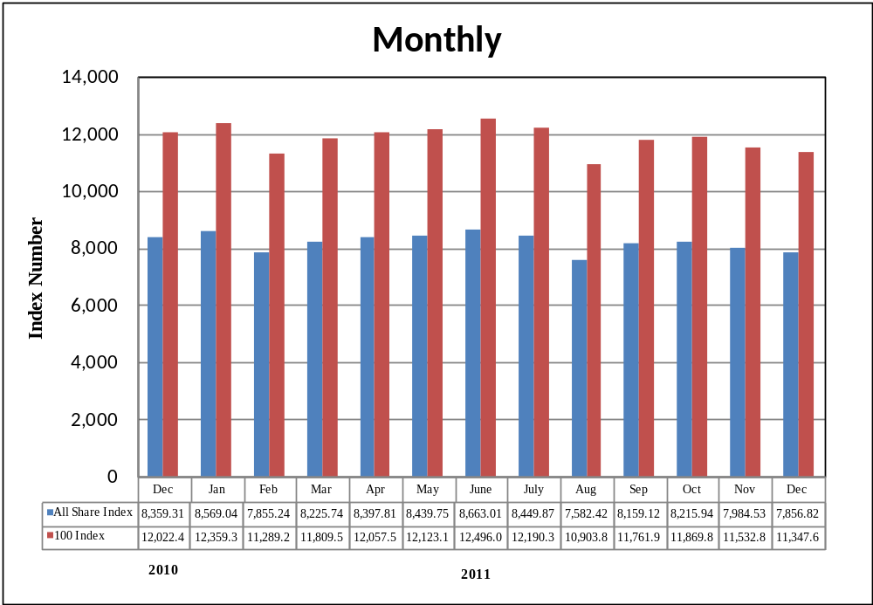

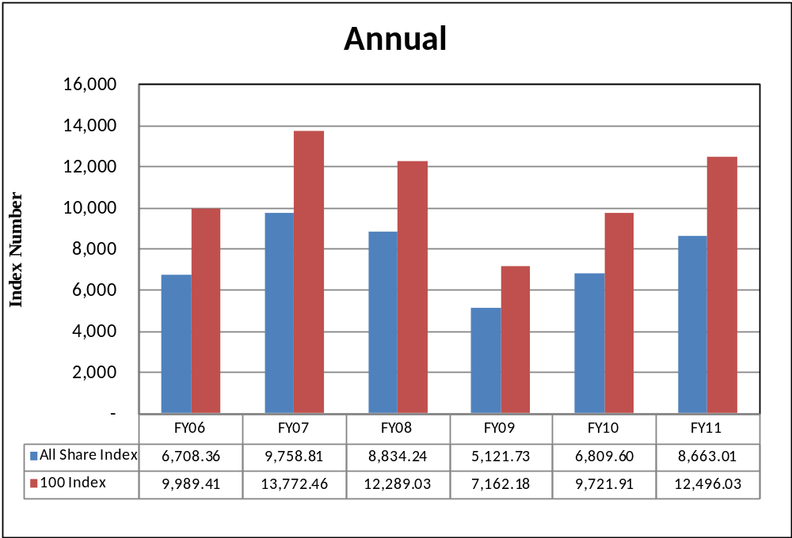

7.2 Karachi Stock Exchange Indicators
(End Period)
Month | KSE 100 Index (1991 = 1,000) |  |  |  |  | KSE All Shares Index (1995 = 1,000)
Month | FY08 | FY09 | FY10 | FY11 | FY12 | FY08 | FY09 | FY10 | FY11 | FY12
Jul. | 13,738.87 | 10,583.58 | 7,720.93 | 10,519.02 | 12,190.37 | 9,775.10 | 7,636.25 | 5,515.95 | 7,348.91 | 8,449.87
Aug. | 12,214.26 | 9,208.26 | 8,675.67 | 9,813.05 | 10,903.88 | 9,675.91 | 6,655.99 | 6,154.81 | 6,849.60 | 7,582.42
Sep. | 13,351.79 | 9,179.68 | 9,349.68 | 10,013.31 | 11,761.97 | 9,445.36 | 6,640.66 | 6,651.16 | 6,996.83 | 8,159.12
Oct. | 14,319.42 | 9,182.88 | 9,159.18 | 10,598.40 | 11,868.88 | 10,143.37 | 6,638.96 | 6,513.12 | 7,382.41 | 8,215.84
Nov. | 13,998.52 | 9,187.10 | 9,206.21 | 11,234.76 | 1,1532.83 | 9,930.48 | 6,641.61 | 6,529.44 | 7,818.10 | 7,984.53
Dec. | 14,075.83 | 5,865.01 | 9,386.92 | 12,022.46 | 11,347.66 | 9,956.76 | 4,400.76 | 6,665.55 | 8,359.31 | 7,856.82
Jan. | 14,017.01 | 5,377.42 | 9,614.19 | 12,359.36 |  | 9,935.08 | 4,016.84 | 6,821.14 | 8,569.04
Feb. | 14,934.30 | 5,727.46 | 9,657.79 | 11,289.23 |  | 10,635.69 | 4,221.57 | 6,844.07 | 7,855.24
Mar. | 15,125.29 | 6,860.22 | 10,178.43 | 11,809.54 |  | 10,750.22 | 4,931.51 | 7,182.37 | 8,225.74
Apr. | 15,122.47 | 7,202.10 | 10,428.12 | 12,057.54 |  | 10,777.40 | 5,168.77 | 7,331.68 | 8,397.81
May | 12,130.51 | 7,276.61 | 9,326.42 | 12,123.15 |  | 8,699.61 | 5,216.66 | 6,546.90 | 8,439.75
Jun. | 12,289.03 | 7,162.18 | 9,721.90 | 12,496.03 |  | 8,834.24 | 5,121.73 | 6,809.60 | 8,663.01

7.3 Turn Over of Shares at Karachi Stock Exchange
(Million Nos.)
Month | Total |  |  |  |  | Average per day ¹
Month | FY08 | FY09 | FY10 | FY11 | FY12 | FY08 | FY09 |  | FY10 | FY11 | FY12
Jul. | 7,735.01 | 2,029.34 | 3,723.68 | 1,514.32 | 1,211.83 | 351.59 | 88.00 |  | 161.90 | 68.83 | 57.71
Aug. | 4,486.12 | 2,162.73 | 3,104.92 | 1,243.38 | 1,032.41 | 203.91 | 108.14 |  | 155.25 | 56.52 | 49.14
Sep. | 4,197.39 | 540.41 | 4,906.84 | 1,215.49 | 1,434.74 | 209.87 | 25.73 |  | 258.25 | 60.77 | 71.74
Oct. | 6,582.42 | 322.61 | 4,728.09 | 2,246.06 | 1,685.95 | 346.44 | 16.13 |  | 214.91 | 106.96 | 93.66
Nov. | 5,217.59 | 137.16 | 2,292.30 | 2,267.72 | 855.83 | 248.46 | 6.86 |  | 127.35 | 125.98 | 45.04
Dec. | 4,662.86 | 900.99 | 2,503.68 | 2,931.92 | 831.09 | 274.29 | 50.05 |  | 119.22 | 139.62 | 41.55
Jan. | 5,626.03 | 3,302.92 | 3,743.60 | 3,579.94 |  | 244.61 | 165.15 |  | 187.18 | 170.47
Feb. | 5,068.07 | 3,218.12 | 3,108.10 | 1,809.47 |  | 266.74 | 169.37 |  | 163.58 | 95.24
Mar. | 5,047.15 | 3,805.28 | 3,465.34 | 2,210.90 |  | 252.36 | 190.26 |  | 157.52 | 100.50
Apr. | 6,387.34 | 6,490.73 | 4,278.02 | 1,585.93 |  | 290.33 | 295.03 |  | 194.46 | 75.52
May | 4,933.40 | 2,729.38 | 2,114.27 | 1,570.54 |  | 234.92 | 136.47 |  | 100.68 | 71.39
Jun. | 3,372.74 | 2,693.11 | 2,187.96 | 1,653.06 |  | 160.61 | 122.41 |  | 99.45 | 75.14
Total | 63,316.12 | 28,332.78 | 40,156.79 | 23,828.73 | 7,051.85 | 257.01 | 114.47 |  | 161.27 | 95.58 | 59.81
1. Average is calculated on the basis of number of trading days in a month. |  |  |  |  |  |  |  | Source : The Karachi Stock Exchange

7.4 Market Capitalization of KSE all Shares
*As per last working day.
(Million Rupees)
Sector Name |  |  | Jun-10 | Jun-11 | 2010 | 2011
 |  |  |  |  | Dec. | Jan | Feb | Mar | Apr
1 | Oil & Gas |  | 959,369 | 1,130,488 | 1,202,906 | 1,212,406 | 1,064,123 | 1,051,737 | 1,099,571
2 | Chemicals |  | 259,060 | 381,534 | 317,268 | 350,231 | 342,249 | 392,929 | 385,792
3 | Forestry & Paper |  | 3,066 | 2,973 | 3,280 | 2,937 | 2,658 | 2,944 | 2,893
4 | Industrial Metals & Mining |  | 9,007 | 15,160 | 10,747 | 10,035 | 9,177 | 9,880 | 9,823
5 | Construction & Materials |  | 62,041 | 64,111 | 72,852 | 67,162 | 59,105 | 63,255 | 66,779
6 | General Industrials |  | 32,470 | 36,585 | 39,341 | 38,999 | 34,056 | 36,525 | 36,503
7 | Electronic & Electrical Equipment |  | 1,223 | 1,357 | 1,630 | 1,619 | 1,531 | 1,565 | 1,506
8 | Industrial Engineering |  | 27,848 | 35,132 | 32,810 | 34,098 | 31,502 | 31,160 | 31,389
9 | Industrial Transportation |  | 13,719 | 12,292 | 13,206 | 12,887 | 11,574 | 12,352 | 11,628
10 | Support Services |  | 1,584 | 987 | 1,376 | 1,233 | 940 | 1,160 | 1,014
11 | Automobile & Parts |  | 43,713 | 41,244 | 43,372 | 47,330 | 40,805 | 41,355 | 42,680
12 | Beverages |  | 1,898 | 2,831 | 2,358 | 2,703 | 2,561 | 2,588 | 2,799
13 | Food Producers |  | 169,353 | 385,429 | 225,450 | 275,223 | 281,577 | 282,091 | 293,067
14 | Household Goods |  | 4,673 | 4,500 | 5,125 | 5,234 | 4,909 | 4,962 | 4,386
15 | Leisure Goods |  | 438 | 307 | 367 | 349 | 351 | 337 | 307
16 | Personal Goods |  | 104,198 | 124,571 | 135,598 | 140,360 | 130,171 | 131,985 | 129,097
17 | Tobacco |  | 38,235 | 35,217 | 46,049 | 45,369 | 39,239 | 39,413 | 39,356
18 | Health Care Equipment & Services |  | 1,364 | 1,714 | 1,516 | 1,570 | 1,584 | 1,481 | 1,604
19 | Pharma & Bio Tech. |  | 30,430 | 32,592 | 33,647 | 30,969 | 27,298 | 31,356 | 31,675
20 | Media |  | 9,420 | 3,141 | 8,381 | 3,455 | 3,595 | 3,608 | 3,106
21 | Travel & Leisure |  | 26,175 | 29,082 | 30,910 | 30,506 | 29,836 | 29,921 | 30,232
22 | Fixed Line Telecommunication |  | 75,204 | 57,464 | 79,323 | 76,048 | 71,861 | 69,037 | 68,042
23 | Electricity |  | 95,224 | 103,102 | 105,414 | 108,853 | 106,232 | 104,318 | 106,714
24 | Gas, Water & Multi-utilities |  | 25,938 | 29,119 | 32,654 | 32,988 | 32,074 | 31,147 | 27,781
25 | Banks |  | 620,402 | 666,020 | 724,817 | 710,706 | 639,277 | 675,449 | 690,137
26 | Non-Life Insurance |  | 49,966 | 45,858 | 48,509 | 48,523 | 44,810 | 48,545 | 45,562
27 | Life Insurance |  | 9,991 | 10,378 | 10,335 | 9,563 | 8,172 | 9,063 | 8,875
28 | Real Estate Investment & Services |  | 1,074 | 699 | 885 | 951 | 813 | 975 | 946
29 | Financial Services |  | 33,899 | 13,553 | 19,070 | 18,840 | 15,858 | 15,746 | 13,048
30 | Equity Investment Instruments |  | 19,379 | 19,556 | 18,215 | 18,819 | 18,411 | 18,765 | 19,672
31 | Software & Computer Services |  | 1,949 | 1,594 | 1,490 | 2,012 | 1,653 | 1,871 | 1,755
32 | Technology Hardware & Equipment |  | 65 | 69 | 49 | 49 | 33 | 31 | 54
 | TOTAL |  | 2,732,375 | 3,288,659 | 3,268,949 | 3,342027 | 3,058,035 | 3,147,551 | 3,207,793
 |  |  |  |  | Source: The Karachi Stock Exchange
Note:- Sector classification has been revised by KSE w.e.f. Jan 2010.

7.4 Market Capitalization of KSE all Shares
*As per last working day.
(Million Rupees)
Sector Name |  |  | 2011
 |  |  | May | Jun. | Jul. | Aug. | Sep. | Oct. | Nov. | Dec.
1 | Oil & Gas |  | 1,126,472 | 1,130,488 | 1,133,331 | 980,401 | 1,047,640 | 1,085,405 | 1,102,318 | 1,081,161
2 | Chemicals |  | 379,533 | 381,534 | 377,358 | 343,226 | 391,177 | 419,184 | 378,042 | 339,471
3 | Forestry & Paper |  | 3,118 | 2,973 | 3,113 | 2,573 | 2,567 | 2,764 | 2,562 | 2,537
4 | Industrial Metals & Mining |  | 9,636 | 15,160 | 15,319 | 13,551 | 13,051 | 11,389 | 10,464 | 11,986
5 | Construction & Materials |  | 64,158 | 64,111 | 69,210 | 65,318 | 68,796 | 69,601 | 69,252 | 69,175
6 | General Industrials |  | 36,570 | 36,585 | 36,056 | 32,688 | 35,002 | 31,773 | 28,821 | 31,895
7 | Electronic & Electrical Equipment |  | 1,443 | 1,357 | 1,396 | 1,237 | 1,235 | 1,052 | 977 | 970
8 | Industrial Engineering |  | 32,680 | 35,132 | 34,320 | 27,891 | 26,121 | 23,922 | 22,645 | 23,601
9 | Industrial Transportation |  | 13,263 | 12,292 | 11,533 | 10,840 | 10,720 | 9,827 | 9,807 | 9,117
10 | Support Services |  | 1,091 | 987 | 886 | 763 | 721 | 674 | 547 | 470
11 | Automobile & Parts |  | 42,477 | 41,244 | 41,421 | 40,958 | 39,354 | 39,623 | 39,370 | 39,440
12 | Beverages |  | 2,798 | 2,831 | 2,745 | 2,466 | 2,418 | 2,093 | 1,989 | 1,898
13 | Food Producers |  | 287,282 | 385,429 | 337,461 | 319,307 | 332,039 | 313,681 | 285,559 | 320,027
14 | Household Goods |  | 4,614 | 4,500 | 4,253 | 4,073 | 4,135 | 3,892 | 3,749 | 4,161
15 | Leisure Goods |  | 345 | 307 | 292 | 279 | 259 | 184 | 176 | 169
16 | Personal Goods |  | 126,193 | 124,571 | 119,368 | 111,030 | 116,983 | 108,491 | 105,655 | 107,087
17 | Tobacco |  | 39,707 | 35,217 | 31,061 | 27,316 | 27,181 | 25,344 | 23,902 | 22,770
18 | Health Care Equipment & Services |  | 1,622 | 1,714 | 1,631 | 1,771 | 1,721 | 1,548 | 1,489 | 1,327
19 | Pharma & Bio Tech. |  | 31,221 | 32,592 | 31,917 | 31,234 | 32,041 | 34,033 | 33,609 | 33,434
20 | Media |  | 3,227 | 3,141 | 2,827 | 2,248 | 2,025 | 2,110 | 1,935 | 2,665
21 | Travel & Leisure |  | 30,076 | 29,082 | 29,053 | 28,760 | 29,221 | 27,755 | 27,623 | 26,976
22 | Fixed Line Telecommunication |  | 70,812 | 57,464 | 51,192 | 44,127 | 46,551 | 44,084 | 42,257 | 41,688
23 | Electricity |  | 105,983 | 103,102 | 111,811 | 108,466 | 113,118 | 104,114 | 101,952 | 98,723
24 | Gas, Water & Multi-utilities |  | 29,003 | 29,119 | 27,584 | 26,127 | 31,637 | 28,428 | 26,818 | 26,051
25 | Banks |  | 681,616 | 666,020 | 656,674 | 587,034 | 641,802 | 622,690 | 599,342 | 568,503
26 | Non-Life Insurance |  | 46,833 | 45,858 | 43,762 | 41,633 | 44,389 | 43,243 | 40,581 | 40,515
27 | Life Insurance |  | 9,737 | 10,378 | 10,014 | 9,748 | 10,605 | 10,831 | 10,617 | 11,056
28 | Real Estate Investment & Services |  | 870 | 699 | 644 | 565 | 517 | 527 | 487 | 422
29 | Financial Services |  | 14,276 | 13,553 | 13,588 | 11,373 | 12,107 | 12,121 | 12,522 | 10,677
30 | Equity Investment Instruments |  | 19,159 | 19,556 | 19,429 | 16,990 | 17,618 | 17,210 | 17,460 | 17,096
31 | Software & Computer Services |  | 1,654 | 1,594 | 1,588 | 1,172 | 1,101 | 929 | 769 | 672
32 | Technology Hardware & Equipment |  | 67 | 69 | 66 | 56 | 57 | 54 | 65 | 46
 | TOTAL |  | 3,217,534 | 3,288,659 | 3,220,906 | 2,895,220 | 3,103,911 | 3,098,578 | 3,003,359 | 2,945,785
 |  |  |  |  | Source: The Karachi Stock Exchange
Note:- Sector classification has been revised by KSE w.e.f. Jan 2010.

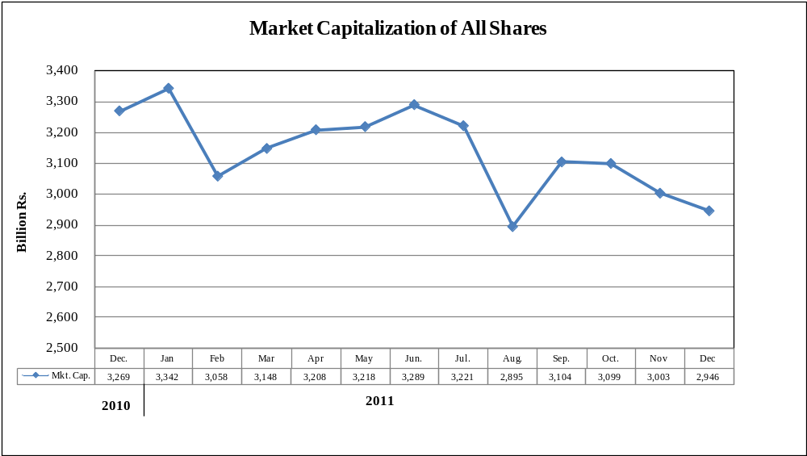

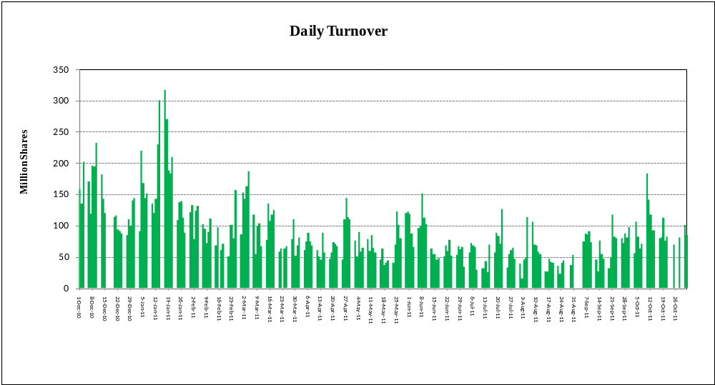

7.5 Financial Statement Analysis of Non-Financial Sector
Overall |  |  |  |  | (Million Rupees)
ITEMS | 2006 | 2007 | 2008 | 2009 |  | 2010
A.Non-Current Assets (A1+A3+A5+A6+A7) | 1,040,091.0 | 1,211,065.8 | 1,388,602.8 | 2,126,247.7 |  | 2,296,798.6
1.Capital work in progress | - | - | - | 335,536.3 |  | 308,027.3
2.Operating fixed assets at cost | 1,671,976.7 | 1,863,049.7 | 2,090,354.5 | 2,355,025.5 |  | 2,556,850.1
3.Operating fixed assets after deducting accumulated depreciation | 1,016,570.4 | 1,160,345.2 | 1,329,643.7 | 1,458,033.9 |  | 1,596,529.9
4.Depreciation for the year | 75,870.1 | 86,225.3 | 96,644.8 | 110,921.0 |  | 117,858.1
5.Intangible assets | 23,520.7 | 50,720.6 | 58,955.6 | 89,797.5 |  | 101,538.7
6.Long term investments | - | - | 3.4 | 163,563.5 |  | 203,501.3
7.Other non-current assets | - | - | - | 79,316.4 |  | 87,201.4
B.Current Assets (B1+B2+B3+B4+B5) | 1,031,847.7 | 1,196,256.0 | 1,493,811.9 | 1,455,518.7 |  | 1,717,466.0
1.Cash & bank balance | 184,141.8 | 169,690.2 | 172,892.1 | 166,163.5 |  | 177,682.0
2.Inventories | 240,567.9 | 271,532.6 | 362,027.0 | 348,195.0 |  | 380,344.1
3.Trade Debt | 200,602.8 | 249,058.6 | 365,627.3 | 551,532.8 |  | 729,126.9
4.Short term investments | 192,516.0 | 239,471.2 | 250,034.0 | 79,141.3 |  | 93,638.8
5.Other current assets | 214,019.2 | 266,503.3 | 343,231.5 | 310,486.2 |  | 336,674.2
C.Current Liabilities (C1+C2) | 888,036.0 | 1,041,342.8 | 1,422,133.5 | 1,399,300.4 |  | 1,669,392.8
1.Short term Secured loans | 273,013.6 | 294,263.2 | 420,103.8 | 430,757.4 |  | 467,530.0
2.Other current liabilities | 615,022.4 | 747,079.5 | 1,002,029.6 | 968,543.0 |  | 1,201,862.8
D.Non-Current Liabilities (D1+D2+D3+D4+D5) | 283,197.9 | 352,081.3 | 422,795.5 | 986,966.5 |  | 946,382.0
1.Long term secured loans | - | - | 86.7 | 431,996.5 |  | 377,927.0
2.Long term unsecured loans | - | - | - | 114,175.2 |  | 107,474.9
3.Debentures/TFCs | 31,265.3 | 45,095.4 | 49,685.8 | 50,796.3 |  | 44,763.9
4.Employees benefit obligations | - | - | - | 51,455.3 |  | 61,483.5
5.Other non-current liabilities | 251,932.6 | 306,985.9 | 373,023.0 | 338,543.2 |  | 354,732.7
E.Shareholders Equity (E1+E2+E3) | 900,704.8 | 1,013,897.7 | 1,037,485.6 | 1,194,753.9 |  | 1,397,744.1
1.Issued, Subscribed & Paid up capital | 375,854.8 | 404,678.0 | 429,007.3 | 478,837.3 |  | 528,563.2
i).Ordinary Shares | 372,335.5 | 394,509.6 | 419,555.4 | 468,331.1 |  | 514,344.5
ii).Preference shares | 3,519.3 | 10,168.4 | 9,451.9 | 10,506.2 |  | 14,218.7
2.Reserves | 524,850.0 | 609,219.7 | 608,367.3 | 559,558.1 |  | 660,013.2
i).Capital Reserve | - | - | - | 116,752.6 |  | 131,463.4
ii).Revenue Reserve | - | - | (62.0) | 433,698.5 |  | 515,868.9
3.Surplus on revaluation of fixed assets | - | - | 111.0 | 156,358.4 |  | 209,167.7
F.Operation: | - | - | - | - |  | -
1.Sales | 2,570,950.5 | 2,837,922.7 | 3,356,261.5 | 3,608,115.6 |  | 4,127,410.9
i).Local sales (Net) | 2,406,191.2 | 2,632,698.1 | 3,104,620.4 | 3,240,654.1 |  | 3,688,311.2
ii).Export Sales (Net) | 164,759.3 | 205,224.6 | 251,641.1 | 367,461.5 |  | 439,099.7
2.Cost of sales | 2,166,348.2 | 2,431,127.0 | 2,859,768.5 | 3,075,281.3 |  | 3,520,254.6
i).Cost of material | - | - | 660.5 | 1,581,556.5 |  | 1,868,548.6
ii).Other input cost | - | - | 54.4 | 1,492,028.5 |  | 1,649,981.8
3.Gross Profit | 404,602.4 | 406,795.7 | 496,492.9 | 532,834.3 |  | 607,156.3
4.General, administrative and other expenses | 162,470.3 | 185,378.1 | 270,162.0 | 255,557.7 |  | 257,240.7
i).Selling & distribution expenses | - | - | 6.9 | 97,040.9 |  | 106,664.7
ii).Administrative and other expenses | 162,470.3 | 185,378.1 | 270,155.1 | 158,516.8 |  | 150,576.0
5.Salaries, wages and employee benefits | - | - | 30.4 | 162,227.2 |  | 195,486.5
6.Financial expenses | 49,293.8 | 67,127.4 | 95,936.5 | 149,689.9 |  | 138,228.6
of which: (i) Interest expenses | - | - | 1.9 | 111,894.6 |  | 101,067.1
7.Net profit before tax | 256,700.5 | 229,298.4 | 202,877.5 | 211,530.3 |  | 309,460.9
8.Tax provision (current year) | 73,133.2 | 60,628.3 | 91,995.2 | 77,630.0 |  | 97,335.3
9.Total amount of dividend | 102,525.7 | 97,589.8 | 106,194.2 | 118,297.5 |  | 123,594.4
10.Total value of bonus shares issued | 5,763.8 | 2,995.8 | 4,765.0 | 7,707.8 |  | 19,265.7
11.Cash flows from operations | - | - | 14.7 | 309,734.2 |  | 333,313.7
G.Miscellaneous | - | - | - | - |  | -
1.Total capital employed (E+D) | 1,183,902.7 | 1,365,979.0 | 1,460,281.2 | 2,181,720.3 |  | 2,344,126.1
2.Total fixed liabilities (D1+D3) | 31,265.3 | 45,095.4 | 49,772.6 | 482,792.8 |  | 422,690.9
3.Retention in business (F7-F8-F9) | 81,041.6 | 71,080.2 | 4,688.2 | 15,602.8 |  | 88,531.1
4.Contractual Liabilities (G2+C1) | 304,278.9 | 339,358.7 | 469,876.4 | 913,550.2 |  | 890,220.9
H.Key Performance Indicators
1.Acid test or quick ratio[(B1+B3+B4) to C] | 0.7 | 0.6 | 0.6 | 0.6 |  | 0.6
2.Financial expenses as % of sales (F6 as % of F1) | 1.9 | 2.4 | 2.9 | 4.2 |  | 3.4
3.Trade Debt as % of sales (B3 as % of F1) | 7.8 | 8.8 | 10.9 | 15.3 |  | 17.7
4.Assets turnover ratio [F1 to (A+B)] | 1.2 | 1.2 | 1.2 | 1.0 |  | 1.0
5.Current ratio (B to C) | 1.2 | 1.2 | 1.1 | 1.0 |  | 1.0
6.Cost of goods sold to sales (F2 as % of F1) | 84.3 | 85.7 | 85.2 | 85.2 |  | 85.3
7.Debt equity ratio [(C+D) to E] | 1.3 | 1.4 | 1.8 | 2.0 |  | 1.9
8.Return on assets [F7 as % of avg.(A+B)] | 13.6 | 10.2 | 7.7 | 6.5 |  | 8.2
9.Return of equity (F7 as % of avg. E) | 30.2 | 24.0 | 19.8 | 19.0 |  | 23.9
10.Return on capital employed ( F7 as % of avg. G1) | 23.2 | 18.0 | 14.4 | 11.6 |  | 13.7
11.Dividend cover ratio [(F7-F8) to F9] | 1.8 | 1.7 | 1.0 | 1.1 |  | 1.7
12.Inventory Turnover Ratio (F1 to B2) | 10.7 | 10.5 | 9.3 | 10.4 |  | 10.9
13.Interest cover ratio [(F7+ F6(i)) to F6(i)] | - | - | - | 2.9 |  | 4.1
14.Net profit margin (F7 as % of F1) | 10.0 | 8.1 | 6.0 | 5.9 |  | 7.5
15.Operating cash flow to debt ratio [F11 to (C+D)] | - | - | - | 0.1 |  | 0.1
16.Earning per share after tax (Rs./share) [(F7-F8)/No. of Ord. shares] | 4.2 | 4.3 | 2.7 | 2.9 |  | 4.1
17.Break-up value shares (Rs./share) (E/No. of Ord. shares) | 20.4 | 25.8 | 24.8 | 25.4 |  | 27.1

*:Companies listed at KSE

7.6 Financial Statement Analysis of Non-Financial Sector
Private Overall |  |  |  |  |  |  | (Million Rupees)
ITEMS |  | 2006 | 2007 |  | 2008 |  | 2009 |  | 2010
A.Non-Current Assets (A1+A3+A5+A6+A7) |  | 664,763.0 | 942,329.1 |  | 1,076,264.8 |  | 1,659,385.0 |  | 1,822,648.8
1.Capital work in progress |  | - | - |  | - |  | 298,757.9 |  | 269,488.4
2.Operating fixed assets at cost |  | 959,600.9 | 1,473,193.7 |  | 1,641,235.5 |  | 1,833,532.5 |  | 2,019,960.2
3.Operating fixed assets after deducting accumulated depreciation |  | 648,283.9 | 920,823.3 |  | 1,054,614.0 |  | 1,123,680.1 |  | 1,269,723.1
4.Depreciation for the year |  | 40,325.0 | 66,381.7 |  | 74,578.8 |  | 83,996.7 |  | 91,880.6
5.Intangible assets |  | 16,479.1 | 21,505.8 |  | 21,647.4 |  | 37,322.5 |  | 39,280.6
6.Long term investments |  | - | - |  | 3.4 |  | 153,677.2 |  | 193,544.7
7.Other non-current assets |  | - | - |  | - |  | 45,947.3 |  | 50,612.2
B.Current Assets (B1+B2+B3+B4+B5) |  | 621,941.7 | 923,248.6 |  | 1,137,493.8 |  | 1,047,943.5 |  | 1,191,688.1
1.Cash & bank balance |  | 89,849.0 | 140,585.1 |  | 145,111.7 |  | 147,975.6 |  | 156,010.4
2.Inventories |  | 200,558.4 | 235,366.3 |  | 297,817.7 |  | 301,316.9 |  | 315,763.6
3.Trade Debt |  | 88,687.9 | 160,085.8 |  | 232,019.2 |  | 319,100.9 |  | 401,412.9
4.Short term investments |  | 123,573.2 | 200,009.6 |  | 209,965.4 |  | 60,291.4 |  | 63,734.6
5.Other current assets |  | 119,273.3 | 187,201.9 |  | 252,579.8 |  | 219,258.7 |  | 254,766.7
C.Current Liabilities (C1+C2) |  | 548,413.1 | 783,896.9 |  | 1,059,182.4 |  | 1,041,816.4 |  | 1,213,614.4
1.Short term Secured loans |  | 227,796.4 | 249,183.5 |  | 361,617.7 |  | 382,031.4 |  | 420,877.1
2.Other current liabilities |  | 320,616.7 | 534,713.3 |  | 697,564.8 |  | 659,785.0 |  | 792,737.2
D.Non-Current Liabilities (D1+D2+D3+D4+D5) |  | 202,249.6 | 262,447.9 |  | 305,483.3 |  | 719,702.5 |  | 682,634.4
1.Long term secured loans |  | - | - |  | 86.7 |  | 381,099.3 |  | 344,756.6
2.Long term unsecured loans |  | - | - |  | - |  | 105,376.9 |  | 98,223.6
3.Debentures/TFCs |  | 18,018.3 | 31,384.0 |  | 37,255.7 |  | 31,145.7 |  | 27,256.5
4.Employees benefit obligations |  | - | - |  | - |  | 26,761.5 |  | 29,479.8
5.Other non-current liabilities |  | 184,231.3 | 231,063.9 |  | 268,140.8 |  | 175,319.2 |  | 182,917.9
E.Shareholders Equity (E1+E2+E3) |  | 536,042.1 | 819,233.0 |  | 849,092.9 |  | 945,063.9 |  | 1,117,342.5
1.Issued, Subscribed & Paid up capital |  | 190,249.4 | 318,182.6 |  | 341,224.0 |  | 388,373.6 |  | 433,945.2
i).Ordinary Shares |  | 186,731.3 | 308,014.1 |  | 331,772.1 |  | 377,874.9 |  | 419,734.1
ii).Preference shares |  | 3,518.1 | 10,168.4 |  | 9,451.9 |  | 10,498.7 |  | 14,211.2
2.Reserves |  | 345,792.7 | 501,050.4 |  | 507,758.0 |  | 444,618.6 |  | 500,873.9
i).Capital Reserve |  | - | - |  | - |  | 108,605.2 |  | 123,260.3
ii).Revenue Reserve |  | - | - |  | (62.0) |  | 326,906.4 |  | 364,932.7
3.Surplus on revaluation of fixed assets |  | - | - |  | 111.0 |  | 112,071.7 |  | 182,523.3
F.Operation: |  | - | - |  | - |  | - |  | -
1.Sales |  | 1,482,758.9 | 1,951,927.6 |  | 2,261,072.4 |  | 2,414,935.2 |  | 2,788,746.9
i).Local sales (Net) |  | 1,339,144.5 | 1,746,703.0 |  | 2,009,432.9 |  | 2,047,473.7 |  | 2,349,647.2
ii).Export Sales (Net) |  | 143,614.4 | 205,224.6 |  | 251,639.5 |  | 367,461.5 |  | 439,099.7
2.Cost of sales |  | 1,265,819.0 | 1,678,644.1 |  | 1,942,315.4 |  | 2,042,738.5 |  | 2,375,515.6
i).Cost of material |  | - | - |  | 660.5 |  | 1,392,215.4 |  | 1,672,724.1
ii).Other input cost |  | - | - |  | 54.4 |  | 648,826.9 |  | 701,067.2
3.Gross Profit |  | 216,939.9 | 273,283.5 |  | 318,757.0 |  | 372,196.7 |  | 413,231.3
4.General, administrative and other expenses |  | 84,473.6 | 133,259.2 |  | 186,234.3 |  | 195,291.0 |  | 202,859.2
i).Selling & distribution expenses |  | - | - |  | 6.9 |  | 84,183.9 |  | 93,493.1
ii).Administrative and other expenses |  | 84,473.6 | 133,259.2 |  | 186,227.4 |  | 111,107.1 |  | 109,366.1
5.Salaries, wages and employee benefits |  | - | - |  | 30.4 |  | 122,521.3 |  | 144,016.3
6.Financial expenses |  | 38,887.9 | 55,508.4 |  | 82,255.8 |  | 127,617.1 |  | 107,574.1
of which: (i) Interest expenses |  | - | - |  | 1.9 |  | 97,102.7 |  | 87,536.5
7.Net profit before tax |  | 124,875.7 | 140,859.9 |  | 101,910.2 |  | 106,900.9 |  | 162,903.9
8.Tax provision (current year) |  | 25,621.8 | 32,990.6 |  | 52,453.3 |  | 44,827.2 |  | 56,779.2
9.Total amount of dividend |  | 47,163.9 | 49,838.1 |  | 46,261.7 |  | 70,594.2 |  | 86,733.2
10.Total value of bonus shares issued |  | 3,988.0 | 2,252.8 |  | 3,942.0 |  | 6,048.1 |  | 15,596.1
11.Cash flows from operations |  | - | - |  | 14.7 |  | 235,536.3 |  | 208,607.5
G.Miscellaneous |  | - | - |  | - |  | - |  | -
1.Total capital employed (E+D) |  | 738,291.6 | 1,081,680.9 |  | 1,154,576.2 |  | 1,664,766.4 |  | 1,799,976.9
2.Total fixed liabilities (D1+D3) |  | 18,018.3 | 31,384.0 |  | 37,342.4 |  | 412,245.0 |  | 372,013.1
3.Retention in business (F7-F8-F9) |  | 52,090.0 | 58,031.3 |  | 3,195.3 |  | (8,520.5) |  | 19,391.6
4.Contractual Liabilities (G2+C1) |  | 245,814.7 | 280,567.6 |  | 398,960.1 |  | 794,276.4 |  | 792,890.2
H.Key Performance Indicators
1.Acid test or quick ratio[(B1+B3+B4) to C] |  | 0.6 | 0.6 |  | 0.6 |  | 0.5 |  | 0.5
2.Financial expenses as % of sales (F6 as % of F1) |  | 2.6 | 2.8 |  | 3.6 |  | 5.3 |  | 3.9
3.Trade Debt as % of sales (B3 as % of F1) |  | 6.0 | 8.2 |  | 10.3 |  | 13.2 |  | 14.4
4.Assets turnover ratio [F1 to (A+B)] |  | 1.2 | 1.1 |  | 1.0 |  | 0.9 |  | 0.9
5.Current ratio (B to C) |  | 1.1 | 1.2 |  | 1.1 |  | 1.0 |  | 1.0
6.Cost of goods sold to sales (F2 as % of F1) |  | 85.4 | 86.0 |  | 85.9 |  | 84.6 |  | 85.2
7.Debt equity ratio [(C+D) to E] |  | 1.4 | 1.3 |  | 1.6 |  | 1.9 |  | 1.7
8.Return on assets [F7 as % of avg.(A+B)] |  | 10.6 | 8.9 |  | 5.0 |  | 4.3 |  | 5.7
9.Return of equity (F7 as % of avg. E) |  | 25.5 | 20.8 |  | 12.2 |  | 11.9 |  | 15.8
10.Return on capital employed ( F7 as % of avg. G1) |  | 18.4 | 15.5 |  | 9.1 |  | 7.6 |  | 9.4
11.Dividend cover ratio [(F7-F8) to F9] |  | 2.1 | 2.2 |  | 1.1 |  | 0.9 |  | 1.2
12.Inventory Turnover Ratio (F1 to B2) |  | 7.4 | 8.3 |  | 7.6 |  | 8.0 |  | 8.8
13.Interest cover ratio [(F7+ F6(i)) to F6(i)] |  | - | - |  | - |  | 2.1 |  | 2.9
14.Net profit margin (F7 as % of F1) |  | 8.4 | 7.2 |  | 4.5 |  | 4.4 |  | 5.8
15.Operating cash flow to debt ratio [F11 to (C+D)] |  | - | - |  | - |  | 0.1 |  | 0.1
16.Earning per share after tax (Rs./share) [(F7-F8)/No. of Ord. shares] |  | 5.3 | 3.5 |  | 1.5 |  | 1.6 |  | 2.5
17.Break-up value shares (Rs./share) (E/No. of Ord. shares) |  | 28.6 | 26.8 |  | 25.7 |  | 24.9 |  | 26.5

7.6 Financial Statement Analysis of Non-Financial Sector
Public Overall |  |  |  |  |  |  | (Million Rupees)
ITEMS |  | 2006 | 2007 |  | 2008 |  | 2009 |  | 2010
A.Non-Current Assets (A1+A3+A5+A6+A7) |  | 375,328.0 | 268,736.7 |  | 312,338.0 |  | 466,862.8 |  | 474,149.8
1.Capital work in progress |  | - | - |  | - |  | 36,778.4 |  | 38,538.9
2.Operating fixed assets at cost |  | 712,375.8 | 389,856.0 |  | 449,119.0 |  | 521,493.0 |  | 536,889.8
3.Operating fixed assets after deducting accumulated depreciation |  | 368,286.5 | 239,521.9 |  | 275,029.8 |  | 334,353.9 |  | 326,806.9
4.Depreciation for the year |  | 35,545.1 | 19,843.6 |  | 22,066.0 |  | 26,924.3 |  | 25,977.5
5.Intangible assets |  | 7,041.5 | 29,214.8 |  | 37,308.2 |  | 52,475.1 |  | 62,258.1
6.Long term investments |  | - | - |  | - |  | 9,886.3 |  | 9,956.7
7.Other non-current assets |  | - | - |  | - |  | 33,369.2 |  | 36,589.2
B.Current Assets (B1+B2+B3+B4+B5) |  | 409,905.9 | 273,007.4 |  | 356,318.0 |  | 407,575.2 |  | 525,777.9
1.Cash & bank balance |  | 94,292.8 | 29,105.2 |  | 27,780.4 |  | 18,187.9 |  | 21,671.6
2.Inventories |  | 40,009.5 | 36,166.4 |  | 64,209.2 |  | 46,878.1 |  | 64,580.5
3.Trade Debt |  | 111,914.9 | 88,972.8 |  | 133,608.1 |  | 232,431.8 |  | 327,714.0
4.Short term investments |  | 68,942.8 | 39,461.6 |  | 40,068.6 |  | 18,849.8 |  | 29,904.2
5.Other current assets |  | 94,745.9 | 79,301.4 |  | 90,651.6 |  | 91,227.5 |  | 81,907.5
C.Current Liabilities (C1+C2) |  | 339,622.9 | 257,445.9 |  | 362,951.0 |  | 357,484.0 |  | 455,778.5
1.Short term Secured loans |  | 45,217.2 | 45,079.7 |  | 58,486.2 |  | 48,726.0 |  | 46,652.9
2.Other current liabilities |  | 294,405.7 | 212,366.2 |  | 304,464.9 |  | 308,758.0 |  | 409,125.6
D.Non-Current Liabilities (D1+D2+D3+D4+D5) |  | 80,948.3 | 89,633.4 |  | 117,312.3 |  | 267,264.0 |  | 263,747.6
1.Long term secured loans |  | - | - |  | - |  | 50,897.3 |  | 33,170.4
2.Long term unsecured loans |  | - | - |  | - |  | 8,798.3 |  | 9,251.2
3.Debentures/TFCs |  | 13,247.0 | 13,711.4 |  | 12,430.1 |  | 19,650.6 |  | 17,507.5
4.Employees benefit obligations |  | - | - |  | - |  | 24,693.8 |  | 32,003.7
5.Other non-current liabilities |  | 67,701.4 | 75,922.0 |  | 104,882.1 |  | 163,224.0 |  | 171,814.8
E.Shareholders Equity (E1+E2+E3) |  | 364,662.7 | 194,664.7 |  | 188,392.7 |  | 249,690.0 |  | 280,401.6
1.Issued, Subscribed & Paid up capital |  | 185,605.4 | 86,495.4 |  | 87,783.3 |  | 90,463.7 |  | 94,618.0
i).Ordinary Shares |  | 185,604.2 | 86,495.4 |  | 87,783.3 |  | 90,456.2 |  | 94,610.5
ii).Preference shares |  | 1.2 | - |  | - |  | 7.5 |  | 7.5
2.Reserves |  | 179,057.4 | 108,169.3 |  | 100,609.4 |  | 114,939.6 |  | 159,139.3
i).Capital Reserve |  | - | - |  | - |  | 8,147.4 |  | 8,203.1
ii).Revenue Reserve |  | - | - |  | - |  | 106,792.1 |  | 150,936.2
3.Surplus on revaluation of fixed assets |  | - | - |  | - |  | 44,286.7 |  | 26,644.4
F.Operation:
1.Sales |  | 1,088,191.6 | 885,995.1 |  | 1,095,189.1 |  | 1,193,180.4 |  | 1,338,664.0
i).Local sales (Net) |  | 1,067,046.7 | 885,995.1 |  | 1,095,187.5 |  | 1,193,180.4 |  | 1,338,664.0
ii).Export Sales (Net) |  | 21,144.9 | - |  | 1.6 |  | - |  | -
2.Cost of sales |  | 900,529.2 | 752,482.9 |  | 917,453.1 |  | 1,032,542.7 |  | 1,144,739.0
i).Cost of material |  | - | - |  | - |  | 189,341.1 |  | 195,824.5
ii).Other input cost |  | - | - |  | - |  | 843,201.6 |  | 948,914.6
3.Gross Profit |  | 187,662.4 | 133,512.2 |  | 177,735.9 |  | 160,637.6 |  | 193,925.0
4.General, administrative and other expenses |  | 77,996.7 | 52,118.9 |  | 83,927.7 |  | 60,266.7 |  | 54,381.5
i).Selling & distribution expenses |  | - | - |  | - |  | 12,857.1 |  | 13,171.7
ii).Administrative and other expenses |  | 77,996.7 | 52,118.9 |  | 83,927.7 |  | 47,409.7 |  | 41,209.8
5.Salaries, wages and employee benefits |  | - | - |  | - |  | 39,705.9 |  | 51,470.1
6.Financial expenses |  | 10,405.9 | 11,619.0 |  | 13,680.7 |  | 22,072.8 |  | 30,654.5
of which: (i) Interest expenses |  | - | - |  | - |  | 14,791.9 |  | 13,530.7
7.Net profit before tax |  | 131,824.8 | 88,438.4 |  | 100,967.3 |  | 104,629.4 |  | 146,556.9
8.Tax provision (current year) |  | 47,511.4 | 27,637.7 |  | 39,541.9 |  | 32,802.8 |  | 40,556.1
9.Total amount of dividend |  | 55,361.8 | 47,751.8 |  | 59,932.5 |  | 47,703.3 |  | 36,861.3
10.Total value of bonus shares issued |  | 1,775.8 | 743.0 |  | 823.0 |  | 1,659.7 |  | 3,669.6
11.Cash flows from operations |  | - | - |  | - |  | 74,197.9 |  | 124,706.2
G.Miscellaneous
1.Total capital employed (E+D) |  | 445,611.1 | 284,298.2 |  | 305,705.0 |  | 516,953.9 |  | 544,149.2
2.Total fixed liabilities (D1+D3) |  | 13,247.0 | 13,711.4 |  | 12,430.1 |  | 70,547.8 |  | 50,677.9
3.Retention in business (F7-F8-F9) |  | 28,951.6 | 13,048.9 |  | 1,492.9 |  | 24,123.2 |  | 69,139.5
4.Contractual Liabilities (G2+C1) |  | 58,464.2 | 58,791.1 |  | 70,916.3 |  | 119,273.8 |  | 97,330.7
H.Key Performance Indicators
1.Acid test or quick ratio[(B1+B3+B4) to C] |  | 0.8 | 0.6 |  | 0.6 |  | 0.8 |  | 0.8
2.Financial expenses as % of sales (F6 as % of F1) |  | 1.0 | 1.3 |  | 1.3 |  | 1.9 |  | 2.3
3.Trade Debt as % of sales (B3 as % of F1) |  | 10.3 | 10.0 |  | 12.2 |  | 19.5 |  | 24.5
4.Assets turnover ratio [F1 to (A+B)] |  | 1.4 | 1.6 |  | 1.6 |  | 1.4 |  | 1.3
5.Current ratio (B to C) |  | 1.2 | 1.1 |  | 1.0 |  | 1.1 |  | 1.2
6.Cost of goods sold to sales (F2 as % of F1) |  | 82.8 | 84.9 |  | 83.8 |  | 86.5 |  | 85.5
7.Debt equity ratio [(C+D) to E] |  | 1.2 | 1.8 |  | 2.6 |  | 2.5 |  | 2.6
8.Return on assets [F7 as % of avg.(A+B)] |  | 20.5 | 15.2 |  | 16.7 |  | 13.6 |  | 15.6
9.Return of equity (F7 as % of avg. E) |  | 43.0 | 40.8 |  | 52.7 |  | 47.8 |  | 55.3
10.Return on capital employed ( F7 as % of avg. G1) |  | 35.3 | 29.3 |  | 34.2 |  | 25.4 |  | 27.6
11.Dividend cover ratio [(F7-F8) to F9] |  | 1.5 | 1.3 |  | 1.0 |  | 1.5 |  | 2.9
12.Inventory Turnover Ratio (F1 to B2) |  | 27.2 | 24.5 |  | 17.1 |  | 25.5 |  | 20.7
13.Interest cover ratio [(F7+ F6(i)) to F6(i)] |  | - | - |  | - |  | 8.1 |  | 11.8
14.Net profit margin (F7 as % of F1) |  | 12.1 | 10.0 |  | 9.2 |  | 8.8 |  | 11.0
15.Operating cash flow to debt ratio [F11 to (C+D)] |  | - | - |  | - |  | 0.1 |  | 0.2
16.Earning per share after tax (Rs./share) [(F7-F8)/No. of Ord. shares] |  | 3.3 | 7.0 |  | 7.0 |  | 7.9 |  | 11.2
17.Break-up value shares (Rs./share) (E/No. of Ord. shares) |  | 14.3 | 22.5 |  | 21.5 |  | 27.6 |  | 29.6

