7.1 KSE 100 & All Share Index
(As per last working day)
Sector Name | June -05 | June -06 | June -07 | June-08 | June -09
KSE 100 Index (1991 = 1,000) | 7,450.12 | 9,989.41 | 13,772.46 | 12,289.03 | 7,162.18
KSE General Index (1995 = 1,000) | 4,876.89 | 6,708.36 | 9,758.81 | 8,834.24 | 5,121.73
1. Textile Spinning | 1,060.55 | 842.76 | 937.09 | 1,110.70 | 514.25
2. Textile Weaving | 2,226.95 | 2,420.49 | 2,384.30 | 1,643.00 | 1,599.20
3. Textile Composite | 6,127.36 | 6,307.61 | 9,658.80 | 10,008.00 | 4,897.20
4. Woolen | 2,291.59 | 2,406.51 | 4,612.00 | 5,558.70 | 2,805.10
5. Synthetics & Rayon | 2,874.65 | 2,728.25 | 3,258.50 | 2,723.20 | 1,706.40
6. Chemicals | 1,134.44 | 1,334.29 | 1,748.10 | 2,060.90 | 1,681.70
7. Pharmaceuticals | 5,047.62 | 7,091.60 | 11,280.00 | 12,829.00 | 12,363.00
8. Engineering | 4,846.99 | 6,063.03 | 11,609.00 | 15,209.00 | 6,683.90
9. Automobile Assembler | 2,325.38 | 4,298.08 | 6,371.60 | 4,515.00 | 2,539.60
10. Automobile Parts & Accessories | 8,891.84 | 11,347.52 | 24,650.00 | 22,219.00 | 20,481.00
11. Cables and Electrical Goods | 3,899.30 | 8,313.05 | 11,762.00 | 8,491.10 | 5,047.50
12. Sugar and Allied Industries | 2,479.87 | 2,387.15 | 2,668.20 | 2,835.50 | 2,346.40
13. Paper & Board | 4,044.41 | 5,026.41 | 8,037.90 | 7,250.30 | 4,202.30
14. Cement | 5,290.26 | 9,748.16 | 12,555.00 | 8,061.40 | 4,527.60
15. Refinery | 8,431.41 | 7,733.53 | 10,116.00 | 16,902.00 | 13,559.00
16. Power Generation & Distribution | 2,973.23 | 3,294.15 | 5,044.70 | 4,206.60 | 3,621.30
17. Oil & Gas Marketing Companies | 16,674.15 | 23,584.19 | 27,925.00 | 23,886.00 | 15,958.00
18. Oil & Gas Exploration Companies | 7,264.95 | 9,753.07 | 10,019.00 | 11,467.00 | 8,760.50
19. Transport | 2,683.35 | 3,735.50 | 3,346.90 | 2,959.10 | 1,730.70
20. Technology & Communication | 4,393.40 | 2,916.23 | 4,429.30 | 3,098.60 | 1,411.00
21. Investment Banks & Companies | 10,071.22 | 14,103.84 | 18,629.00 | 26,228.00 | 4,419.60
22. Commercial Banks | 8,154.42 | 15,338.78 | 27,052.00 | 13,348.00 | 6,956.80
23. Modarabas | 829.86 | 800.04 | 849.56 | 850.12 | 529.92
24. Leasing Companies | 1,811.62 | 2,106.55 | 2,088.30 | 1,996.80 | 1,304.60
25. Insurance | 4,235.29 | 7,689.25 | 18,181.00 | 24,674.00 | 8,897.80
26. Close End Mutual Fund | 5,336.64 | 6,970.85 | 8,309.44 | 9,189.70 | 2,572.90
27. Jute | 7,067.07 | 10,842.83 | 31,089.00 | 29,140.00 | 17,173.00
28. Food & Personal Care Products | 3,560.07 | 5,981.26 | 8,917.20 | 10,211.00 | 7,392.30
29. Glass & Ceramics | 3,550.66 | 3,960.84 | 5,918.60 | 7,712.90 | 4,068.10
30. Vanaspati & Allied | 960.17 | 1,235.41 | 1,186.80 | 1,453.10 | 720.42
31. Tobacco | 5,735.22 | 7,418.73 | 18,673.00 | 14,390.00 | 15,484.00
32. Fertilizer | 4,250.91 | 6,236.84 | 7,777.90 | 9,656.90 | 6,582.40
33. Leather & Tanneries | 834.01 | 1,338.55 | 4,419.70 | 8,870.50 | 6,526.80
34. Miscellaneous | 3,687.11 | 6,545.22 | 7,751.50 | 8,874.40 | 5,124.70
Source: The Karachi Stock Exchange

7.1 KSE 100 & All Share Index
Sector Name |  | 2010 |  |  |  |  | 2011
 |  | Aug. | Sep. | Oct. | Nov. | Dec. | Jan. | Feb. | Mar. | Apr. | May | Jun. | Jul. | Aug.
KSE 100 Index (1991 = 1,000) |  | 9,813.05 | 10,013.31 | 10,598.40 | 11,234.76 | 12,022.46 | 12,359.36 | 11,289.23 | 11,809.54 | 12,057.54 | 12,123.15 | 12,496.03 | 12,190.37 | 10,903.88
KSE General Index (1995 = 1,000) |  | 6,849.60 | 6,996.83 | 7,382.41 | 7,818.10 | 8,359.31 | 8,569.04 | 7,855.24 | 8,225.74 | 8,397.81 | 8,439.75 | 8,663.10 | 8,449.87 | 7,582.42
1. Oil & Gas |  | 11,888.83 | 11,666.28 | 12,306.63 | 13,228.25 | 13,915.19 | 14,025.07 | 12,309.74 | 12,166.44 | 12,719.80 | 13,030.98 | 13,077.44 | 13,110.35 | 11,341.27
2. Chemicals |  | 10,635.68 | 10,701.08 | 10,945.46 | 11,685.45 | 12,716.31 | 14,037.25 | 12,923.02 | 13,342.84 | 13,100.45 | 12,887.92 | 12,955.86 | 12,814.05 | 11,655.02
3. Forestry & Paper |  | 9,970.36 | 10,262.31 | 9,289.91 | 9,343.14 | 10,130.99 | 9,069.45 | 8,208.44 | 9,092.83 | 8,935.67 | 9,628.22 | 9,181.25 | 9,613.75 | 7,945.41
4. Industrial Metals & Mining |  | 8,929.87 | 7,574.36 | 7,179.91 | 7,799.83 | 8,772.19 | 8,190.50 | 7,490.00 | 8,064.56 | 8,017.34 | 7,865.05 | 7,569.61 | 7,649.03 | 6,766.10
5. Construction & Materials |  | 8,465.36 | 8,640.55 | 8,754.78 | 9,079.22 | 9,195.83 | 8,469.22 | 7,340.61 | 7,852.85 | 8,290.25 | 7,963.37 | 7,738.12 | 7,452.59 | 7,033.47
6. General Industrials |  | 8,214.20 | 8,271.63 | 8,010.10 | 8,541.20 | 9,401.79 | 9,320.24 | 8,138.96 | 8,728.86 | 8,723.76 | 8,739.73 | 8,873.13 | 8,547.75 | 7,749.22
7. Electronic & Electrical  Equipment |  | 11,091.23 | 12,070.84 | 10,613.20 | 11,139.38 | 11,111.68 | 11,035.05 | 10,437.36 | 10,668.98 | 10,269.26 | 9,836.21 | 9,250.52 | 9,516.35 | 8,435.28
8. Industrial Engineering |  | 10,844.24 | 11,025.88 | 9,975.92 | 10,214.32 | 10,378.73 | 10,786.20 | 9,965.06 | 9,856.91 | 9,929.23 | 10,337.57 | 11,113.24 | 10,856.37 | 8,822.74
9. Industrial Transportation |  | 7,294.83 | 6,739.26 | 7,066.09 | 6,823.07 | 7,070.52 | 6,899.54 | 6,196.75 | 6,612.91 | 6,225.33 | 7,100.99 | 6,580.87 | 6,174.74 | 5,803.67
10. Support Services |  | 12,429.00 | 14,715.65 | 14,789.41 | 15,490.15 | 13,166.64 | 11,802.04 | 8,999.06 | 11,101.31 | 9,699.79 | 10,437.44 | 9,441.63 | 8,482.70 | 7,302.50
11. Automobile & Parts |  | 9,536.14 | 9,054.26 | 9,663.09 | 10,335.60 | 10,528.83 | 11,489.86 | 9,905.78 | 10,039.23 | 10,351.14 | 10,302.05 | 9,724.07 | 9,706.30 | 9,597.73
12. Beverages |  | 8,311.17 | 8,591.94 | 7,414.84 | 7,649.86 | 9,217.71 | 10,566.08 | 10,011.64 | 10,118.58 | 10,944.07 | 10,938.49 | 11,067.49 | 10,731.60 | 9,636.75
13. Food Producers |  | 12,705.17 | 13,241.63 | 13,805.47 | 14,339.15 | 15,922.99 | 19,342.35 | 19,788.91 | 19,823.70 | 20,594.99 | 20,188.47 | 27,076.67 | 23,702.86 | 21,203.71
14. Household Goods |  | 8,651.65 | 9,337.73 | 9,141.27 | 8,778.90 | 8,735.49 | 8,633.40 | 8,096.37 | 8,183.74 | 7,133.27 | 6,621.08 | 8,416.83 | 6,065.20 | 5,808.86
15. Leisure Goods |  | 9,639.24 | 9,163.68 | 7,367.29 | 7,912.38 | 7,898.16 | 7,504.74 | 7,555.30 | 7,256.69 | 6,604.17 | 7,416.26 | 6,610.48 | 6,285.01 | 6,005.36
16. Personal Goods |  | 8,753.36 | 8,998.54 | 9,652.00 | 10,226.46 | 10,723.92 | 11,115.21 | 10,307.80 | 10,440.86 | 10,152.87 | 9,920.80 | 9,793.32 | 9,384.31 | 8,728.78
17. Tobacco |  | 9,539.32 | 10,937.41 | 11,671.86 | 12,118.52 | 10,950.24 | 10,788.49 | 9,330.91 | 9,372.21 | 9,358.79 | 9,442.28 | 8,374.42 | 7,386.22 | 6,495.64
18. Health Care Equipment &  Services |  | 16,768.72 | 18,603.75 | 14,408.62 | 14,811.68 | 15,920.14 | 16,482.31 | 16,625.53 | 15,548.88 | 16,837.66 | 17,033.90 | 17,999.14 | 17,124.05 | 18,593.14
19. Pharma & Bio-Tech |  | 7,310.09 | 7,407.89 | 7,793.13 | 7,932.04 | 8,935.65 | 8,224.50 | 7,249.58 | 8,327.25 | 7,891.21 | 7,778.14 | 8,013.90 | 7,847.97 | 7,679.94
20. Media |  | 10,546.77 | 10,235.44 | 10,145.29 | 8,675.40 | 9,708.30 | 4,001.83 | 4,164.74 | 4,179.01 | 3,598.24 | 3,737.66 | 3,638.07 | 3,274.79 | 2,604.27
21. Travel & Leisure |  | 8,153.12 | 10,229.15 | 11,257.99 | 10,214.26 | 9,938.45 | 9,808.46 | 9,593.02 | 9,620.52 | 9,519.13 | 9,470.06 | 9,156.95 | 9,147.98 | 9,055.68
22. Fixed Line Telecommunication |  | 9,350.05 | 9,377.16 | 9,058.68 | 9,547.65 | 9,642.15 | 9,244.12 | 8,735.15 | 8,391.82 | 8,270.88 | 8,607.56 | 6,985.01 | 6,222.69 | 5,363.94
23. Electricity |  | 9,776.09 | 9,416.48 | 9,494.25 | 9,876.31 | 10,311.56 | 10,647.99 | 10,391.56 | 10,204.39 | 10,438.75 | 10,367.29 | 10,085.46 | 10,245.53 | 9,936.96
24. Gas, Water & Multi-utilities |  | 12,115.06 | 15,397.10 | 13,989.26 | 12,980.96 | 12,105.06 | 12,228.83 | 11,890.20 | 11,546.47 | 10,298.83 | 10,751.83 | 10,794.54 | 10,225.56 | 9,685.64
25. Banks |  | 7,725.94 | 7,562.70 | 8,034.41 | 8,420.56 | 9,409.36 | 9,213.94 | 8,287.89 | 8,015.31 | 8,189.60 | 8,088.50 | 7,893.87 | 7,774.99 | 6,934.00
26. Non-Life Insurance |  | 5,990.54 | 5,953.47 | 6,337.53 | 6,844.77 | 7,083.27 | 7,082.68 | 6,533.25 | 7,045.85 | 6,067.32 | 6,236.67 | 6,106.79 | 5,827.61 | 5,544.07
27. Life Insurance |  | 5,205.91 | 5,369.89 | 5,801.57 | 6,816.61 | 6,372.01 | 5,889.31 | 5,032.63 | 5,581.53 | 5,466.04 | 5,996.62 | 6,391.39 | 6,167.29 | 6,003.16
28. Real Estate Investment & . Services |  | 3,765.14 | 4,219.69 | 4,970.68 | 4,456.13 | 4,273.28 | 4,594.41 | 3,928.99 | 4,710.45 | 4,569.92 | 4,202.60 | 3,379.11 | 3,111.21 | 2,728.51
29. Financial Services |  | 3,701.45 | 3,555.99 | 3,569.18 | 4,101.82 | 3,849.56 | 3,803.10 | 3,201.25 | 3,178.58 | 2,633.97 | 2,881.73 | 2,674.91 | 2,681.84 | 2,244.29
30. Equity Investment.  Instruments |  | 8,100.85 | 7,560.81 | 7,489.90 | 7,403.66 | 7,839.74 | 8,099.81 | 7,924.00 | 8,076.20 | 8,466.72 | 8,245.79 | 6,416.82 | 8,362.15 | 7,312.46
31. Software & Computer  Services |  | 5,832.82 | 5,575.81 | 5,839.07 | 5,992.65 | 5,995.78 | 8,092.58 | 6,647.70 | 7,528.41 | 7,061.41 | 6,653.96 | 6,412.62 | 6,387.57 | 4,713.89
32. Technology Hardware &  Equipment |  | 8,402.50 | 4,649.38 | 4,901.45 | 5,601.64 | 6,581.92 | 6,581.93 | 4,425.31 | 4,117.23 | 7,251.18 | 8,906.67 | 9,242.77 | 8,822.65 | 7,506.25
 | Source: The Karachi Stock Exchange.

Karachi Stock Exchange Index

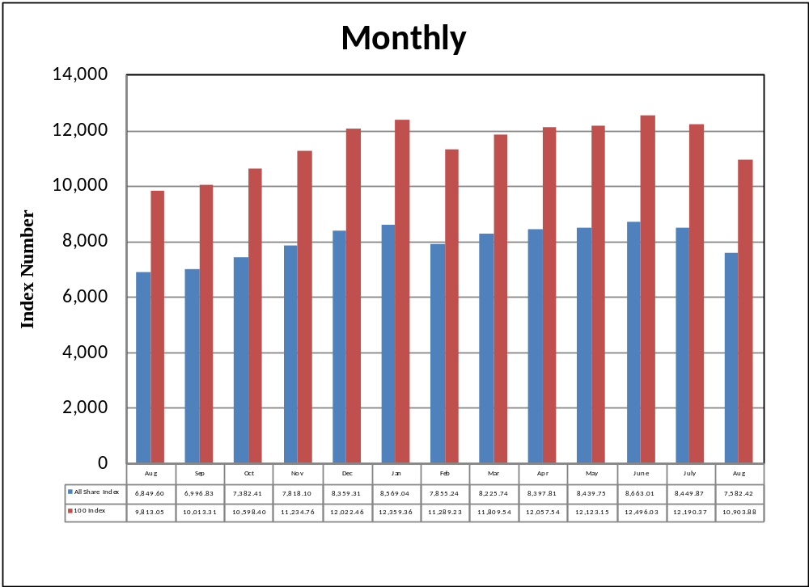

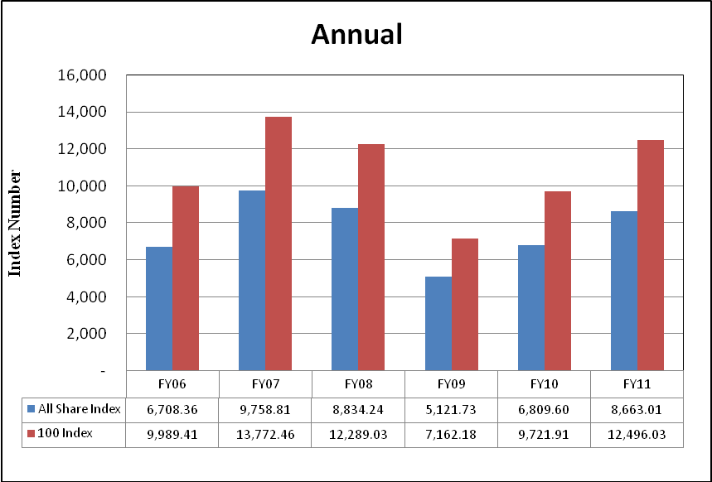

7.2 Karachi Stock Exchange Indicators
(End Period)
Month | KSE 100 Index (1991 = 1,000) |  |  |  |  | KSE All Shares Index (1995 = 1,000)
Month | FY08 | FY09 | FY10 | FY11 | FY12 | FY08 | FY09 | FY10 | FY11 | FY12
Jul. | 13,738.87 | 10,583.58 | 7,720.93 | 10,519.02 | 12,190.37 | 9,775.10 | 7,636.25 | 5,515.95 | 7,348.91 | 8,449.87
Aug. | 12,214.26 | 9,208.26 | 8,675.67 | 9,813.05 | 10,903.88 | 9,675.91 | 6,655.99 | 6,154.81 | 6,849.60 | 7,582.42
Sep. | 13,351.79 | 9,179.68 | 9,349.68 | 10,013.31 |  | 9,445.36 | 6,640.66 | 6,651.16 | 6,996.83
Oct. | 14,319.42 | 9,182.88 | 9,159.18 | 10,598.40 |  | 10,143.37 | 6,638.96 | 6,513.12 | 7,382.41
Nov. | 13,998.52 | 9,187.10 | 9,206.21 | 11,234.76 |  | 9,930.48 | 6,641.61 | 6,529.44 | 7,818.10
Dec. | 14,075.83 | 5,865.01 | 9,386.92 | 12,022.46 |  | 9,956.76 | 4,400.76 | 6,665.55 | 8,359.31
Jan. | 14,017.01 | 5,377.42 | 9,614.19 | 12,359.36 |  | 9,935.08 | 4,016.84 | 6,821.14 | 8,569.04
Feb. | 14,934.30 | 5,727.46 | 9,657.79 | 11,289.23 |  | 10,635.69 | 4,221.57 | 6,844.07 | 7,855.24
Mar. | 15,125.29 | 6,860.22 | 10,178.43 | 11,809.54 |  | 10,750.22 | 4,931.51 | 7,182.37 | 8,225.74
Apr. | 15,122.47 | 7,202.10 | 10,428.12 | 12,057.54 |  | 10,777.40 | 5,168.77 | 7,331.68 | 8,397.81
May | 12,130.51 | 7,276.61 | 9,326.42 | 12,123.15 |  | 8,699.61 | 5,216.66 | 6,546.90 | 8,439.75
Jun. | 12,289.03 | 7,162.18 | 9,721.90 | 12,496.03 |  | 8,834.24 | 5,121.73 | 6,809.60 | 8,663.01

7.3 Turn Over of Shares at Karachi Stock Exchange
(Million Nos.)
Month | Total |  |  |  |  | Average per day ¹
Month | FY08 | FY09 | FY10 | FY11 | FY12 | FY08 | FY09 | FY10 | FY11 | FY12
Jul. | 7,735.01 | 2,029.34 | 3,723.68 | 1,514.32 | 1,211.83 | 351.59 | 88.00 | 161.90 | 68.83 | 57.71
Aug. | 4,486.12 | 2,162.73 | 3,104.92 | 1,243.38 | 1,032.41 | 203.91 | 108.14 | 155.25 | 56.52 | 49.14
Sep. | 4,197.39 | 540.41 | 4,906.84 | 1,215.49 |  | 209.87 | 25.73 | 258.25 | 60.77
Oct. | 6,582.42 | 322.61 | 4,728.09 | 2,246.06 |  | 346.44 | 16.13 | 214.91 | 106.96
Nov. | 5,217.59 | 137.16 | 2,292.30 | 2,267.72 |  | 248.46 | 6.86 | 127.35 | 125.98
Dec. | 4,662.86 | 900.99 | 2,503.68 | 2,931.92 |  | 274.29 | 50.05 | 119.22 | 139.62
Jan. | 5,626.03 | 3,302.92 | 3,743.60 | 3,579.94 |  | 244.61 | 165.15 | 187.18 | 170.47
Feb. | 5,068.07 | 3,218.12 | 3,108.10 | 1,809.47 |  | 266.74 | 169.37 | 163.58 | 95.24
Mar. | 5,047.15 | 3,805.28 | 3,465.34 | 2,210.90 |  | 252.36 | 190.26 | 157.52 | 100.50
Apr. | 6,387.34 | 6,490.73 | 4,278.02 | 1,585.93 |  | 290.33 | 295.03 | 194.46 | 75.52
May | 4,933.40 | 2,729.38 | 2,114.27 | 1,570.54 |  | 234.92 | 136.47 | 100.68 | 71.39
Jun. | 3,372.74 | 2,693.11 | 2,187.96 | 1,653.06 |  | 160.61 | 122.41 | 99.45 | 75.14
Total | 63,316.12 | 28,332.78 | 40,156.79 | 23,828.73 | 2,224.24 | 257.01 | 114.47 | 161.27 | 95.57833 | 53.425
1. Average is calculated on the basis of number of trading days in a month. |  |  |  |  |  |  |  | Source : The Karachi Stock Exchange

7.4 Market Capitalization of KSE all Shares
(Million Rupees)
Sector Name |  | (As per last working day)
 |  | June -05 | June -06 | June -07 | June-08 | June -09
- Textile Spinning | 21,347 |  | 18,253 | 19,661 | 23,028 | 10,675
- Textile Weaving | 2,418 |  | 2,780 | 2,396 | 1,547 | 1,586
- Textile Composite | 48,811 |  | 48,856 | 79,643 | 77,032 | 38,753
- Woolen | 205 |  | 215 | 413 | 498 | 156
- Synthetics & Rayon | 30,307 |  | 28,614 | 34,127 | 26,846 | 16,607
- Chemicals | 37,125 |  | 43,351 | 56,346 | 66,497 | 55,863
- Pharmaceuticals | 32,551 |  | 41,119 | 55,480 | 60,631 | 35,918
- Engineering | 9,289 |  | 11,323 | 18,781 | 25,275 | 10,565
- Automobile Assembler | 35,844 |  | 64,810 | 95,019 | 67,024 | 37,351
- Automobile Parts & Accessories | 4,837 |  | 5,774 | 7,482 | 6,627 | 4,136
- Cables and Electrical Goods | 9,051 |  | 18,625 | 25,306 | 21,402 | 12,672
- Sugar and Allied Industries | 12,629 |  | 17,299 | 19,421 | 20,634 | 16,993
- Paper and Board | 16,800 |  | 21,785 | 32,306 | 29,210 | 16,929
- Cement | 68,581 |  | 133,118 | 165,628 | 117,133 | 69,923
- Refinery | 33,992 |  | 32,353 | 40,360 | 52,101 | 34,110
- Power Generation & Distribution | 83,013 |  | 87,854 | 125,703 | 100,824 | 83,573
- Oil & Gas Marketing Companies | 139,088 |  | 157,181 | 166,552 | 161,066 | 98,466
- Oil & Gas Exploration Companies | 644,541 |  | 804,088 | 764,164 | 802,263 | 535,496
- Transport | 28,735 |  | 39,077 | 35,361 | 31,471 | 18,295
- Technology & Communication | 262,652 |  | 170,382 | 249,086 | 172,483 | 78,225
- Investment Banks & Companies | 46,948 |  | 58,680 | 140,330 | 214,279 | 44,332
- Commercial Banks | 207,364 |  | 582,590 | 1,263,816 | 1,011,209 | 516,174
- Modarabas | 6,833 |  | 6,569 | 6,887 | 6,571 | 4,069
- Leasing Companies | 7,557 |  | 8,472 | 7,403 | 6,057 | 4,069
- Insurance | 32,935 |  | 58,517 | 135,049 | 173,909 | 61,110
- Close End Mutual Funds | 31,534 |  | 34,776 | 38,635 | 33,581 | 12,974
- Jute | 1,685 |  | 2,588 | 6,747 | 6,290 | 3,444
- Food & Personal Care Products | 58,140 |  | 93,928 | 137,684 | 154,897 | 105,930
- Glass & Ceramics | 4,278 |  | 4,673 | 9,274 | 12,230 | 7,142
- Vanaspati & Allied | 472 |  | 607 | 566 | 676 | 304
- Tobacco | 29,624 |  | 35,858 | 75,593 | 53,323 | 28,921
- Fertilizer | 102,054 |  | 137,428 | 161,939 | 191,956 | 127,844
- Leather & Tanneries | 816 |  | 1,271 | 4,155 | 8,142 | 5,816
- Miscellaneous | 16,129 |  | 28,368 | 38,105 | 40,995 | 22,231
TOTAL | 2,068,187 |  | 2,801,182 | 4,019,418 | 3,777,705 | 2,120,651

7.4 Market Capitalization of KSE all Shares
(Million Rupees)
Sector Name |  |  | 2010 |  |  |  |  | 2011
 |  |  | Aug. | Sep. | Oct. | Nov. | Dec. | Jan. | Feb. | Mar. | Apr. | May | Jun. | Jul. | Aug.
1 | Oil & Gas |  | 989,515 | 1,005,314 | 1,063,852 | 1,143,522 | 1,202,906 | 1,212,406 | 1,064,123 | 1,051,737 | 1,099,571 | 1,126,472 | 1,130,488 | 1,133,331 | 980,401
2 | Chemicals |  | 257,248 | 258,829 | 264,857 | 282,763 | 317,268 | 350,231 | 342,249 | 392,929 | 385,792 | 379,533 | 381,534 | 377,358 | 343,226
3 | Forestry & Paper |  | 3,175 | 3,268 | 3,008 | 3,025 | 3,280 | 2,937 | 2,658 | 2,944 | 2,893 | 3,118 | 2,973 | 3,113 | 2,573
4 | Industrial Metals & Mining |  | 9,770 | 9,280 | 8,797 | 9,556 | 10,747 | 10,035 | 9,177 | 9,880 | 9,823 | 9,636 | 15,160 | 15,319 | 13,551
5 | Construction & Materials |  | 66,635 | 68,014 | 69,358 | 71,929 | 72,852 | 67,162 | 59,105 | 63,255 | 66,779 | 64,158 | 64,111 | 69,210 | 65,318
6 | General Industrials |  | 32,832 | 33,062 | 33,517 | 35,739 | 39,341 | 38,999 | 34,056 | 36,525 | 36,503 | 36,570 | 36,585 | 36,056 | 32,688
7 | Electronic & Electrical Equipment |  | 1,242 | 1,352 | 1,189 | 1,248 | 1,630 | 1,619 | 1,531 | 1,565 | 1,506 | 1,443 | 1,357 | 1,396 | 1,237
8 | Industrial Engineering |  | 30,676 | 31,190 | 31,536 | 32,290 | 32,810 | 34,098 | 31,502 | 31,160 | 31,389 | 32,680 | 35,132 | 34,320 | 27,891
9 | Industrial Transportation |  | 13,625 | 12,588 | 13,198 | 12,744 | 13,206 | 12,887 | 11,574 | 12,352 | 11,628 | 13,263 | 12,292 | 11,533 | 10,840
10 | Support Services |  | 1,299 | 1,538 | 1,545 | 1,619 | 1,376 | 1,233 | 940 | 1,160 | 1,014 | 1,091 | 987 | 886 | 763
11 | Automobile & Parts |  | 38,990 | 37,249 | 39,805 | 42,576 | 43,372 | 47,330 | 40,805 | 41,355 | 42,680 | 42,477 | 41,244 | 41,421 | 40,958
12 | Beverages |  | 1,885 | 1,948 | 1,897 | 1,957 | 2,358 | 2,703 | 2,561 | 2,588 | 2,799 | 2,798 | 2,831 | 2,745 | 2,466
13 | Food Producers |  | 179,491 | 187,422 | 195,402 | 202,956 | 225,450 | 275,223 | 281,577 | 282,091 | 293,067 | 287,282 | 385,429 | 337,461 | 319,307
14 | Household Goods |  | 5,018 | 5,416 | 5,363 | 5,150 | 5,125 | 5,234 | 4,909 | 4,962 | 4,386 | 4,614 | 4,500 | 4,253 | 4,073
15 | Leisure Goods |  | 448 | 426 | 343 | 368 | 367 | 349 | 351 | 337 | 307 | 345 | 307 | 292 | 279
16 | Personal Goods |  | 110,239 | 113,399 | 121,750 | 129,024 | 135,598 | 140,360 | 130,171 | 131,985 | 129,097 | 126,193 | 124,571 | 119,368 | 111,030
17 | Tobacco |  | 40,116 | 45,995 | 49,084 | 50,962 | 46,049 | 45,369 | 39,239 | 39,413 | 39,356 | 39,707 | 35,217 | 31,061 | 27,316
18 | Health Care Equipment & Services |  | 1,597 | 1,772 | 1,372 | 1,411 | 1,516 | 1,570 | 1,584 | 1,481 | 1,604 | 1,622 | 1,714 | 1,631 | 1,771
19 | Pharma & Bio Tech. |  | 27,161 | 27,524 | 29,344 | 29,868 | 33,647 | 30,969 | 27,298 | 31,356 | 31,675 | 31,221 | 32,592 | 31,917 | 31,234
20 | Media |  | 9,104 | 8,836 | 8,758 | 7,489 | 8,381 | 3,455 | 3,595 | 3,608 | 3,106 | 3,227 | 3,141 | 2,827 | 2,248
21 | Travel & Leisure |  | 25,357 | 31,814 | 35,014 | 31,768 | 30,910 | 30,506 | 29,836 | 29,921 | 30,232 | 30,076 | 29,082 | 29,053 | 28,760
22 | Fixed Line Telecommunication |  | 76,920 | 77,143 | 74,523 | 78,546 | 79,323 | 76,048 | 71,861 | 69,037 | 68,042 | 70,812 | 57,464 | 51,192 | 44,127
23 | Electricity |  | 99,925 | 96,249 | 97,044 | 100,949 | 105,414 | 108,853 | 106,232 | 104,318 | 106,714 | 105,983 | 103,102 | 111,811 | 108,466
24 | Gas, Water & Multi-utilities |  | 29,324 | 37,269 | 37,737 | 35,017 | 32,654 | 32,988 | 32,074 | 31,147 | 27,781 | 29,003 | 29,119 | 27,584 | 26,127
25 | Banks |  | 588,184 | 580,518 | 616,728 | 648,145 | 724,817 | 710,706 | 639,277 | 675,449 | 690,137 | 681,616 | 666,020 | 656,674 | 587,034
26 | Non-Life Insurance |  | 45,100 | 40,111 | 42,771 | 46,876 | 48,509 | 48,523 | 44,810 | 48,545 | 45,562 | 46,833 | 45,858 | 43,762 | 41,633
27 | Life Insurance |  | 8,443 | 8,709 | 9,409 | 11,056 | 10,335 | 9,563 | 8,172 | 9,063 | 8,875 | 9,737 | 10,378 | 10,014 | 9,748
28 | Real Estate Investment & Services |  | 779 | 873 | 1,029 | 922 | 885 | 951 | 813 | 975 | 946 | 870 | 699 | 644 | 565
29 | Financial Services |  | 27,067 | 26,286 | 26,495 | 30,449 | 19,070 | 18,840 | 15,858 | 15,746 | 13,048 | 14,276 | 13,553 | 13,588 | 11,373
30 | Equity Investment Instruments |  | 18,819 | 17,564 | 17,402 | 17,202 | 18,215 | 18,819 | 18,411 | 18,765 | 19,672 | 19,159 | 19,556 | 19,429 | 16,990
31 | Software & Computer Services |  | 1,450 | 1,386 | 1,451 | 1,490 | 1,490 | 2,012 | 1,653 | 1,871 | 1,755 | 1,654 | 1,594 | 1,588 | 1,172
32 | Technology Hardware & Equipment |  | 63 | 35 | 37 | 42 | 49 | 49 | 33 | 31 | 54 | 67 | 69 | 66 | 56
 | TOTAL |  | 2,948,877 | 2,741,497 | 2,772,379 | 2,903,615 | 3,068,658 | 3,268,950 | 3,342,026 | 3,058,035 | 3,147,551 | 3,207,793 | 3,217,534 | 3,220,906 | 2,895,220
Source: The Karachi Stock Exchange

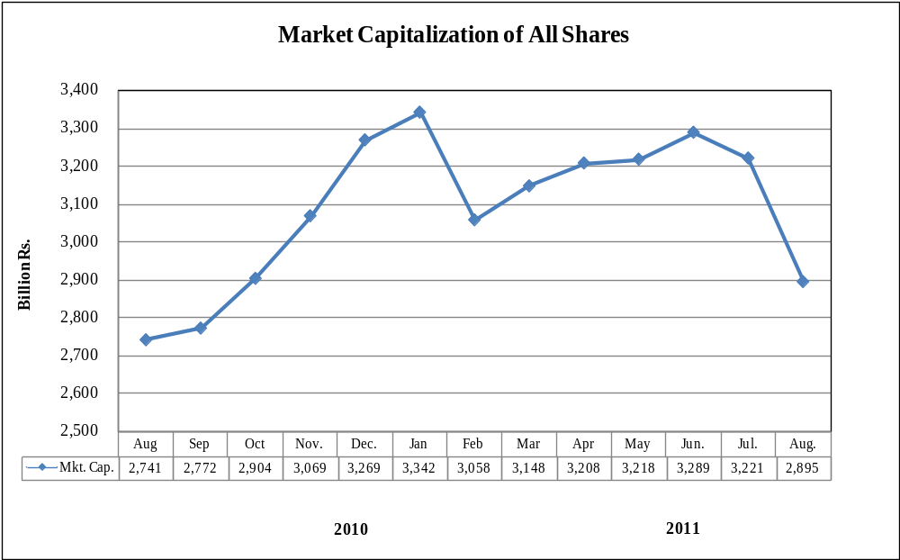

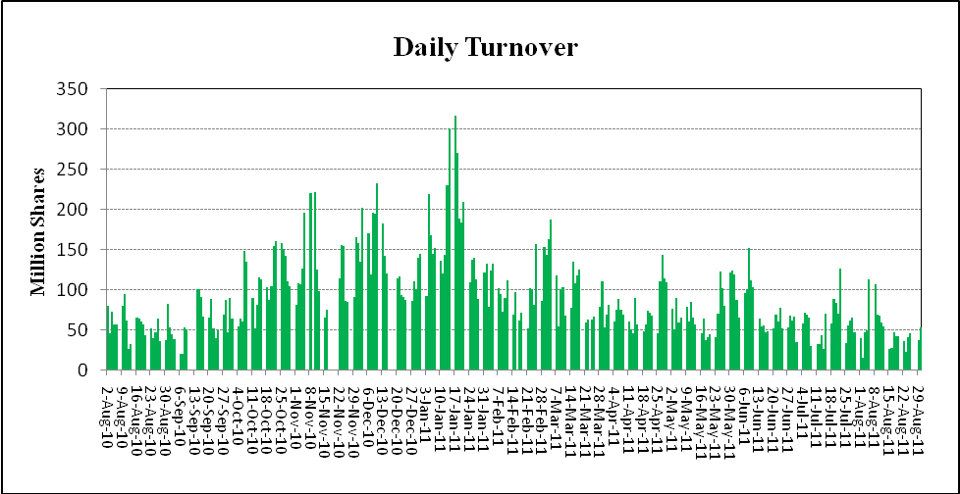

7.5 Balance Sheet Analysis*- Overall (Non-Financial)
(Million Rupees)
ITEMS | 2005 | 2006 | 2007 | 2008 | 2009
A. Capital Structure:
1.Ordinary Share Capital | 354,204 | 372,336 | 394,510 | 220,928 | 439,998
2.Surplus | 430,746 | 501,329 | 558,499 | 319,838 | 609,688
3.Shareholder's Equity (A1+A2) | 784,949 | 873,665 | 953,009 | 540,766 | 1,049,686
4.Prefrence Shares | 3,628 | 3,519 | 10,168 | 3,627 | 11,989
5.Debentures | 30,905 | 31,265 | 45,095 | 16,485 | 53,488
6.Other Fixed Liabilities | 198,831 | 251,933 | 306,986 | 161,821 | 387,291
7.Total Fixed Liabilities (A4+A5+A6) | 233,364 | 286,717 | 362,250 | 181,933 | 452,768
8.Total Capital Employed (A3+A7) | 1,018,313 | 1,160,382 | 1,315,258 | 722,699 | 1,502,454
B. Liquidity:
1.Liquid Assets: | 300,874 | 376,658 | 409,161 | 224,658 | 395,016
(1)Cash | 188,306 | 184,142 | 169,690 | 139,135 | 139,380
(II)Investments | 112,567 | 192,516 | 239,471 | 85,522 | 255,636
2.Other Current Assets | 337,303 | 414,622 | 515,562 | 208,526 | 971,037
3.Inventories | 206,674 | 240,568 | 271,533 | 179,421 | 329,585
4.Current Assets (B1+B2+B3) | 844,851 | 1,031,848 | 1,196,256 | 612,605 | 1,695,638
5.Current Liabilities | 685,142 | 888,036 | 1,041,343 | 486,179 | 1,647,078
6.Total Liabilities(A7+B5) | 918,506 | 1,174,753 | 1,403,592 | 668,111 | 2,099,846
7.Net Current Assets(B4-B5) | 159,709 | 143,812 | 154,913 | 126,426 | 48,560
8.Contractual Liabilities | 445,336 | 556,212 | 646,345 | 374,633 | 802,082
9.Net liquid assets (B1-B5) | (384,269) | (511,378) | (632,181) | (261,521) | (1,252,062)
C. Fixed Assets:
1.Fixed Asset At Cost | 1,458,664 | 1,671,977 | 1,863,050 | 932,477 | 2,343,723
2.Fixed assets after deducting accumulated depreciation | 858,605 | 1,016,570 | 1,160,345 | 596,273 | 1,453,895
3.Depreciation for the year | 69,186 | 75,870 | 86,225 | 41,703 | 100,172
4.Total assets (B4+C2) | 1,703,455 | 2,048,418 | 2,356,601 | 1,208,877 | 3,149,532
D. Operation:
1.Gross sales | 2,031,217 | 2,570,951 | 2,837,923 | 1,287,627 | 3,431,922
(1)Local sales | 1,898,311 | 2,406,191 | 2,632,698 | 1,167,238 | 3,104,740
(2)Export sales | 132,906 | 164,759 | 205,225 | 120,390 | 327,183
2.Cost of Sales | 1,672,724 | 2,166,348 | 2,431,127 | 1,040,154 | 2,938,186
3.Gross profit | 358,493 | 404,602 | 406,796 | 247,473 | 493,737
4.Overhead and Other Expenses | 1,814,613 | 2,328,819 | 2,616,505 | 1,116,097 | 3,189,173
5.Operating profit | 254,458 | 305,994 | 296,426 | 195,110 | 325,320
6.Financial expenses | 29,473 | 49,294 | 67,127 | 23,993 | 128,334
7.Net profit before tax (D5-D6) | 224,985 | 256,700 | 229,299 | 171,117 | 196,986
8.Tax provision | 62,678 | 73,133 | 60,628 | 39,923 | 71,174
9.Total amount of dividend | 70,028 | 102,526 | 97,590 | 60,169 | 115,341
10.Total value of bonus shares issued | 3,399 | 5,764 | 2,996 | 3,341 | 4,841
E. Sources of Increase In Capital Employed:
1.Increase/decrease in capital employed (A8 - A8 of preceding year) | 202,192 | 142,069 | 154,876 | 182,019 | 101,277
2.Retention in business (D7-D8-D9) | 92,279 | 81,042 | 71,080 | 71,026 | 10,471
3.Finance from outside the company (E1-E2) | 109,913 | 61,028 | 83,796 | 110,993 | 90,807
F. Cash Flow Data
1.Depreciation for the year plus retention in business: cash flow (C3+E2) | 161,465 | 156,912 | 157,306 | 112,728 | 110,643
2.Depreciation for the year plus changes in capital employed (C3+E1) | 271,378 | 217,939 | 241,102 | 223,721 | 201,450
G. Operating Financial & Investment Ratios:
1.Gearing ratio (A7 as % of A8) | 23 | 25 | 28 | 25 | 30
2.Current ratio (B4 as % of B5) | 123 | 116 | 115 | 126 | 103
3.Acid test or Quick ratio (B4-B3 as % B5) | 93 | 89 | 89 | 89 | 83
4.Debt equity ratio (B6 as % of A3) | 117 | 135 | 147 | 124 | 200
5.Return on assets (D7 as % of C4) | 13 | 13 | 10 | 14 | 6
6.Self financing ratio (E2 as % of E1) | 46 | 57 | 46 | 39 | 10
7.Cash flow ratio F1 as % of F2 | 60 | 72 | 65 | 50 | 55
8.Shareholders equity as % of ordinary share capital (A3 as % of A1) | 222 | 235 | 242 | 245 | 239
9.Overhead and other expenses as % of gross sales (D4 as % D1) | 89 | 91 | 92 | 87 | 93
10.Financial expenses as % of operating profit (D6 as % of D5) | 12 | 16 | 23 | 12 | 39
11.Financial expense as % of gross sales (D6 as % of D1) | 2 | 2 | 2 | 2 | 4
12.Financial expenses as % of contractual liabilities (D6 as % B8) | 7 | 9 | 10 | 6 | 16
13.Tax provision as % of net pre-tax profit (D8 as % of D7) | 28 | 29 | 26 | 23 | 36
14.Sundry debtors as % of gross sales | 8 | 8 | 9 | 7 | 16
15.Return on Equity (D7 as % of A3) | 29 | 29 | 24 | 32 | 19
H .Key Performance Indicators:
1.Dividend cover ratio [(D7 - D8) as % of D9] | 232 | 179 | 173 | 218 | 109
2.Dividend ratio to equity (D9 as % of A3) | 9 | 12 | 10 | 11 | 11
3.Net profit margin (D7 as % of D1) | 11 | 10 | 8 | 13 | 6
4.Earning per share before tax (D7/No. of ordinary shares) | 6 | 7 | 6 | 8 | 5
5.Earning per share after tax [(D7-D8)/No. of ordinary shares] | 5 | 5 | 4 | 6 | 3
6.Average annual % depreciation on written down fixed assets | 9 | 9 | 9 | 8 | 8
7.Sales as % of total assets (D1 as % of C4) | 119 | 126 | 120 | 107 | 109
8.Earning per share before tax growth (current year EPS - last year EPS/ last year EPS) | 12 | 8 | (16) | 35 | (6)
9.Sales growth (current year's 'sales - last year's sales / last year's sales) | 24 | 27 | 10 | 25 | 2
10.Break-up value of ordinary shares (in rupees) | 22 | 24 | 24 | 25 | 24
I. No. of Companies | 443 | 436 | 437 | 424 | 414

*:Companies listed at KSE

7.6 Balance Sheet Analysis- Private Sector
(Million Rupees)
ITEMS | 2005 | 2006 | 2007 | 2008 | 2009
A. Capital Structure:
1.Ordinary Share Capital | 220,928 | 236,670 | 308,093 | 331,851 | 349,613
2.Surplus | 319,838 | 402,749 | 479,868 | 486,620 | 471,551
3.Shareholder's Equity (A1+A2) | 540,766 | 639,420 | 787,961 | 818,470 | 821,163
4.Prefrence Shares | 3,627 | 3,518 | 10,168 | 9,452 | 11,979
5.Debentures | 16,485 | 18,018 | 31,384 | 37,256 | 33,890
6.Other Fixed Liabilities | 161,821 | 184,311 | 231,064 | 268,079 | 291,921
7.Total Fixed Liabilities (A4+A5+A6) | 181,933 | 205,847 | 272,616 | 314,786 | 337,790
8.Total Capital Employed (A3+A7) | 722,699 | 845,267 | 1,060,577 | 1,133,257 | 1,158,954
B. Liquidity:
1.Liquid Assets: | 224,658 | 266,378 | 340,788 | 355,256 | 347,177
(1)Cash | 139,135 | 108,408 | 140,649 | 145,194 | 125,268
(II)Investments | 85,522 | 157,970 | 200,139 | 210,062 | 221,909
2.Other Current Assets | 208,526 | 260,344 | 347,485 | 484,899 | 565,484
3.Inventories | 179,421 | 200,624 | 235,366 | 297,818 | 286,747
4.Current Assets (B1+B2+B3) | 612,605 | 727,346 | 923,639 | 1,137,973 | 1,199,408
5.Current Liabilities | 486,179 | 585,273 | 784,172 | 1,059,688 | 1,167,002
6.Total Liabilities(A7+B5) | 668,111 | 791,120 | 1,056,788 | 1,374,474 | 1,504,793
7.Net Current Assets(B4-B5) | 126,426 | 142,074 | 139,467 | 78,285 | 32,406
8.Contractual Liabilities | 374,633 | 430,170 | 511,631 | 666,958 | 648,935
9.Net liquid assets (B1-B5) | (261,521) | (318,894) | (443,384) | (704,432) | (819,825)
C. Fixed Assets:
1.Fixed Asset At Cost | 932,477 | 1,072,793 | 1,473,687 | 1,641,850 | 1,839,043
2.Fixed assets after deducting accumulated depreciation | 596,273 | 703,193 | 921,110 | 1,054,972 | 1,126,549
3.Depreciation for the year | 41,703 | 47,780 | 66,433 | 74,569 | 80,515
4.Total assets (B4+C2) | 1,208,877 | 1,430,539 | 1,844,749 | 2,192,944 | 2,325,957
D. Operation:
1.Gross sales | 1,287,627 | 1,640,222 | 1,952,451 | 2,261,888 | 2,248,471
(1)Local sales | 1,167,238 | 1,496,605 | 1,747,227 | 2,010,247 | 1,921,288
(2)Export sales | 120,390 | 143,617 | 205,225 | 251,641 | 327,183
2.Cost of Sales | 1,040,154 | 1,337,243 | 1,678,945 | 1,942,861 | 1,932,042
3.Gross profit | 247,473 | 302,979 | 273,506 | 319,027 | 316,429
4.Overhead and Other Expenses | 1,116,097 | 1,427,525 | 1,812,290 | 2,129,222 | 2,104,045
5.Operating profit | 195,110 | 249,915 | 196,527 | 184,342 | 201,204
6.Financial expenses | 23,993 | 38,928 | 55,509 | 82,256 | 106,623
7.Net profit before tax (D5-D6) | 171,117 | 210,986 | 141,018 | 102,086 | 94,581
8.Tax provision | 39,923 | 51,181 | 33,043 | 52,494 | 38,792
9.Total amount of dividend | 60,169 | 89,644 | 49,877 | 46,304 | 67,495
10.Total value of bonus shares issued | 3,341 | 3,988 | 2,253 | 3,942 | 3,181
E. Sources of Increase In Capital Employed:
1.Increase/decrease in capital employed (A8 - A8 of preceding year) | 182,019 | 122,568 | 215,310 | 72,680 | 25,697
2.Retention in business (D7-D8-D9) | 71,026 | 70,161 | 58,098 | 3,288 | (11,705)
3.Finance from outside the company (E1-E2) | 110,993 | 52,407 | 157,213 | 69,392 | 37,402
F. Cash Flow Data
1.Depreciation for the year plus retention in business: cash flow (C3+E2) | 112,728 | 117,941 | 124,530 | 77,857 | 68,810
2.Depreciation for the year plus changes in capital employed (C3+E1) | 223,721 | 170,348 | 281,743 | 147,249 | 106,212
G. Operating Financial & Investment Ratios:
1.Gearing ratio (A7 as % of A8) | 25 | 24 | 26 | 28 | 29
2.Current ratio (B4 as % of B5) | 126 | 124 | 118 | 107 | 103
3.Acid test or Quick ratio (B4-B3 as % B5) | 89 | 90 | 88 | 79 | 78
4.Debt equity ratio (B6 as % of A3) | 124 | 124 | 134 | 168 | 183
5.Return on assets (D7 as % of C4) | 14 | 15 | 8 | 5 | 4
6.Self financing ratio (E2 as % of E1) | 39 | 57 | 27 | 5 | (46)
7.Cash flow ratio F1 as % of F2 | 50 | 69 | 44 | 53 | 65
8.Shareholders equity as % of ordinary share capital (A3 as % of A1) | 245 | 270 | 256 | 247 | 235
9.Overhead and other expenses as % of gross sales (D4 as % D1) | 87 | 87 | 93 | 94 | 94
10.Financial expenses as % of operating profit (D6 as % of D5) | 12 | 16 | 28 | 45 | 53
11.Financial expense as % of gross sales (D6 as % of D1) | 2 | 2 | 3 | 4 | 5
12.Financial expenses as % of contractual liabilities (D6 as % B8) | 6 | 9 | 11 | 12 | 16
13.Tax provision as % of net pre-tax profit (D8 as % of D7) | 23 | 24 | 23 | 51 | 41
14.Sundry debtors as % of gross sales | 7 | 7 | 8 | 10 | 14
15.Return on Equity (D7 as % of A3) | 32 | 33 | 18 | 13 | 12
H .Key Performance Indicators:
1.Dividend cover ratio [(D7 - D8) as % of D9] | 218 | 178 | 217 | 107 | 83
2.Dividend ratio to equity (D9 as % of A3) | 11 | 14 | 6 | 6 | 8
3.Net profit margin (D7 as % of D1) | 13 | 13 | 7 | 5 | 4
4.Earning per share before tax (D7/No. of ordinary shares) | 8 | 9 | 5 | 3 | 3
5.Earning per share after tax [(D7-D8)/No. of ordinary shares] | 6 | 7 | 4 | 2 | 2
6.Average annual % depreciation on written down fixed assets | 8 | 8 | 8 | 8 | 8
7.Sales as % of total assets (D1 as % of C4) | 107 | 115 | 106 | 103 | 97
8.Earning per share before tax growth (current year EPS - last year EPS/ last year EPS) | 35 | 16 | (48) | (33) | (13)
9.Sales growth (current year's 'sales - last year's sales / last year's sales) | 25 | 27 | 19 | 16 | (1)
10.Break-up value of ordinary shares (in rupees) | 25 | 27 | 26 | 25 | 24
I. No. of Companies | 424 | 420 | 427 | 427 | 404

7.7 Balance Sheet Analysis- Public Sector
(Million Rupees)
ITEMS | 2005 | 2006 | 2007 | 2008 | 2009
A. Capital Structure:
1.Ordinary Share Capital | 133,275 | 135,665 | 86,417 | 87,705 | 90,385
2.Surplus | 110,908 | 98,580 | 78,631 | 62,903 | 138,137
3.Shareholder's Equity (A1+A2) | 244,183 | 234,245 | 165,048 | 150,608 | 228,523
4.Prefrence Shares | 1 | 1 | - | - | 10
5.Debentures | 14,420 | 13,247 | 13,711 | 12,430 | 19,597
6.Other Fixed Liabilities | 37,010 | 67,622 | 75,922 | 104,882 | 95,370
7.Total Fixed Liabilities (A4+A5+A6) | 51,432 | 80,870 | 89,633 | 117,312 | 114,978
8.Total Capital Employed (A3+A7) | 295,615 | 315,115 | 254,682 | 267,920 | 343,500
B. Liquidity:
1.Liquid Assets: | 76,216 | 110,280 | 68,374 | 67,670 | 47,839
(1)Cash | 49,171 | 75,734 | 29,042 | 27,698 | 14,112
(II)Investments | 27,045 | 34,546 | 39,332 | 39,972 | 33,727
2.Other Current Assets | 128,778 | 154,278 | 168,077 | 223,963 | 405,553
3.Inventories | 27,253 | 39,944 | 36,166 | 64,209 | 42,838
4.Current Assets (B1+B2+B3) | 232,246 | 304,501 | 272,617 | 355,843 | 496,230
5.Current Liabilities | 198,964 | 302,764 | 257,171 | 362,595 | 480,075
6.Total Liabilities(A7+B5) | 250,395 | 383,634 | 346,804 | 479,907 | 595,053
7.Net Current Assets(B4-B5) | 33,282 | 1,738 | 15,446 | (6,752) | 16,154
8.Contractual Liabilities | 70,703 | 126,042 | 134,713 | 175,798 | 153,147
9.Net liquid assets (B1-B5) | (122,748) | (192,484) | (188,797) | (294,924) | (432,236)
C. Fixed Assets:
1.Fixed Asset At Cost | 526,188 | 599,184 | 389,363 | 448,504 | 504,680
2.Fixed assets after deducting accumulated depreciation | 262,332 | 313,378 | 239,236 | 274,672 | 327,346
3.Depreciation for the year | 27,483 | 28,091 | 19,793 | 21,996 | 19,657
4.Total assets (B4+C2) | 494,578 | 617,879 | 511,853 | 630,515 | 823,576
D. Operation:
1.Gross sales | 743,590 | 930,728 | 885,472 | 1,094,499 | 1,183,452
(1)Local sales | 731,073 | 909,586 | 885,472 | 1,094,499 | 1,183,452
(2)Export sales | 12,516 | 21,142 | - | - | -
2.Cost of Sales | 632,570 | 829,105 | 752,182 | 917,032 | 1,006,144
3.Gross profit | 111,020 | 101,623 | 133,290 | 177,466 | 177,308
4.Overhead and Other Expenses | 698,516 | 901,294 | 804,215 | 1,000,834 | 1,085,128
5.Operating profit | 59,348 | 56,080 | 99,899 | 114,473 | 124,116
6.Financial expenses | 5,481 | 10,366 | 11,619 | 13,680 | 21,711
7.Net profit before tax (D5-D6) | 53,867 | 45,714 | 88,281 | 100,792 | 102,405
8.Tax provision | 22,755 | 21,952 | 27,585 | 39,499 | 32,382
9.Total amount of dividend | 9,859 | 12,881 | 47,713 | 59,901 | 47,847
10.Total value of bonus shares issued | 58 | 1,776 | 743 | 823 | 1,660
E. Sources of Increase In Capital Employed:
1.Increase/decrease in capital employed (A8 - A8 of preceding year) | 20,173 | 19,501 | (60,434) | 13,239 | 75,580
2.Retention in business (D7-D8-D9) | 21,253 | 10,881 | 12,983 | 1,392 | 22,176
3.Finance from outside the company (E1-E2) | (1,080) | 8,620 | (73,417) | 11,847 | 53,404
F. Cash Flow Data
1.Depreciation for the year plus retention in business: cash flow (C3+E2) | 48,737 | 38,971 | 32,775 | 23,388 | 41,833
2.Depreciation for the year plus changes in capital employed (C3+E1) | 47,656 | 47,591 | (40,641) | 35,235 | 95,237
G. Operating Financial & Investment Ratios:
1.Gearing ratio (A7 as % of A8) | 17 | 26 | 35 | 44 | 34
2.Current ratio (B4 as % of B5) | 117 | 101 | 106 | 98 | 103
3.Acid test or Quick ratio (B4-B3 as % B5) | 103 | 87 | 92 | 80 | 94
4.Debt equity ratio (B6 as % of A3) | 103 | 164 | 210 | 319 | 260
5.Return on assets (D7 as % of C4) | 11 | 7 | 17 | 16 | 12
6.Self financing ratio (E2 as % of E1) | 105 | 56 | (22) | 11 | 29
7.Cash flow ratio F1 as % of F2 | 102 | 82 | (81) | 66 | 44
8.Shareholders equity as % of ordinary share capital (A3 as % of A1) | 183 | 173 | 191 | 172 | 253
9.Overhead and other expenses as % of gross sales (D4 as % D1) | 94 | 97 | 91 | 91 | 92
10.Financial expenses as % of operating profit (D6 as % of D5) | 9 | 19 | 12 | 12 | 18
11.Financial expense as % of gross sales (D6 as % of D1) | 1 | 1 | 1 | 1 | 2
12.Financial expenses as % of contractual liabilities (D6 as % B8) | 8 | 8 | 9 | 8 | 14
13.Tax provision as % of net pre-tax profit (D8 as % of D7) | 42 | 48 | 31 | 39 | 32
14.Sundry debtors as % of gross sales | 9 | 9 | 10 | 12 | 20
15.Return on Equity (D7 as % of A3) | 22 | 20 | 54 | 67 | 45
H .Key Performance Indicators:
1.Dividend cover ratio [(D7 - D8) as % of D9] | 316 | 185 | 127 | 102 | 146
2.Dividend ratio to equity (D9 as % of A3) | 4 | 6 | 29 | 40 | 21
3.Net profit margin (D7 as % of D1) | 7 | 5 | 10 | 9 | 9
4.Earning per share before tax (D7/No. of ordinary shares) | 4 | 3 | 10 | 12 | 11
5.Earning per share after tax [(D7-D8)/No. of ordinary shares] | 2 | 2 | 7 | 7 | 8
6.Average annual % depreciation on written down fixed assets | 11 | 10 | 10 | 10 | 7
7.Sales as % of total assets (D1 as % of C4) | 150 | 151 | 173 | 174 | 144
8.Earning per share before tax growth (current year EPS - last year EPS/ last year EPS) | (31) | (15) | 200 | 13 | (2)
9.Sales growth (current year's 'sales - last year's sales / last year's sales) | 24 | 25 | (5) | 24 | 8
10.Break-up value of ordinary shares (in rupees) | 18 | 17 | 19 | 17 | 25
I. No. of Companies | 19 | 16 | 10 | 10 | 10

