VI. Capital Markets

Introduction
Capital markets can play a crucial role in mobilizing domestic and foreign resources, and channeling them to the most productive medium and long-term uses. Since these funds are not intermediated, resource allocation should be more efficient. In Pakistan, the capital market includes: (1) an equity market, which consists of three stock exchanges, and (2) an intermediated financial system dominated by NBFIs.
Pakistan’s equity markets showed a mixed trend during FY00. While the first quarter showed a mild improvement, the second and third quarters of FY00 posted a strong market rally riding on positive expectations regarding privatization in the energy sector, and margin liberalization for Oil Marketing Companies (OMCs). However, the last quarter (April-June, 2000) witnessed a crisis in May, after which the KSE-100 index has been fluctuating around the 1,500 mark (see Figure VI.1).

Stock Markets’ Performance
The Karachi Stock Exchange (KSE) maintained its dominance in the country and will form the basis of analysis (see Tables VI.1 & VI.2). More generally, the stock markets in FY00 witnessed a steady rise in the first quarter, followed by a sharp increase in the second quarter, which was maintained in the third. Positive expectations regarding privatization in the energy sector and hopes that the new government would focus on resolving the Hubco issue, drove the market to a pronounced rally from mid-November 1999 to end-April 2000.
With a longer-term perspective, the Securities & Exchange Commission of Pakistan (SECP) is playing an active role in safeguarding the interest of small investors in an effort to enhance retail interest in the equity markets. During FY00, SECP began implementing the following laws:
- The Companies (Buyback of shares) Rule (1999): This law is primarily motivated to inject liquidity into those scrips that are not actively traded. Since many of these companies are largely family owned (and controlled), public offerings when these companies were first floated were done on compulsion rather than a strategic decision to diversify the capital base of the company. Hence, since these token scrips were first issued to the public, trading was minimal. It has long been discussed that such companies should have the right to buy back these scrips to inject liquidity into the market and to encourage more accurate market valuation. The decision to permit buy
Table VI.1: Key Indicators of Capital Market
Capital Market Indicators | FY98 | FY99 | FY00 | Percentage Changes
 |  |  |  | FY98 | FY99 | FY00
I. Stock Market Indicators
KSE-100 Index¹ (1991=1000) | 879.6 | 1,054.7 | 1,520.7 | -43.8 | 19.9 | 44.2
SBP General Index² (1991=100) | 98.8 | 106.4 | 128.8 | -30.9 | 7.7 | 21.1
SBP Turnover Index of Shares³ | 6,511.6 | 9,089.9 | 20,878.4 | 203.0 | 39.6 | 129.7
Market Capitalization (Rs billion) | 259.4 | 289.2 | 391.9 | -44.7 | 11.5 | 35.5
Turnover of Shares (billion No) ⁴ | 21.1 | 38.6 | 66.7 | 91.8 | 82.9 | 72.8
II. DFIs (Rs billion)
Deposits | 71.1 | 70.4 | 59.7 | -4.4 | -1.0 | -15.2
Sanctions⁵ | 15.0 | 16.1 | 17.0 | 2.0 | 7.3 | 5.6
Disbursements⁵ | 15.9 | 15.7 | 13.4 | 8.2 | -1.3 | -14.6
1-Based on closing rates;
2-Based on midday rates at KSE;
3-Averages of weekly Index Values;
4-Aggregate turnover of share in three stock exchanges;
5-Term Financing

Table VI.2: Profile of Stock Exchanges in Pakistan
Stock Exchanges | Paid-up Capital (Rs billion) |  |  | Indices of share prices |  |  | Turnover of Shares (billion No)
Stock Exchanges | FY98 | FY99 | FY00 | FY98 | FY99 | FY00 | FY98 | FY99 |  | FY00
Karachi Stock Exchange | 211.2 | 215.0 | 229.3 |  |  |  | 15.0 | 25.5 |  | 48.1
 |  |  |  |  |  |  | (70.4) | (66.1) |  | (72.1)
1. SBP General Index of  Share Prices (1991=100) |  |  |  | 98.8 | 106.4 | 128.8
2. KSE-100 Index  (1991=1000) |  |  |  | 879.6 | 1054.7 | 1520.7
Lahore Stock Exchange | 186.9 | 186.9 | 207.7 | 272.8 | 288.9 | 372.0 | 5.8 | 9.8 |  | 15.5
 |  |  |  |  |  |  | (27.2) | (25.4) |  | (23.2)
Islamabad Stock Exchange | 149.4 | 150.7 | 150.7 | 4291.5 | 4498.7 | 5327.1 | 0.5 | 3.3 |  | 3.1
 |  |  |  |  |  |  | (2.3) | (8.5) |  | (4.6)
Total |  |  |  |  |  |  | 21.3 | 38.6 |  | 66.7
Note: Figures in parentheses indicate percentage share in total.

back has been allowed on the condition that SECP will carefully monitor such activity to ensure that companies cannot manipulate share prices.
- The Companies (Asset backed securitization) Rule (1999): Securitization is the process of using financial assets of banks, leasing companies and corporations to issue securities there against. This results in Asset-backed tradable debt instrument, where the asset quality is closely scrutinized and monitored by a rating agency. Securitization confers certain advantages to the originator or the company whose assets get securitized. It is an emerging option for NBFI’s to raise capital, which is relevant in the current state of financial markets. Technically speaking, this allows a company to realize its discounted future revenues up-front, which can then be used for long-term investment. However, other than monitoring and rating of the public company, the financial institution willing to lend against such assets will bear the risk of any changes in collateral value. This should force banks and NBFIs to improve their risk management capabilities.
- Companies Share Capital (variation in rights & privileges) Rule (2000): This Rule is in the process of being formally notified. It effectively allows public companies to issue different types of shares, with a variety of attached rights. This flexibility will open up options of financing and make such companies less dependent on financial institutions for credit. Depending on public interest, this leeway should deepen Pakistan’s capital markets.
- Prohibition of Insider Trading Regulation (1999): To protect small investors from excessive volatility in share prices on the basis of trading driven by privileged information, this law has long been in the offing. Expected to become effective in the immediate future, this should help dispel the insider-outsider perception that has deterred small investors from approaching the capital markets. If this is effectively implemented, this law should be able to extend the short-term investment horizon that currently dominates the stock markets. In the first week of October 2000, SECP issued a draft of the proposed law to solicit public opinion.

Operations at KSE
The KSE-100 index began FY00 at 1,066.1 and continued its steady upward movement carried on since the fourth quarter of FY99, to reach 1,221.6 by end-September 1999. This steady rise was punctuated by the 127.8-point fall following the change in government on 12th October 1999. What was unexpected was the sharp increase thereafter. Despite the fact that the military government was initially struggling to gain international credibility and the fact that lingering discussions with the IMF ended abruptly, local sentiments turned bullish after mid-November 1999. There was a further boost in domestic sentiments at the end of December after the new government outlined its broad strategy (see Figure VI.1). The key factors precipitating the change in market sentiment were:
- Public expectations that the new government would initiate policies conducive to a quick turnaround of the economy.

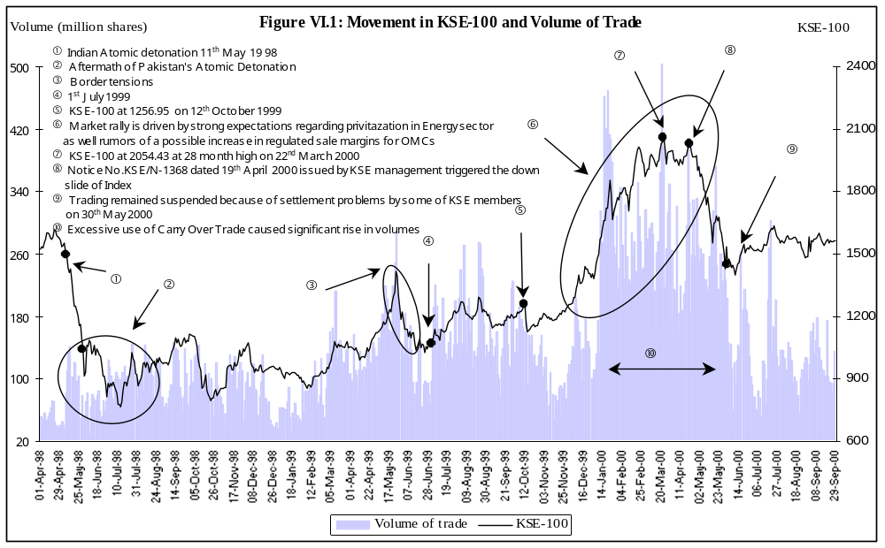

- With the accountability drive launched by the government, there was a sense of hesitancy in placing funds in real estate. With falling property prices, investors sought the relative anonymity of the stock markets.
- An unusually high inflow of liquidity from the banking sector flowed into equity markets as depositors went searching for higher yields; this was more pronounced nearing the end-December, 1999 deadline to liquidate all lottery schemes that had been launched by the NCBs. The consecutive rate cuts in NSS instruments and the reduction of deposit rates in response to the consistent fall in T-bill rates, encouraged depositors to look at more profitable options. With improved sentiments following the change in government and the suppressed market valuation in October, 1999 some depositor began investing in safer blue chip scrips like Hubco, PSO, Shell, Ibrahim Fiber, and Lever Brothers. With a low base in October, there was a corresponding increase in the yields offered by such scrips. This induction of new money had a self-fulfilling impact on the markets.
- Hopes that the new government would focus on a rapid settlement of the dispute between Index heavyweight Hubco and WAPDA. Since this dispute had already triggered a market decline months before Pakistan’s nuclear tests, investors still believed that the end to this issue would again encourage foreign investment flows into the equity market.
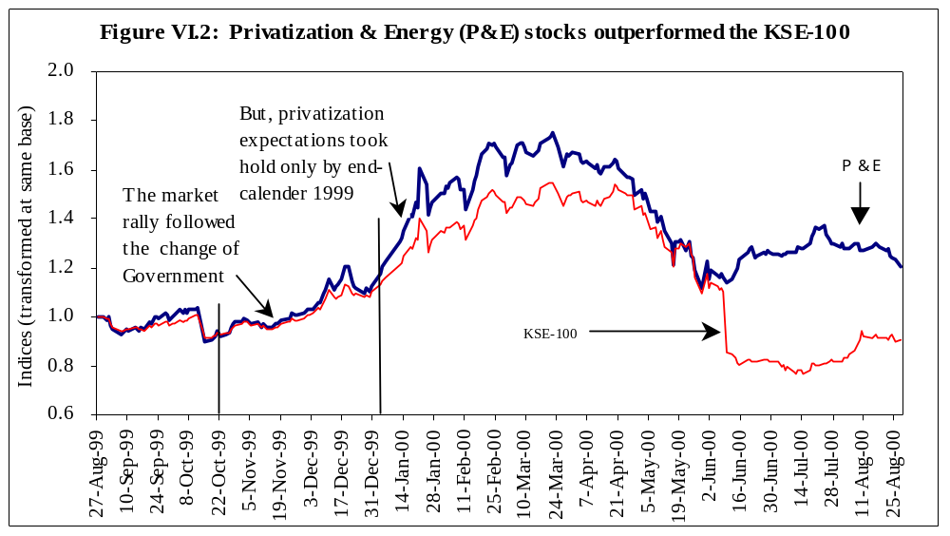
- Positive expectations concerning privatization were also important, helping drive up market capitalization of energy stocks like KESC, SSGC & SNGPL (especially after the establishment of a Natural Gas Regulatory Authority, which is a key precursor to privatization), as well as PSO (on rumors of a possible relaxation in the regulated sale margins). Not surprisingly, the energy sector was a key driver in the entire rally (see Figure VI.2).
- 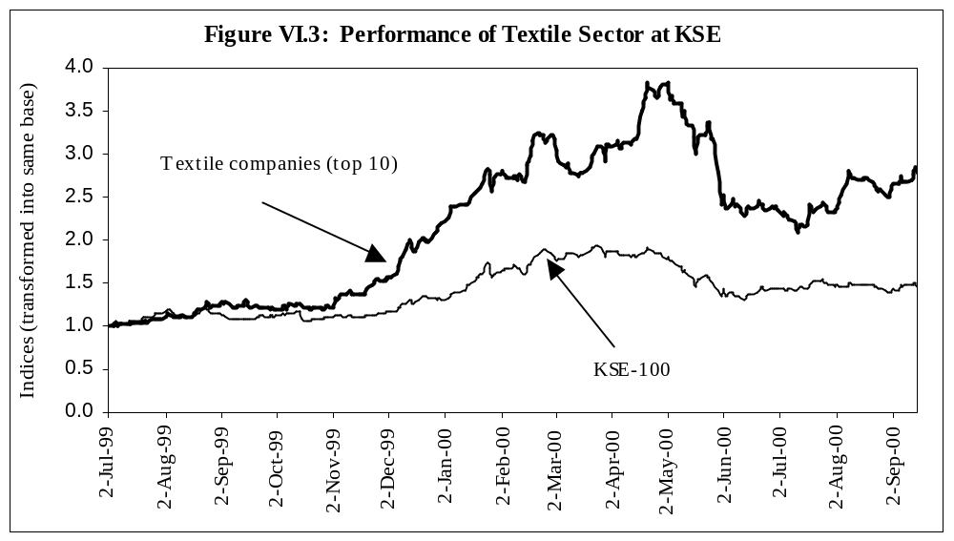Finally, textile stocks also helped the stock market rally, benefiting from the turnaround in this sector. The bumper cotton crop, low domestic cotton prices, low interest rates and the resulting increase in profitability, were instrumental factors that allowed these stocks to outperform the KSE-100 index (see Figure VI.3). As shown in Figure VIII.6, exporters were fortunate that export prices of yarn did not fall as sharply as domestic prices. The sense of optimism in the textile sector was at a peak at the end of calendar 1999, and could have triggered fixed capital investment in this sector.

The KSE-100 rally continued past the calendar year-end mark of 1408.9, with the index powering on to reach a new 28-month peak of 2054.4 on 22nd March 2000. By this time, it was becoming clear that a change in market sentiments had started. The factors underlying this downturn could be listed as follows: (1) the quick privatization of state-owned utilities was unlikely, (2) the Hubco issue was also likely to linger on, (3) actions to liberalize OMC margins were not likely to materialize in the immediate future, and (4) the liquidity induced market rally would not be able to sustain itself.
By end-April 2000, concern about the unsustainability of carry-over transactions (badla), forced the KSE to increase the risk rating of certain scrips that had been heavily used for margin requirements. This raised the margin requirements of speculators, which in turn saw a sharp fall in certain key stocks that triggered a broader fall in the market price of other scrips (see Figure VI.1). This tight liquidity position coupled with futile efforts to prop up the market (by retaining speculative positions in the hope of a turnaround in prices), did not have the desired effect. As a result, one member of the KSE defaulted, and four from the Lahore Stock Exchange (LSE) were suspended. This also forced the closure of the important markets in end-May and early June 2000 (see Box VI.1).
Other factors contributing to the downturn included the following:
- National Power, the main sponsor of Hubco, made provisions on the basis of internal expectations by reducing the value of its investment from £ 262 million to £ 131 million in April 2000. This indicated a certain degree of pessimism regarding the settlement of the Hubco dispute. These sentiments were compounded by the Supreme Court decision restraining Hubco from proceeding for arbitration in the International Chamber of Commerce.
- The Government initiated a comprehensive tax survey on 27th May 2000, which was not well received by the trading community.
Box VI.1: The 30th May Crisis

According to market sources and SECP’s formal assessment of the crises, a group of investors had traded heavily in the equity markets during the third quarter of FY00, contributing to the sharp rise in trading volumes during this period. It is said that these investors had taken heavy speculative positions, which were financed by loans against specific stocks. It is claimed that speculators had cornered these stocks, and were able to manipulate their prices. Such stocks could be used as collateral for loans, and also pledged to fulfill margin requirements of brokers. Since the market price of these scrips determines the value of collateral and margins, this created a moral hazard problem. Investors have the incentive to play the market to inflate the price of these select scrips, which in turn, allowed them to increase their speculative positions.

It was observed that the volume of weekly trading in stocks of Adamjee Insurance and Bank of Punjab, far exceeded what had been observed before, without any real improvement in the fundamentals of these companies. During February and March, the carry-over trade in Adamjee Insurance even exceeded the net free float of the scrip. This contributed to the large volume of shares traded during March and April 2000.

If this were indeed the case, KSE acted prudently to increase margin requirements by downgrading the risk profile of these stocks, which effectively increased margin requirements for speculators. The resultant liquidity squeeze for speculators is directly responsible for the sharp fall in the markets (see Figure VI.1) and the resulting settlement problems that led to the closure of trading on the KSE and the LSE in end-May and early June, 2000. This also resulted in the subsequent default of one member from KSE, while four members of LSE were suspended.

In order to investigate the causes of this crisis and suggest measures to preclude such situations in the future, SECP formed a committee in June 2000, which presented its recommendations on 31st August 2000. The committee gave comprehensive recommendations regarding improvements in SECP’s role as a regulatory authority and suggested measures to safeguard against such crises in future.

Sectoral Performance in KSE
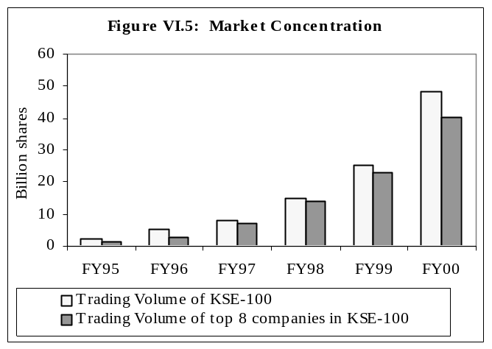The equity markets in Pakistan have historically been grounded on a narrow base, with a few companies dominating the volumes traded. As shown in Figure VI.5, the market concentration of the top eight companies has further increased in the latter half of the 1990s; from 54.2 percent of traded volume (at KSE) in FY95, to 93.0 percent in FY98, which has become a little broader based since then. Nevertheless, in FY00 the top eight companies in KSE still accounted for 83.4 percent of total trading. Despite a sharp increase in the volumes traded, equity markets in Pakistan remain shallow and therefore vulnerable to external shocks and internal manipulations.
Looking at the performance of the stock market using the SBP General Index, it is observed that market capitalization increased by 35.5 percent in FY00 as against an increase of 11.5 percent in FY99 (see Table VI.3). The sectors that recorded notable improvement in market capitalization during FY00 are: (1) Fuel & Energy by 63.6 percent, (2) Cement by 69.6 percent, (3) Cotton & other Textiles by 57.9 percent, and (4) Transport & Communication by 31.7 percent.
The dividend declaration record of companies listed at KSE showed an improvement over the past couple of years (see Table VI.4). A sectoral distribution of the capital, raised through new issues of stocks and Term Finance Certificates (TFCs) at KSE, is shown in Table VI.5. Summary statistics concerning the Karachi Stock Exchange are shown in Table VI.6.

Credit and Recovery Operations of NBFIs

Sanction of term loans by DFIs and specialized banks in FY00 stood at Rs 17.0 billion which was marginally higher than last year’s amount of Rs 16.1 billion. However, disbursement by DFIs has continued to decline in the last few years. The falling disbursements since FY98 (see Table VI.7) can be explained on the basis of the following points: (1) credit lines from IFIs dried up as part of their policy shift to stop financing DFIs, (2) the increasing financial weakness of these institutions undermined their ability to mobilize (or even maintain) domestic resources, and (3) the growing acknowledgement of the true weakness of the asset portfolio of the large DFIs. In terms of the latter point, the sharp increase in the volume of NPLs, forced DFIs to consolidate their operations by easing their gross lending. More recently, with the recovery drive and the focus on term lending, both the supply and demand of long-term credit fell. As shown in Tables VI.8, the outstanding level of deposits of the larger DFIs actually declined by 15.2 percent in comparison with FY99.

Table VI.3: SBP General Index of Stock Prices
& Market Capitalization of Common Shares
(Percentage changes)
Groups | SBP General Index |  |  | Market Capitalization
Groups | FY98 | FY99 | FY00 | FY98 | FY99 | FY00
Cotton and other Textiles | -12.2 | -2.1 | 28.9 | -29.0 | 10.7 | 57.9
Textile Spinning | -9.9 | -10.3 | 37.6 | -20.8 | -6.6 | 32.1
Textile Weaving & Composites | -14.6 | 5.7 | 53.9 | -24.0 | 7.2 | 79.0
Other Textile | -12.6 | 1.6 | 5.8 | -39.9 | 34.6 | 65.3
Chemicals & Pharmaceuticals | -16.9 | -9.7 | 12.7 | -38.1 | 3.7 | 15.6
Engineering | -6.5 | -2.0 | 18.7 | -7.6 | -6.2 | 11.7
Auto and Allied | -3.4 | -0.9 | 27.7 | -17.8 | 6.3 | 21.0
Cables & Electrical Goods | -11.3 | -9.8 | 8.5 | -24.6 | -16.3 | 24.3
Sugar and Allied | -12.1 | 0.6 | -2.1 | -9.6 | -3.2 | -8.2
Paper and Board | -13.1 | -14.5 | 34.8 | -27.8 | 14.9 | 37.8
Cement | -54.6 | 5.8 | 53.0 | -55.9 | -5.5 | 69.6
Fuel and Energy | -46.3 | 12.1 | 35.8 | -61.0 | 17.5 | 63.6
Transport and Communication | -34.2 | 35.2 | -6.4 | -53.6 | 23.7 | 31.7
Banks & Other Financial Institutions | -27.5 | 3.0 | 7.8 | -32.9 | 6.9 | 20.7
Banks and Investment Companies | -34.2 | 1.8 | 9.4 | -41.3 | 10.9 | 21.3
Modarabas | -13.9 | 2.9 | 9.9 | -23.3 | 1.3 | 12.5
Leasing Companies | -22.4 | -9.2 | 3.3 | -26.7 | -6.7 | 8.4
Insurance Companies | -22.0 | 2.8 | 0.9 | -13.5 | 8.1 | 28.8
Miscellaneous | -8.1 | -0.8 | 14.0 | 4.4 | 0.9 | 24.2
Jute | 8.9 | 21.7 | 4.7 | 8.3 | 15.4 | 23.3
Food & Allied | 0.7 | -3.7 | 36.3 | 11.7 | 1.0 | 31.0
Glass & Ceramics | -15.8 | -0.8 | 26.8 | -19.6 | -8.1 | 8.8
Vanaspati & Allied | 3.6 | 2.3 | -6.8 | 3.2 | 12.5 | 8.3
Others | -10.4 | 1.1 | 6.5 | -9.4 | 0.8 | 7.5
Overall | -30.9 | 7.7 | 21.1 | -44.7 | 11.5 | 35.5

Activities of National Investment (Unit) Trust
During FY00, gross sales of NIT Units were lower than gross repurchases by Rs 2.0 billion. In the preceding year, there were net inflows of Rs 0.34 billion. NIT remained active in KSE during the year, with gross sales of 22.6 million shares (Rs 1.9 billion) and repurchases of 10.6 million shares (Rs 0.2 billion) during FY00. The impact of the market rally is amply demonstrated by the fact that 86.3 percent of gross sales in the year were concentrated in the January to May 2000 period.

Table VI.4: Dividends Declared by Companies Listed at KSE
 | No. of companies declaring :
 | Cash Dividend | Bonus Shares | Right Shares | Total
FY00
Up to 20% | 281 | 34 | 4 | 319
Above 20% | 117 | 14 | 20 | 151
Total | 398 | 48 | 24 | 470
FY99
Up to 20% | 168 | 51 | - | 219
Above 20% | 70 | 13 | 19 | 102
Total | 238 | 64 | 19 | 321
FY98
Up to 20% | 43 | 38 | 2 | 83
Above 20% | 83 | 11 | 12 | 106
Total | 126 | 49 | 14 | 189

Table VI.5: Capital Raised Through New Common Stocks & TFCs at KSE
(Rs million)
Groups/Sectors | Number of Issues |  |  | Amount Offered |  |  | Amount Subscribed
Groups/Sectors | FY98 | FY99 | FY00 | FY98 | FY99 | FY00 | FY98 | FY99 | FY00
Textiles | 1 | - | - | 100.0 | - | - | 13.9 | - | -
Fuel and Energy | 1 | - | - | 99.6 | - | - | 11.4 | - | -
Synthetic & Rayon | 1 | 1 | - | 250.0 | 700.0 | - | 274.3 | 863.7 | -
Transport & Communication | - | - | 2 | - | - | 335.0 | - | - | 610.4
Leasing Companies | - | 1 | 2 | - | 250.0 | 350.0 | - | 284.0 | 396.0
Investment Banks | - | - | 1 | - | - | 180.0 | - | - | 35.8
Total | 3 | 2 | 5 | 449.6 | 950.0 | 865.0 | 299.6 | 1147.7 | 1042.2
In order to strengthen the role of NIT in the development of Pakistan’s capital markets, the government announced two measures in the Finance Bill of FY00: (1) the exemption of dividend income of all mutual funds from the 10 percent withholding tax, and (2) a two-year exemption from income tax payments even if NIT is unable to distribute 90 percent of its net income to unit holders. For individual holders, NIT changed its dividend policy in July 1999, whereby instead of paying out dividends, investors would have to rely on capital gains. It is still uncertain whether gains in the stock markets will be able to sustain the per unit prices that will be posted by NIT in the future.
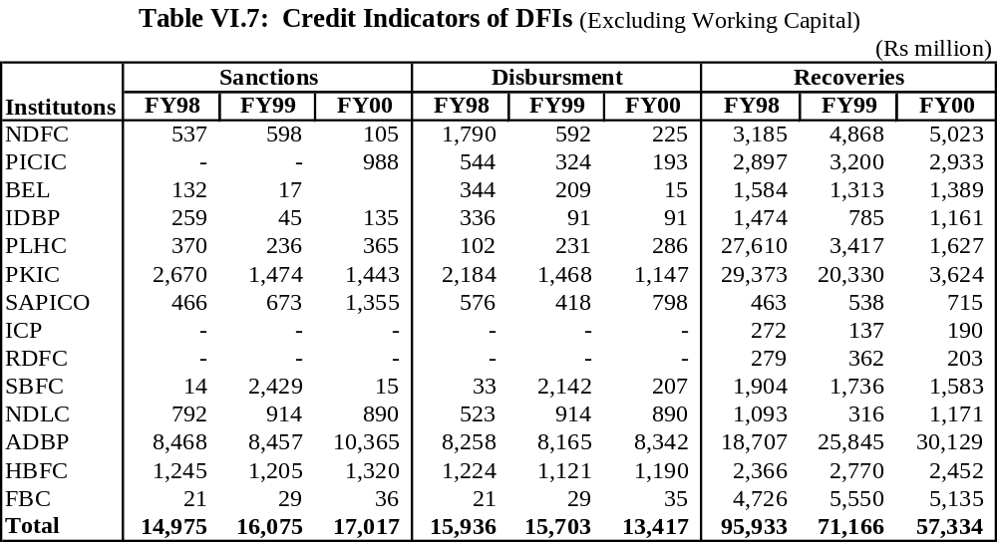
Table VI.6: Profile of Karachi Stock Exchange
 | FY97 | FY98 | FY99 | FY00
Total No. of Listed Companies as on 30th June | 782 | 779 | 769 | 762
Total Listed Capital as on 30th June (Rs billion) | 206.7 | 211.2 | 215.0 | 229.0
KSE-100 Index as on 30th June | 1,565.7 | 879.6 | 1,054.7 | 1,520.7
KSE All Share Index as on 30th June | 1,057.0 | 586.8 | 675.4 | 942.7
Initial Public Offering (Number) | 7 | 2 | 0 | 3
New Debt Instrument Listed (Number) | 1 | 3 | 2 | 3
Trade Volume (million shares) | 8,095.1 | 14,992.4 | 25,524.8 | 48,097.0
Value of Shares Traded (Rs billion) | 233.2 | 509.6 | 605.3 | 1,877.8
Average Daily Turnover (Million Shares) | 34.0 | 63.9 | 103.0 | 194.3
Trading Days | 239 | 235 | 247 | 249
Foreign Investment (Rs billion)
Inflow | 8.4 | 31.1 | 8.9 | 7.4
Outflow | 8.6 | 27.8 | 10.0 | 8.6
Net flow | -0.2 | 3.3 | -1.1 | -1.1
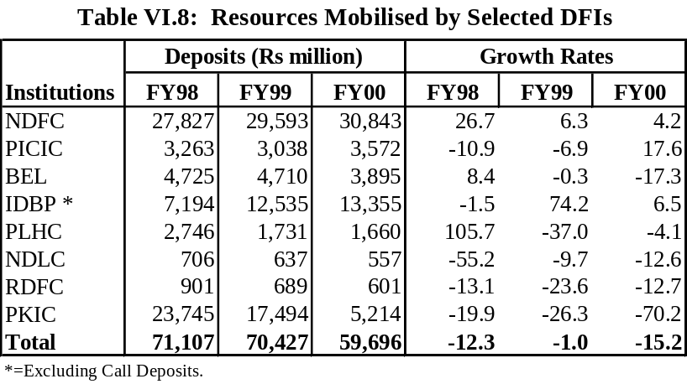
Credit Operations of Investment Banks, Modarabas and Leasing Companies
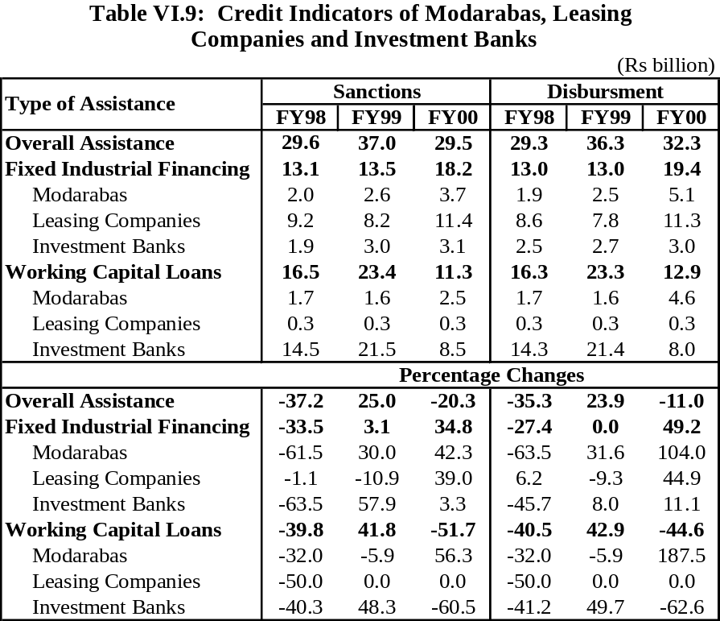The overall assistance extended by Investment banks, Modarabas and Leasing companies showed a decline in comparison with the previous year. Details are given in Table VI.9.
Corporate Debt
As shown in Table VI.10, corporate interest in issuing bonds has increased since they were first introduced in the mid-1990s. With the fall in interest rates, and more importantly, the cut in NSS rates since mid-1999, the effective benchmark for the pricing of corporate bonds has fallen sharply. However, it was the decision to ban institutional investment in NSS (in April 2000) that has given a strong boost to corporate interest in issuing Term Finance Certificates (TFCs). Since institutional funds constitute a large part of long-term savings in Pakistan, it is this target that corporates are interested in. Although only three companies have launched new TFC’s since the institutional ban in NSS, there are about 8-10 new issues in the pipeline. It is hoped that with the launch of the Pakistan Investment Bond (PIB) before end-December 2000, which should create a market determined yield curve, corporates will have a better benchmark to price their bonds. These developments on NSS and the creation of the new long-term PIB should help deepen Pakistan’s corporate bond market.

Table VI.10: Listed Corporate Debt. (Term Finance Certificates)
Security | Issue Date | Maturity | Issuance Size Rs million | Coupon Rate | Indicative Yields*
ICI | 30-Sep-96 | 30-Sep-01 | 1000.00 | 18.70 | 14.32
GATRON | 17-Jun-98 | 17-Jun-03 | 274.00 | 18.00 | 13.80
FIIB | 31-Dec-98 | 31-Dec-03 | 300.00 | 17.50 | 14.41
SPLC | 28-Jan-99 | 28-Jan-03 | 250.00 | 18.25 | 13.05
DSFL | 26-May-99 | 26-May-04 | 863.00 | 19.00 | 14.23
NDLC | 1-Dec-99 | 1-Dec-04 | 550.00 | 17.00 | 14.73
PILCORP | 21-Dec-99 | 21-Dec-04 | 287.50 | 18.00 | 15.11
SIGMA | 18-Jan-00 | 18-Jan-03 | 100.00 | 17.00 | 15.14
PARAMOUNT | 28-Jun-00 | 28-Jun-04 | 250.00 | 16.25 | 15.41
ATLAS | 27-Sep-00 | 27-Sep-05 | 200.00 | 15.00 | 14.29
NETWORK | 4-Oct-00 | 4-Oct-05 | 100.00 | 16.25 | 15.59
* End October 2000

