Review on Pakistan’s Balance of Payments

July 2006 - June 2007

Pakistan’s balance of payments showed a deficit of $ 6,878 million in its current account balance during 2006-07 as against a deficit of $ 4,990 million during 2005-06. The deterioration of $ 1,888 million in current account balance as compared to last year was the combined effect of higher net payments of $ 1,270 million and $ 915 million under goods and income accounts respectively, offset partly through lower net payment $ 260 million under services and higher net receipts by $ 37 million under current transfer.
The capital and financial account showed a net inflow of $ 10,449 million and increased by $ 4,378 million over net inflows of previous year resulting in an increase of $ 2,396 million in overall surplus during the year 2006-07. On quarterly basis, the overall balance registered deficits of $ 670 million in first quarter while surpluses of $ 595 million, $ 502 million and $ 3,303 million were observed in second, third and fourth quarters of financial year 2006-07.

The quarterly and annual balance of payments position is summarized below: -
(Million US $)
ITEM | 2006-07(QUARTERLY) |  |  |  | ANNUAL
ITEM | Jul - Sep | Oct - Dec | Jan- Mar | Apr - Jun | 2006-07 | 2005-06
Current Account Balance | -2,722 | -1,912 | -1,534 | -710 | -6,878 | -4,990
Trade balance (Goods) | -2,742 | -2,566 | -2,312 | -2,091 | -9,711 | -8,441
Exports f.o.b. | 4,191 | 4,202 | 4,142 | 4,743 | 17,278 | 16,553
Imports f.o.b. | -6,933 | -6,768 | -6,454 | -6,834 | -26,989 | -24,994
Services (net) | -1,393 | -1,066 | -1,014 | -697 | -4,170 | -4,430
Income (net) | -840 | -971 | -804 | -967 | -3,582 | -2,667
Current transfers (net) | 2,253 | 2,691 | 2,596 | 3,045 | 10,585 | 10,548
General govt. | 59 | 128 | 54 | 284 | 525 | 681
Other sectors | 2,194 | 2,563 | 2,542 | 2,761 | 10,060 | 9,867
Capital account (net) | 87 | 88 | 71 | 58 | 304 | 241
Financial account | 1,597 | 2,366 | 2,416 | 3,766 | 10,145 | 5,830
Errors and Omissions (net) | 368 | 53 | -451 | 189 | 159 | 253
Overall balance | -670 | 595 | 502 | 3,303 | 3,730 | 1,334
Reserves and related items | 670 | -595 | -502 | -3,303 | -3,730 | -1,334
Reserves assets | 680 | -652 | -492 | -3,246 | -3,710 | -1,136
Use of Fund Credits & Loans | -10 | -43 | -10 | -57 | -120 | -143
Exceptional financing | 0 | 100 | 0 | 0 | 100 | -55

Merchandise Trade

During 2006-07 exports and imports of goods (general merchandise plus repairs of goods and goods procured in ports by carriers) were $ 17,278 million and $ 26,989 million while the same in 2005-06 were $ 16,553 million and $ 24,994 million respectively.
During current financial year, the trade deficit widened by $ 1,270 million to reach $ 9,711 million compared to $ 8,441 million during the preceding financial year. Both exports and imports went up during 2006-07 over 2005-06; imports, however, at a higher rate than exports. The ratio of exports to imports fell from 66.2 (2005-06) to 64.0 (2006-07). A widening trade deficit was due to increase in imports by $ 1,995 million or 8.0 percent, offset partly by increase of $ 725 million or 4.4 percent in exports.

The quarterly and annual positions of exports and imports by source are as follows: -
(Million US $)
ITEM | 2006-07 (QUARTERLY) |  |  |  | ANNUAL
ITEM | Jul – Sep | Oct -Dec | Jan –Mar | Apr -Jun | 2006-07 | 2005-06
Trade Balance | -2,742 | -2,566 | -2,312 | -2,091 | -9,711 | -8,441
Exports (I+II+III) | 4,191 | 4,202 | 4,142 | 4,743 | 17,278 | 16,553
I. General merchandise exports  (f.o.b.) | 4,153 | 4,162 | 4,102 | 4,702 | 17,119 | 16,388
(a) Exchange record | 3,840 | 3,768 | 3,925 | 4,302 | 15,835 | 14,817
i) F.o.b. & c.f. basis | 3,977 | 3,900 | 4,039 | 4,393 | 16,310 | 15,311
ii) Freight adjustment | -137 | -132 | -114 | -91 | -475 | -494
(b) Timing adjustment | -36 | 175 | 22 | 109 | 270 | 363
(c) Coverage adjustment | 349 | 219 | 156 | 291 | 1,015 | 1,208
II. Repairs of goods | 0 | 0 | 0 | 0 | 0 | 1
III.Goods procured in ports by  carriers | 38 | 40 | 40 | 41 | 159 | 164
Imports (I+II+III) | 6,933 | 6,768 | 6,454 | 6,834 | 26,989 | 24,994
1.General merchandise imports  (f.o.b.) | 6,824 | 6,681 | 6,359 | 6,751 | 26,615 | 24,624
(a) Exchange record | 6,558 | 6,260 | 5,983 | 6,358 | 25,159 | 22,997
(b) Personal baggage, NRI &  duty free shops | 49 | 27 | 23 | 85 | 183 | 337
(c) Foreign economic assistance | 157 | 147 | 219 | 224 | 747 | 814
(d) Others | 60 | 247 | 134 | 85 | 526 | 476
11. Repairs of goods | 27 | 26 | 33 | 29 | 115 | 101
111.Goods procured in ports by  carriers | 82 | 61 | 62 | 54 | 259 | 269

The general merchandise transactions reported through banks (export receipts) on a mixed f.o.b and c&f basis amounted to $ 16,310 million as compared to $ 15,311 million a year earlier. The General merchandise export at a uniform f.o.b are arrived at by deducting the element of freight amounting to $ 475 million, adding adjustments of timing (outstanding export bills) of $ 270 million and other exports of $ 1,015 million not covered through banking channel in 2006-07.
Major commodities groups constituting 88 percent of total export receipts during FY07 in descending order except others group are shown below along with export receipts during FY06: -

(Million US $)
Commodity | 2006-07 (Quarterly) |  |  |  | Annual
Commodity | Jul – Sep | Oct -Dec | Jan –Mar | Apr -Jun | 2006-07 | 2005-06
Cotton, clothing & textile group:
Cotton | 864 | 853 | 823 | 860 | 3,401 | 3,197
Articles of Apparel & Clothing Accessories Knit/Cr | 586 | 527 | 481 | 527 | 2,121 | 1,954
Other Made-up Textile Articles; Sets, Worn Clothing | 473 | 491 | 507 | 514 | 1,986 | 1,848
Articles of Apparel/Clothing Acces not Knited /Cro | 271 | 255 | 266 | 290 | 1,081 | 929
Cereals | 249 | 247 | 344 | 360 | 1,199 | 1,039
Mineral Fuels, Oils and Their Distillation Product | 211 | 193 | 221 | 263 | 888 | 779
Special Woven Fabrics, Tufted Textiles Fabrics, Lace | 131 | 127 | 131 | 142 | 531 | 526
Toys, Games and Sports Requisites; Parts & Acces. | 93 | 79 | 77 | 106 | 356 | 418
Leather & manufactures of leather group:
Raw Hides, Skins and Leather other than Fur skins | 129 | 118 | 115 | 144 | 505 | 472
Articles of Leather, Travel Goods and Handbags etc | 97 | 98 | 91 | 97 | 383 | 547
Man-Made Staple Fibers | 46 | 82 | 89 | 96 | 313 | 196
Carpets and other Textile Floor Coverings | 61 | 68 | 63 | 67 | 260 | 271
Optical, Photographic, Measuring and Medical Inst. | 54 | 57 | 53 | 66 | 230 | 216
Man-Made Filaments | 49 | 49 | 57 | 52 | 207 | 209
Fish and Crustaceans | 37 | 44 | 39 | 45 | 164 | 163
Salt, Sulfur, Earth's and Stones, Lime and Stone | 39 | 25 | 46 | 50 | 161 | 123
Plastics and Articles thereof | 42 | 38 | 41 | 38 | 159 | 237
Silk | 34 | 42 | 24 | 49 | 149 | 80
Electrical Machinery & Equipment and Parts thereof | 36 | 47 | 26 | 36 | 145 | 135
Edible Fruits and Nuts | 35 | 27 | 54 | 26 | 141 | 137
All Others | 439 | 436 | 489 | 565 | 1930 | 1835
Grand Total | 3,977 | 3,900 | 4,039 | 4,393 | 16,310 | 15,311

The commodity-wise analysis of export receipts revealed that cotton, clothing & textile group fetched the highest foreign exchange of $ 8,589 million or 52.7 percent of total export receipts during the current year. Cereals group was the second largest foreign exchange earner with 7.4 percent share at $1,199 million.
Country-wise pattern of export receipts showed that during FY07, USA was the prominent buyer of Pakistani merchandise contributing to an amount of $ 3,844 million. The second highest buyer was UAE that imported goods worth $ 1,263 million from Pakistan.
The country-wise comparison of export receipts during 2006-07 along with 2005-06 is exhibited in the figure given below: -

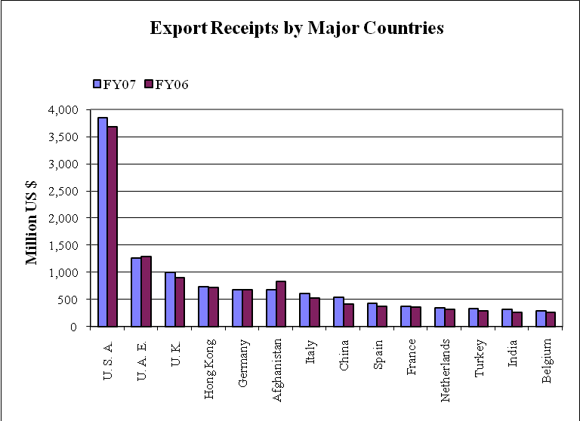

The General merchandise (imports) recorded a rise of $ 1,991 million or 8.1 percent over the previous year. Of the total imports payments, $ 25,159 million or 94.5 percent were reported by banks while those under foreign economic assistance, personal baggage & NRI, sale of duty free shops and others taken together amounted to $ 1,456 million or 5.5 percent.

Principal commodities groups constituting 88 percent of total import payments reported by banks during 2006-07 in descending order except other groups are shown below along with import payments during 2005-06: -

(Million US $)
Commodity | 2006-07 (Quarterly) |  |  |  | Annual
Commodity | Jul – Sep | Oct -Dec | Jan –Mar | Oct -Dec |  | 2006-07 | 2005-06
Mineral Fuels, Oils and Their Distillation Product | 2,217 | 1,783 | 1,682 | 2,008 |  | 7,691 | 6,209
Nuclear Reactors, Boilers, Machinery and Appliance | 618 | 691 | 752 | 703 |  | 2,763 | 2,705
Electrical Machinery & Equipment and Parts thereof | 553 | 516 | 514 | 495 |  | 2078 | 1844
Organic Chemicals | 324 | 381 | 342 | 343 |  | 1,390 | 1,353
Vehicles other than Railway /Tramway Rolling Stock | 314 | 320 | 290 | 255 |  | 1,180 | 1,206
Iron and Steel | 262 | 270 | 287 | 315 |  | 1,134 | 1,387
Special Classification Provisions | 300 | 253 | 167 | 354 |  | 1,074 | 826
Plastics and Articles thereof | 237 | 258 | 264 | 276 |  | 1,035 | 920
Animal or Vegetable Fats, Oils & Cleavage Products | 214 | 251 | 204 | 279 |  | 948 | 787
Cotton | 123 | 120 | 236 | 201 |  | 680 | 483
Fertilizers | 118 | 134 | 26 | 131 |  | 409 | 642
Oil Seeds and Oleaginous Fruit | 41 | 153 | 105 | 91 |  | 390 | 286
Sugars and Sugar Confectionery | 282 | 58 | 9 | 16 |  | 366 | 692
Optical, Photographic, Measuring and Medical Inst. | 97 | 92 | 92 | 85 |  | 365 | 304
Paper and Paperboard, Articles of Paper Pulp | 74 | 69 | 107 | 85 |  | 334 | 276
Miscellaneous Chemical Products | 73 | 85 | 75 | 90 |  | 323 | 327
Articles of Iron or Steel | 74 | 115 | 66 | 47 |  | 302 | 254
Edible Vegetables | 77 | 75 | 81 | 45 |  | 277 | 191
Rubbers and Articles thereof | 75 | 68 | 64 | 70 |  | 276 | 281
Organic or Inorganic Compounds of Precious Metals | 62 | 64 | 69 | 54 |  | 250 | 224
All Others | 772 | 748 | 784 | 794 |  | 3,099 | 2,995
Grand Total | 6,906 | 6,505 | 6,215 | 6,738 |  | 26,364 | 24,193

The country-wise comparison of import payments including freight during 2006-07 along with 2005-06 is exhibited in the figure given below:-

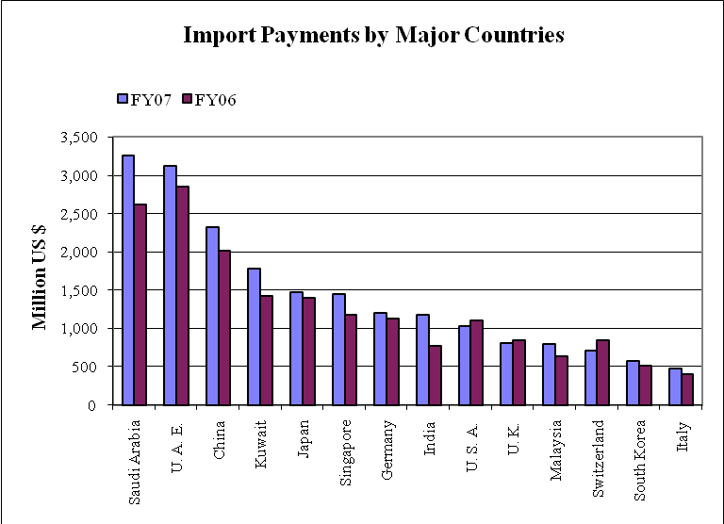

Services

The deficit in services account decreased by $ 260 million from $ 4,430 million in 2005-06 to $ 4,170 million in 2006-07. The aggregate receipts of services transactions during 2006-07 increased by $ 371 million or 9.8 percent to $ 4,140 million from $ 3,769 million during 2005-06 and aggregate payments went up by $ 111 million or 1.4 percent to $ 8,310 million from $ 8,199 million during 2005-06. The higher receipts were recorded under government services, transportation services and other business services. The rise in outflows of services account was due to transportation, other business and travel services.
The item-wise receipts and payments in services account are as follows:
(Million US $)
ITEM | 2006-07 |  |  | 2005-06
ITEM | Credit | Debit | Net | Credit | Debit | Net
Services | 4,140 | 8,310 | -4,170 | 3,769 | 8,199 | -4,430
1. Transportation | 1,102 | 3,177 | -2,075 | 1,080 | 2,863 | -1,783
1.1 Passenger | 646 | 521 | 125 | 656 | 453 | 203
1.2 Freight | 127 | 2,224 | -2,097 | 124 | 2,083 | -1,959
1 .3 Other | 329 | 432 | -103 | 300 | 327 | -27
2. Travel | 277 | 1,625 | -1,348 | 216 | 1,411 | -1,195
2.1 Business | 15 | 62 | -47 | 8 | 57 | -49
2.2 Personal | 262 | 1,563 | -1,301 | 208 | 1,354 | -1,146
3. Communications services | 123 | 98 | 25 | 198 | 101 | 97
4. Construction services | 74 | 60 | 14 | 16 | 143 | -127
5. Insurance services | 30 | 126 | -96 | 29 | 131 | -102
6. Financial services | 74 | 135 | -61 | 70 | 133 | -63
7. Computer and information services | 104 | 90 | 14 | 72 | 44 | 28
8. Royalties and license fees | 41 | 115 | -74 | 33 | 99 | -66
9. Other business services | 459 | 2,557 | -2,098 | 391 | 2,953 | -2,562
10. Personal, cultural, and recreational services | 2 | 0 | 2 | 1 | 6 | -5
11. Government services. | 1,854 | 327 | 1,527 | 1,663 | 315 | 1,348

Income
The income deficit of $ 2,667 million in 2005-06 increased by $ 915 million during 2006-07 to $ 3,582 million. The net outflows of direct investment income rose to $ 2,809 million during 2006-07 as compared with $ 2,076 million during 2005-06. Also net outflows of portfolio investment income and other investment income increased by $ 166 million & $ 17 million respectively during 2006-07 over 2005-06.

The details of receipts and payments under “Income” are as under:

(Million US $)
ITEM | 2006-07 |  |  | 2005-06
ITEM | Credit | Debit | Net | Credit | Debit | Net
Income | 940 | 4,522 | -3,582 | 784 | 3,451 | -2,667
- Compensation of employees | 7 | 1 | 6 | 6 | 1 | 5
- Investment income | 933 | 4,521 | -3,588 | 778 | 3,450 | -2,672
2.1 Direct investment | 30 | 2,839 | -2,809 | 39 | 2,115 | -2,076
2.1.1 Income on equity | 30 | 2,839 | -2,809 | 39 | 2,115 | -2,076
2.1.2 Income on debt  (interest) | 0 | 0 | 0 | 0 | 0 | 0
2.2 Portfolio investment | 348 | 607 | -259 | 357 | 450 | -93
2.2.1 Income on equity (dividends) | 6 | 266 | -260 | 2 | 88 | -86
2.2.2 Income on debt  (interest) | 342 | 341 | 1 | 355 | 362 | -7
2.3 Other investment | 555 | 1,075 | -520 | 382 | 885 | -503
2.3.1. IMF charges | 0 | 23 | -23 | 0 | 16 | -16
2.3.2. Interest on  External debt | 0 | 674 | -674 | 0 | 626 | -626
2.3.2.1 Civil | 0 | 666 | -666 | 0 | 618 | -618
2.3.2.2. Military | 0 | 8 | -8 | 0 | 8 | -8
2.3.3. Commercial  ( Medium & short) | 0 | 11 | -11 | 0 | 8 | -8
2.3.4. IDB (Medium & short-term) | 0 | 10 | -10 | 0 | 14 | -14
2.3.5. Interest on  private sector debt | 0 | 154 | -154 | 0 | 85 | -85
2.3.6.Other investment income | 555 | 203 | 352 | 382 | 136 | 246

Current Transfers

The net inflows of current transfers amounted to $10,585 million during 2006-07 as compared with $ 10,548 million in the previous year showing an increase of $ 37 million. The net decrease in general government transfers was $ 156 million during 2006-07, where the net inflows were $ 525 million in current year as compared to $ 681 million in 2005-06. This decrease is mainly due to decline in cash grants of $ 180 million for budgetary supports as compared to last fiscal year. The net transfers in other sectors increased by $ 193 million due to higher receipts under workers’ remittances of $ 894 million.

The details of receipts and payments under “Current Transfers” are as follows: -

(Million US $)
ITEM | 2006-07 (Quarterly) |  |  |  | Annual
ITEM | Jul - Sep | Oct - Dec | Jan- Mar | Apr - Jun | 2006-07 | 2005-06
Current transfers ( net ) | 2,253 | 2,691 | 2,596 | 3,045 | 10,585 | 10,548
Current transfers receipts | 2,268 | 2,706 | 2,614 | 3,070 | 10,658 | 10,655
General government | 61 | 129 | 63 | 295 | 548 | 715
Saudi oil facility | 0 | 0 | 0 | 0 | 0 | 0
Cash grants for budgetary support | 0 | 29 | 40 | 215 | 284 | 464
Others | 61 | 100 | 23 | 80 | 264 | 251
Other sectors | 2,207 | 2,577 | 2,551 | 2,775 | 10,110 | 9,940
Workers remittances | 1,233 | 1,335 | 1,369 | 1,557 | 5,494 | 4,600
Residents FCAs | -50 | 74 | 41 | 131 | 196 | 312
Others | 1,024 | 1,168 | 1,141 | 1,087 | 4,420 | 5,028
Current transfers payments | 15 | 15 | 18 | 25 | 73 | 107
General government | 2 | 1 | 9 | 11 | 23 | 34
Other sectors | 13 | 14 | 9 | 14 | 50 | 73

Capital & Financial Account

The net inflow in capital & financial account during 2006-07 stood at $ 10,449 million as against $ 6,071 million during the previous year. The net capital inflow amounted to $ 304 million in current period as against net inflow of $ 241 million in 2005-06. The project grant increased by $ 75 million in 2006-07 compared to previous year. The net inflow in financial account during 2006-07 stood at $ 10,145 million as against a net inflow of $ 5,830 million in the previous year.

The quarterly and annual position of the capital & financial account is given below -

(Million US $)
ITEM | 2006-07 (Quarterly) |  |  |  |  | Annual
ITEM | Jul - Sep |  | Oct - Dec | Jan- Mar | Apr - Jun | 2006-07 | 2005-06
Capital and Financial Account (net) | 1,684 | 2,454 |  | 2,487 | 3,824 | 10,449 |  | 6,071
Capital Account (net)  Of which | 87 | 88 |  | 71 | 58 | 304 |  | 241
-Debt Forgiveness | 0 | 0 |  | 0 | 0 | 0 |  | 0
-Project Grant | 82 | 64 |  | 64 | 47 | 257 |  | 182
Financial Account (net) | 1,597 | 2,366 |  | 2,416 | 3,766 | 10,145 |  | 5,830
1- Direct Investment | 974 | 849 |  | 1,955 | 1,248 | 5,026 |  | 3,450
2-Portfolio Investment | 88 | 1207 |  | 392 | 1596 | 3,283 |  | 986
3-Other Investment | 535 | 310 |  | 69 | 922 | 1,836 |  | 1,394

The inflow of foreign loans/credits including short-term loans stood at $ 3,530 million as compared with $ 2,789 million in the previous year. Of the total disbursement of long-term loans of $ 3,305 million, $ 921 million were received for financing of different projects while $ 1,523 million were non-projects loans. An amount of $ 225 million was received from Islamic Development Bank (IDB) for import of crude petroleum during the year as against $ 169 million in the previous year. The repayment of long-term loans/credits stood at $ 1,433 million during the current year as against $ 1,379 million in the previous year. The repayment of short-term loans/credits stood at $ 308 million during current year as against $ 387 million during the previous year.

The annual position of utilization and repayment of foreign loans/credits is given below: -

(Million US $)
I T E M | 2006-07 | 2005 – 06
1.Utilization of foreign loans / credits | 3,530 | 2,789
I) Long-term | 3,305 | 2,620
Official | 2,444 | 2,069
a) Project loans | 921 | 696
b) Non-project loans | 1,523 | 1,373
i) Food | 0 | 0
ii) Non-food | 1,523 | 1,373
Private un-guaranteed | 861 | 551
II) Short-term | 225 | 169
Official | 225 | 169
Private un-guaranteed | 0 | 0
2. Repayment of foreign loans /credits | 1,741 | 1,766
I) Long-term | 1,433 | 1,379
Official | 1,031 | 1,059
Civil | 985 | 999
Military | 46 | 60
Private un-guaranteed | 402 | 320
II) Short-term | 308 | 387
Official | 308 | 387
Private un-guaranteed | 0 | 0

The interest paid on public and publicly guaranteed loans amounted to $ 695 million whereas interest on un-guaranteed private loans stood at $ 154 million. An amount of $ 23 million was paid to International Monetary Fund (IMF) as charges.
The details of interest on external debt / liabilities are as under:--

(Million US $)
ITEM | 2006-07 | 2005-06
1. Medium and long-term | 666 | 618
2. Military | 8 | 8
3. Commercial | 11 | 8
4. IDB | 10 | 14
Total public and publicly guaranteed | 695 | 648
5. Private un-guaranteed debt | 154 | 85
6. IMF charges | 23 | 16
7. Other Interest | 364 | 264
Total Interest | 1,236 | 1,013

Reserves
In context of an overall surplus of $ 3,730 million, reserves position showed a net increase of $ 3,830 million with net receipts of $ 100 million under the exceptional financing during the year. Reserves held by the Central Bank i.e. State Bank of Pakistan (including SDR) and Deposit Money Banks increased to $ 3,537 million and $ 173 million respectively during the year. The repurchases / repayments of $ 120 million (SDR 81 million) were made to IMF during the year as against $ 143 million (SDR 98 million) in last year.

The quarter-wise and annual position of reserves is as under: -
(Million US $)
ITEM | 2006-07 (Quarterly) |  |  |  | Annual
ITEM | Jul – Sep | Oct – Dec | Jan – Mar | Apr – Jun | 2006-07 | 2005-06
Reserves (1 plus 2) | 670 | -695 | -502 | -3,303 | -3,830 | -1,279
1. Central bank (net) | 570 | -531 | -681 | -3,015 | -3,657 | -922
1.1 Reserves | 580 | -488 | -671 | -2,958 | -3,537 | -779
1.2 Reserves position in the Fund | 0 | 0 | 0 | 0 | 0 | 0
1.3 Use of Fund credit & loans from the Fund | -10 | -43 | -10 | -57 | -120 | -143
i) Purchases/ drawings | 0 | 0 | 0 | 0 | 0 | 0
a) PRGF | 0 | 0 | 0 | 0 | 0 | 0
b) Extended fund facility | 0 | 0 | 0 | 0 | 0 | 0
ii) Repurchases/Repayments | -10 | -43 | -10 | -57 | -120 | -143
a) Stand – by arrangement | 0 | 0 | 0 | 0 | 0 | -39
b) Extended fund facility | -5 | -9 | -5 | -9 | -28 | -27
c) PRGF | -5 | -34 | -5 | -48 | -92 | -77
2. Deposit Money Banks | 100 | -164 | 179 | -288 | -173 | -357
2.1 Reserves (Balance with authorized Dealers) | 100 | -164 | 179 | -288 | -173 | -357

