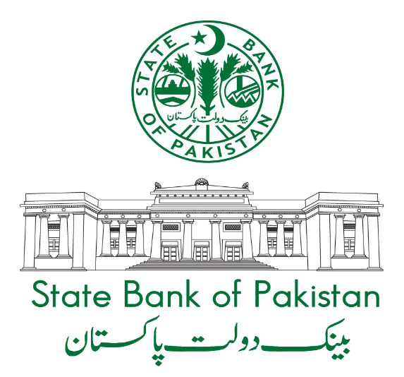

PAKISTAN’S
BALANCE OF PAYMENTS

JULY 2022 – JUNE 2023

Core Statistics Department

Data Compilation Team
Acknowledgements
- Arshad Riaz Joint Director
- Asif Ali Joint Director
- Raja Muhammad Ali Deputy Director
- Ghazanfar Aatzaz Amjad Deputy Director
- Shama Iqbal Deputy Director
Formatting Team
- Raja Muhammd Ali Deputy Director
Publication Manager
- Syed Kamran Najam Senior Joint Director
Publication Reviewer
- Muhammad Naeem Senior Joint Director
Director
    - Dr. Muhammad Nadim Hanif

Contents

 |  | Page
Preface |  | i
Introduction |  | ii - iv
Explanatory Notes on Standard Components |  | v - xii
Regions / Countries and Territories |  | xiii - xiv
Tables |  | 1 – 89
1. | Pakistan’s Balance of Payments –overall | 2 - 9
 | (a) Pak Rupees  (b) US Dollars | 2 - 5  6 - 9
2. | Pakistan’s Balance of Payments with Organisation of Islamic  Cooperation (O.I.C) | 10 - 13
3. | Pakistan’s Balance of Payments with Middle East | 14 - 17
4. | Pakistan’s Balance of Payments with Saudi Arabia | 18 - 21
5. | Pakistan’s Balance of Payments with United Arab Emirates | 22 - 25
6. | Pakistan’s Balance of Payments with Turkiye | 26 – 29
7. | Pakistan’s Balance of Payments with European Union (EU) | 30 – 33
8. | Pakistan’s Balance of Payments with United Kingdom | 34 – 37
9. | Pakistan’s Balance of Payments with Germany | 38 – 41
10. | Pakistan’s Balance of Payments with France | 42 – 45
11. | Pakistan’s Balance of Payments with Italy | 46 – 49
12. | Pakistan’s Balance of Payments with Netherlands | 50 – 53
13. | Pakistan’s Balance of Payments with USA  Pakistan’s Balance of Payments with USA | 54 – 57
14. | Pakistan’s Balance of Payments with Singapore | 58 - 61
15. | Pakistan’s Balance of Payments with Canada | 62 – 65
16. | Pakistan’s Balance of Payments with Japan | 66 – 69
17. | Pakistan’s Balance of Payments with People’s Republic of China | 70 – 73
18. | Pakistan’s Balance of Payments with Hong Kong | 74 – 77
19. | Pakistan’s Balance of Payments with Other European Countries | 78 – 81
20. | Pakistan’s Balance of Payments with Russian Federation | 82 – 85
21. | Pakistan’s Balance of Payments with International Institutions | 86 – 89
22. | Pakistan’s Balance of Payments with Other Countries | 90 – 93

