Record Note: “Meeting on 02 days thematic program arrangements”
Name of BSC Office: | Faisalabad
Event Category: | Meeting
Program Title: | “02 days thematic program arrangements”
Main Responsibility | SBPBSC Office Faisalabad
Event Date: | 06-January-2022
Event Time: | 11:00 AM to 12:00 PM
Event Location (Venue & City): | 2nd Floor SBP-BSC Faisalabad
Presentations made By: | N/A
Total no. of participants: | 24
Summary of Discussion
To improve synergies and coordination with commercial Banks of Faisalabad region, a meeting with Regional heads of commercial banks was arranged on 06-Jan-2022. It was an exposure meeting to to welcome the suggestions for arrangements of two days thematic program.

Mr. Sarfraz Ahmed Nadeem, Chief Manager, SBP-BSC Faisalabad welcomed the participants. In his welcome address, He briefed that, SBP BSC plays an integral role in facilitating target beneficiaries of SBP Schemes, particularly SMEs, by enhancing their awareness about these subsidized financing opportunities and developing their linkages with banks. To extend these efforts, SBP-BSC Faisalabad under supervision of DFSD-HOK plans to conduct 2-Days thematic program for Promotion of Renewable Energy Financing to SMEs and Promotion of SAAF Scheme to Women Borrowers. He also explained participants regarding outline of event.
In order to make this event successful and fruitful, he requested participant banks to submit their suggestions if any to improve the thematic event.

In meeting, following Points were discussed,

- Commercial Banks will share list of potential borrowers till 14-01-21 who will participate in thematic event.
- Installation of stalls from commercial banks for guidance of participants of event. Banks will nominate focal persons who will be responsible for completion of the task.
- List of Satisfied beneficiaries who have availed financing under Renewable energy schemes and CGS scheme will be provided by commercial banks to SBP-BSC Faisalabad till 14-01-22.
- Commercial banks will provide at least two nominations of solar energy vendors whose stalls will be displayed at the event by 14-01-22.
- Standees will be displayed by the commercials banks at FCCI and Associations for promotion of thematic event. Banks will nominate focal persons who will be responsible for completion of the task.
- SBP-BSC Faisalabad will hold follow up meetings with commercial banks on 18-Jan-2022 for updated status of event arrangements.
Later, Mr. Sarfraz Ahmed Nadeem, Chief Manager, SBP-BSC Faisalabad expressed his hope that banks operating in the region will actively be participate in thematic event.

Concluding the meeting, Mr. Tahir Abbas thanked participating banks and they ensured their cooperation in future as well.

There being no other point, the meeting ended with a vote of thanks to the chair.
Suggestions:
Nil
Action Plans/Agreement Points: [What, Why, Impacts, Task, Assigned to, Timeline]
As mentioned above in details
Suggestions/ Queries/Issues or any other discussion points other than the agenda of program:
As stated above in detail
Suggestions:
- Nil
Deferred Items [Describe any items that may have been deferred for a later discussion]
Nil

Annexure A
List of Attendees
Officials of SBP-BSC Faisalabad
Regional Heads of commercial Banks

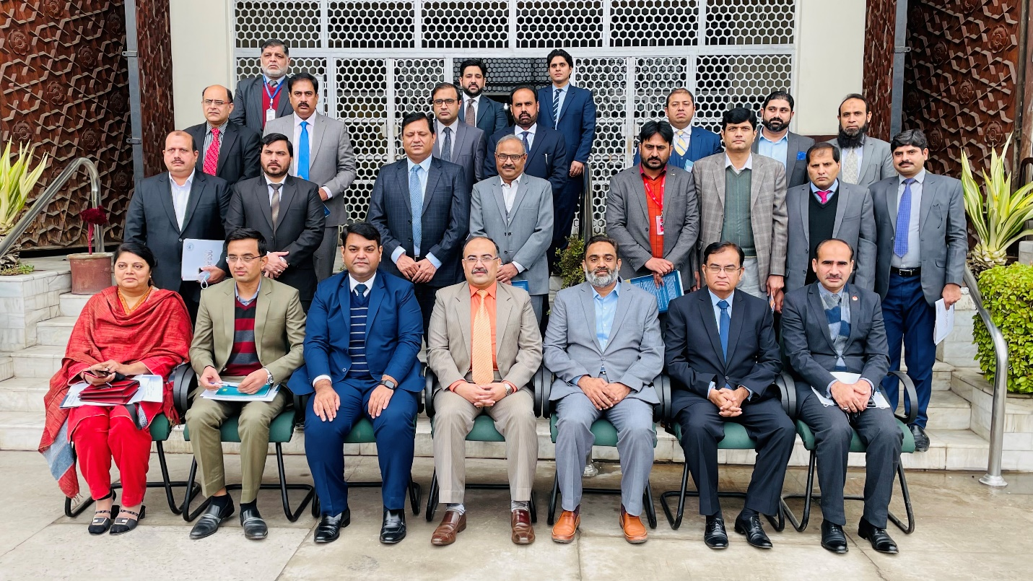
Pictures of Meeting

