7.1 Market Capitalisation of Ordinary Shares
 |  |  |  |  |  |  |  |  |  |  |  |  |  | (Million Rupees)
 |  |  |  | June |  |  |  |  |  |  |  |  |  | 2005
SECTOR / SUB - SECTOR |  |  |  | 2002 | 2003 |  |  | 2004 |  |  | 2005 | 2006 |  | Jun. | Jul. |  | Aug. |  | Sep.
1. | Cotton & Other Textiles |  |  | 41,091.6 | 65,681.1 |  |  | 88,777.0 |  |  | 102,867.9 | 98,718.4 |  | 102,867.9 | 101,924.5 |  | 103,152.6 |  | 104,447.3
 | a. | Textile Spinning |  | 12,479.4 | 17,211.4 |  |  | 22,749.4 |  |  | 21,382.3 | 18,685.5 |  | 21,382.3 | 21,264.1 |  | 20,667.4 |  | 19,903.7
 | b. | Textile Weaving & Composite |  | 13,,267.5 | 24,597.3 |  |  | 33,157.9 |  |  | 50,927.2 | 51,215.4 |  | 50,927.2 | 51,365.4 |  | 53,144.3 |  | 56,867.8
 | c. | Other Textiles |  | 15,344.7 | 23,872.4 |  |  | 32,869.7 |  |  | 30,558.4 | 28,817.5 |  | 30,558.4 | 29,295.0 |  | 29,340.9 |  | 27,675.8
2. | Chemical & Pharmaceuticals |  |  | 50,751.6 | 108,198.3 |  |  | 158,736.9 |  |  | 170,637.7 | 221,897.3 |  | 170,637.7 | 178,675.7 |  | 189,183.1 |  | 207,586.0
3. | Engineering |  |  | 2,062.3 | 4,301.9 |  |  | 6,752.1 |  |  | 9,341.1 | 11,322.9 |  | 9,341.1 | 8,597.3 |  | 8,830.0 |  | 9,288.3
4. | Auto and Allied |  |  | 10,194.6 | 30,549.8 |  |  | 38,715.9 |  |  | 40,240.0 | 70,584.0 |  | 40,240.0 | 42,410.6 |  | 42,570.9 |  | 53,419.1
5. | Cables and Electrical Goods |  |  | 2,355.3 | 4,447.6 |  |  | 7,202.5 |  |  | 9,056.5 | 18,625.5 |  | 9,056.5 | 8,597.9 |  | 9,357.4 |  | 9,984.6
6. | Sugar and Allied |  |  | 4,523.2 | 7,223.9 |  |  | 11,078.3 |  |  | 12,805.3 | 17,299.0 |  | 12,805.3 | 13,114.7 |  | 13,355.3 |  | 13,751.5
7. | Paper and Board |  |  | 6,536.1 | 11,998.9 |  |  | 16,420.0 |  |  | 16,641.5 | 21,784.8 |  | 16,641.5 | 17,022.9 |  | 16,923.9 |  | 18,019.7
8. | Cement |  |  | 15,758.5 | 33,542.1 |  |  | 65,111.0 |  |  | 68,391.3 | 133,118.2 |  | 68,391.3 | 70,628.0 |  | 74,635.9 |  | 90,494.6
9. | Fuel and Energy |  |  | 104,477.1 | 191,543.2 |  |  | 485,745.7 |  |  | 890,868.0 | 1,081,476.9 |  | 890,868.0 | 848,867.2 |  | 905,527.7 |  | 968,404.0
10. | Transport and Communication |  |  | 70,,092.3 | 123,285.3 |  |  | 193,624.2 |  |  | 285,409.6 | 209,459.1 |  | 285,409.6 | 268,303.1 |  | 288,474.3 |  | 281,985.1
11. | Banks and Other Financial
 | Institutions |  |  | 55,007.6 | 99,674.2 |  |  | 187,113.6 |  |  | 295,904.8 | 714,828.2 |  | 295,904.8 | 347,385.4 |  | 370,246.3 |  | 457,932.4
 | a. | Banks and Investment
 |  | Companies |  | 36,327.6 | 65,012.2 |  |  | 143,108.3 |  |  | 248,705.8 | 641,269.7 |  | 248,705.8 | 298,033.5 |  | 320,384.8 |  | 403,544.1
 | b. | Modarabas |  | 4,655.4 | 7,184.0 |  |  | 8,903.0 |  |  | 6,942.4 | 6,568.8 |  | 6,942.4 | 7,400.4 |  | 7,171.2 |  | 7,434.7
 | c. | Leasing Companies |  | 3,692.9 | 7,094.7 |  |  | 6,661.3 |  |  | 7,424.8 | 8,472.3 |  | 7,424.8 | 7,679.0 |  | 8,157.6 |  | 8,140.5
 | d. | Insurance |  | 10,331.7 | 20,383.3 |  |  | 28,441.0 |  |  | 32,831.8 | 58,517.48 |  | 32,831.8 | 34,272.5 |  | 34,532.7 |  | 38,813.1
12. | Miscellaneous |  |  | 44,787.5 | 65,988.2 |  |  | 98,198.0 |  |  | 111,039.1 | 167,292.9 |  | 111,039.1 | 108,146.4 |  | 110,236.6 |  | 114,416.2
 | a. | Jute |  | 376.9 | 1,049.0 |  |  | 1,801.9 |  |  | 1,649.5 | 2,587.7 |  | 1,649.5 | 1,648.9 |  | 1,819.2 |  | 1,887.2
 | b. | Food and Allied |  | 26,363.0 | 35,029.2 |  |  | 53,805.3 |  |  | 58,615.5 | 93,927.8 |  | 58,615.5 | 59,495.6 |  | 59,294.8 |  | 60,506.2
 | c. | Glass and Ceramics |  | 1,273.1 | 2,995.0 |  |  | 3,797.5 |  |  | 4,278.5 | 4,673.3 |  | 4,278.5 | 4,241.2 |  | 4,169.1 |  | 4,379.35
 | d. | Vanaspati and Allied |  | 226.8 | 512.4 |  |  | 720.8 |  |  | 451.8 | 607.5 |  | 451.8 | 471.0 |  | 459.3 |  | 615.5
 | e. | Others |  | 16,547.7 | 26,402.6 |  |  | 38,072.5 |  |  | 46,043.8 | 65,496.6 |  | 46,043.8 | 42,289.7 |  | 44,494.1 |  | 47,028.0
Aggregate Market Capitalisation |  |  |  | 407,637.7 | 746,434.5 |  |  | 1,357,475.2 |  |  | 2,013,202.8 | 2,766,407.2 |  | 2,013,202.8 | 2,013,673.7 |  | 2,132,494.0 |  | 2,329,728.8

7.1 Market Capitalisation of Ordinary Shares
 |  |  |  |  |  |  | ( Million Rupees )
 |  |  | 2005 |  |  |  |  |  |  | 2006
SECTOR / SUB - SECTOR |  |  | Oct. | Nov. |  |  |  | Dec. |  | Jan. | Feb. | Mar. | Apr. | May. | Jun.
1. | Cotton & Other Textiles |  | 100,350.8 | 106,860.7 |  |  |  | 110,892.2 | 117,772.7 |  | 119,082.2 | 113,606.5 | 107,924.0 | 99,994.3 | 98,718.4
 | a. | Textile Spinning | 19,353.8 | 20,587.8 |  |  |  | 20,472.9 | 21,186.4 |  | 22,071.4 | 20,376.1 | 20,321.6 | 19,327.4 | 18,685.5
 | b. | Textile Weaving & Composite | 53,890.1 | 58,683.5 |  |  |  | 62,830.71 | 66,957.6 |  | 66,991.5 | 63,676.6 | 58,823.1 | 52,870.4 | 51,215.4
 | c. | Other Textiles | 27,106.9 | 27,589.3 |  |  |  | 27,588.6 | 29,628.7 |  | 30,019.3 | 29,553.8 | 28,779.3 | 27,796.5 | 28,817.5
2. | Chemical & Pharmaceuticals |  | 214,202.3 | 233,499.5 |  |  |  | 242,156.7 | 269,010.1 |  | 271,184.1 | 272,615.5 | 251,146.7 | 243,012.8 | 221,897.3
3. | Engineering |  | 9,424.4 | 10,573.9 |  |  |  | 13,453.3 | 12,529.6 |  | 12,927.1 | 13,017.8 | 12,473.4 | 12,094.1 | 11,322.9
4. | Auto and Allied |  | 56,851.3 | 61,587.2 |  |  |  | 63,568.2 | 77,086.2 |  | 71,029.0 | 67,632.6 | 71,653.9 | 73,724.4 | 70,584.0
5. | Cables and Electrical Goods |  | 9,808.6 | 11,666.1 |  |  |  | 12,777.5 | 15,202.3 |  | 17,191.4 | 17,712.9 | 18,928.5 | 18,985.9 | 18,625.5
6. | Sugar and Allied |  | 14,577.0 | 16,757.0 |  |  |  | 18,315.5 | 19,369.5 |  | 18,923.1 | 18,727.8 | 19,322.3 | 18,464.3 | 17,299.0
7. | Paper and Board |  | 17,326.4 | 19,524.1 |  |  |  | 20,955.8 | 22,819.1 |  | 21,910.7 | 21,681.5 | 22,027.0 | 20,901.7 | 21,784.8
8. | Cement |  | 109,264.9 | 132,345.5 |  |  |  | 136,994.8 | 157,005.7 |  | 158,669.3 | 167,956.7 | 151,142.3 | 142,405.8 | 133,118.2
9. | Fuel and Energy |  | 933,991.4 | 977,584.1 |  |  |  | 1,030,991.1 | 1,097,146.3 |  | 1,305,909.3 | 1,287,890.4 | 1,265,437.6 | 1,158,192.7 | 1,081,476.9
10. | Transport and Communication |  | 273,797.1 | 297,870.6 |  |  |  | 310,536.2 | 332,872.1 |  | 326,401.8 | 318,699.1 | 270,838.4 | 243,153.9 | 209,459.1
11. | Banks and Other Financial
 | Institutions |  | 487,721.7 | 563,601.9 |  |  |  | 605,509.3 | 694,511.9 |  | 773,238.4 | 770,256.9 | 811,187.1 | 773,145.3 | 714,828.2
 | a. | Banks and Investment
 |  | Companies | 435,161.8 | 503,716.6 |  |  |  | 543,108.3 | 625,134.2 |  | 701,707.2 | 695,844.8 | 735,615.7 | 697,358.6 | 641,269.7
 | b. | Modarabas | 6,752.9 | 7,240.3 |  |  |  | 7,712.2 | 7,937.4 |  | 7,695.4 | 7,218.1 | 7,194.7 | 6,765.4 | 6,568.8
 | c. | Leasing Companies | 7,665.2 | 8,479.4 |  |  |  | 8,569.7 | 8,794.3 |  | 8,878.4 | 9,308.8 | 8,865.0 | 8,314.2 | 8,472.3
 | d. | Insurance | 38,141.9 | 44,165.7 |  |  |  | 46,119.1 | 52,646.0 |  | 54,957.5 | 57,885.3 | 59,511.8 | 60,707.1 | 58,517.48
12. | Miscellaneous |  | 113,448.4 | 125,369.1 |  |  |  | 143,369.9 | 154,874.6 |  | 150,857.5 | 148,731.9 | 158,015.8 | 166,640.9 | 167,292.9
 | a. | Jute | 2,053.9 | 2,683.0 |  |  |  | 2,885.8 | 3,577.8 |  | 3,453.5 | 3,084.3 | 3,235.6 | 2,884.3 | 2,587.7
 | b. | Food and Allied | 60,734.4 | 65,614.8 |  |  |  | 78,178.5 | 85,283.6 |  | 83,510.6 | 82,433.4 | 85,043.6 | 94,483.0 | 93,927.8
 | c. | Glass and Ceramics | 4,208.8 | 4,494.4 |  |  |  | 4,439.8 | 4,690.5 |  | 4,735.6 | 4,690.8 | 5,688.4 | 4,895.9 | 4,673.3
 | d. | Vanaspati and Allied | 615.3 | 651.1 |  |  |  | 576.8 | 722.6 |  | 725.9 | 652.6 | 641.1 | 651.8 | 607.5
 | e. | Others | 45,836.0 | 51,925.8 |  |  |  | 57,289.0 | 60,600.2 |  | 58,431.8 | 57,870.9 | 63,407.1 | 63,726.0 | 65,496.6
Aggregate Market Capitalisation |  |  | 2,340,764.2 | 2,557,239.5 |  |  |  | 2,709,520.6 | 2,970,200.0 |  | 3,247,323.7 | 3,218,529.7 | 3,160,096.8 | 2,970,716.0 | 2,766,407.2
Source: KSE/Statistics Department, SBP

7.2 State Bank General Index of Share Prices
(Base: 2000-01=100)*
 |  |  | June |  |  |  |  |  | 2005
SECTOR / SUB - SECTOR |  |  | 2002 | 2003 | 2004 | 2005 | 2006 |  | Jun. | Jul. |  | Aug. |  | Sep.
1. | Cotton & Other Textiles |  | 113.45 | 163.79 | 257.33 | 254.66 | 234.82 |  | 254.66 | 244.35 |  | 239.67 |  | 235.40
 | a. | Textile Spinning | 107.81 | 140.57 | 232.04 | 248.35 | 212.87 |  | 248.35 | 244.43 |  | 239.32 |  | 234.66
 | b. | Textile Weaving & Composite | 97.89 | 160.62 | 245.07 | 234.02 | 221.74 |  | 234.02 | 227.87 |  | 221.78 |  | 223.69
 | c. | Other Textiles | 136.48 | 194.26 | 300.49 | 290.76 | 283.75 |  | 290.76 | 267.38 |  | 267.90 |  | 254.45
2. | Chemical & Pharmaceuticals |  | 129.59 | 207.31 | 340.55 | 282.49 | 342.30 |  | 282.49 | 295.14 |  | 302.83 |  | 322.89
3. | Engineering |  | 130.31 | 248.91 | 430.35 | 570.60 | 783.61 |  | 570.60 | 545.70 |  | 557.83 |  | 638.69
4. | Auto and Allied |  | 140.52 | 362.53 | 572.48 | 569.03 | 783.94 |  | 569.03 | 566.78 |  | 578.13 |  | 718.49
5. | Cables and Electrical Goods |  | 118.22 | 209.58 | 374.15 | 326.05 | 541.62 |  | 326.05 | 328.56 |  | 345.14 |  | 394.95
6. | Sugar and Allied |  | 103.62 | 181.84 | 274.03 | 339.33 | 459.64 |  | 339.33 | 335.05 |  | 330.44 |  | 344.45
7. | Paper and Board |  | 126.99 | 229.46 | 280.42 | 274.78 | 288.93 |  | 274.78 | 273.56 |  | 270.98 |  | 277.03
8. | Cement |  | 110.05 | 217.65 | 434.19 | 390.65 | 708.89 |  | 390.65 | 395.31 |  | 411.04 |  | 532.51
9. | Fuel and Energy |  | 100.23 | 194.84 | 233.55 | 374.03 | 343.08 |  | 374.03 | 297.31 |  | 301.46 |  | 321.00
10. | Transport and Communication |  | 94.17 | 199.99 | 348.61 | 538.14 | 513.83 |  | 538.14 | 530.28 |  | 528.56 |  | 586.01
11. | Banks and Other Financial
 | Institutions |  | 102.72 | 217.29 | 346.86 | 316.02 | 445.90 |  | 316.02 | 334.20 |  | 339.37 |  | 389.79
 | a. | Banks and Investment
 |  | Companies | 103.16 | 223.14 | 396.12 | 363.87 | 503.91 |  | 363.87 | 381.94 |  | 386.30 |  | 450.53
 | b. | Modarabas | 105.72 | 268.64 | 281.42 | 173.12 | 164.28 |  | 173.12 | 179.45 |  | 168.26 |  | 169.41
 | c. | Leasing Companies | 99.06 | 153.44 | 220.14 | 220.30 | 208.13 |  | 220.30 | 220.03 |  | 232.86 |  | 229.13
 | d. | Insurance | 97.49 | 153.92 | 194.22 | 189.95 | 303.78 |  | 189.95 | 190.96 |  | 192.85 |  | 201.23
12. | Miscellaneous |  | 122.19 | 223.20 | 331.09 | 344.67 | 410.68 |  | 344.67 | 346.01 |  | 348.24 |  | 353.52
 | a. | Jute | 137.99 | 250.0 | 565.02 | 373.67 | 399.74 |  | 373.67 | 337.27 |  | 345.25 |  | 332.80
 | b. | Food and Allied | 118.60 | 186.15 | 367.98 | 480.65 | 493.77 |  | 480.65 | 465.54 |  | 456.52 |  | 446.42
 | c. | Glass and Ceramics | 114.82 | 252.48 | 280.36 | 269.36 | 269.54 |  | 269.36 | 265.13 |  | 283.12 |  | 290.09
 | d. | Vanaspati and Allied | 99.78 | 263.74 | 342.29 | 295.55 | 455.86 |  | 295.55 | 294.02 |  | 281.89 |  | 545.82
 | e. | Others | 125.09 | 224.06 | 309.36 | 311.50 | 408.76 |  | 311.50 | 323.61 |  | 326.94 |  | 321.12
General Index Number |  |  | 106.74 | 204.10 | 312.70 | 359.99 | 427.01 |  | 359.99 | 353.29 |  | 356.70 |  | 397.87
* From July,2001 the base has been shifted from 1990-91 to 2000-01

7.2 State Bank General Index of Share Prices
(Base: 2000-01=100)
 |  |  |  | 2005 |  |  | 2006
SECTOR / SUB - SECTOR |  |  |  | Oct. | Nov. | Dec. |  |  | Jan. | Feb. | Mar. | Apr. | May. | Jun.
1. | Cotton & Other Textiles |  |  | 230.04 | 243.86 | 252.93 |  |  | 261.40 | 267.48 | 252.75 | 247.56 | 242.88 | 234.82
 | a. | Textile Spinning |  | 226.53 | 231.68 | 239.91 |  |  | 247.54 | 251.51 | 232.39 | 231.86 | 219.60 | 212.87
 | b. | Textile Weaving & Composite |  | 220.63 | 237.29 | 245.47 |  |  | 252.79 | 262.61 | 247.03 | 240.35 | 226.72 | 221.74
 | c. | Other Textiles |  | 248.83 | 268.60 | 280.00 |  |  | 291.20 | 295.48 | 287.65 | 278.90 | 297.93 | 283.75
2. | Chemical & Pharmaceuticals |  |  | 325.32 | 364.09 | 383.22 |  |  | 417.78 | 433.69 | 415.03 | 386.69 | 370.87 | 342.30
3. | Engineering |  |  | 579.80 | 676.65 | 885.10 |  |  | 878.09 | 882.09 | 811.42 | 805.18 | 818.35 | 783.61
4. | Auto and Allied |  |  | 730.92 | 799.75 | 866.65 |  |  | 1,008.75 | 904.14 | 885.13 | 974.24 | 871.25 | 783.94
5. | Cables and Electrical Goods |  |  | 342.43 | 369.66 | 429.28 |  |  | 481.35 | 496.01 | 507.35 | 534.74 | 542.92 | 541.62
6. | Sugar and Allied |  |  | 376.10 | 431.16 | 456.28 |  |  | 466.35 | 470.68 | 489.79 | 506.75 | 497.41 | 459.64
7. | Paper and Board |  |  | 268.94 | 292.55 | 294.35 |  |  | 330.02 | 326.20 | 313.45 | 324.78 | 310.43 | 288.93
8. | Cement |  |  | 623.94 | 740.11 | 766.88 |  |  | 852.49 | 856.71 | 895.35 | 833.47 | 774.31 | 708.89
9. | Fuel and Energy |  |  | 313.67 | 334.00 | 381.89 |  |  | 383.18 | 537.49 | 431.61 | 419.23 | 360.15 | 343.08
10. | Transport and Communication |  |  | 545.20 | 592.79 | 631.75 |  |  | 805.52 | 721.98 | 631.24 | 598.05 | 534.21 | 513.83
11. | Banks and Other Financial
 | Institutions |  |  | 395.17 | 453.63 | 487.43 |  |  | 539.22 | 565.96 | 509.95 | 498.96 | 471.25 | 445.90
 | a. | Banks and Investment
 |  | Companies |  | 460.17 | 529.65 | 565.09 |  |  | 630.22 | 661.55 | 580.79 | 568.10 | 534.43 | 503.91
 | b. | Modarabas |  | 157.28 | 172.10 | 207.67 |  |  | 201.55 | 197.09 | 175.64 | 179.21 | 175.54 | 164.28
 | c. | Leasing Companies |  | 204.89 | 224.50 | 235.03 |  |  | 240.54 | 247.93 | 254.60 | 231.25 | 213.57 | 208.13
 | d. | Insurance |  | 200.89 | 230.16 | 257.67 |  |  | 273.57 | 304.79 | 309.29 | 291.13 | 303.66 | 303.78
12. | Miscellaneous |  |  | 335.02 | 358.49 | 366.84 |  |  | 394.65 | 401.87 | 389.80 | 411.29 | 410.98 | 410.68
 | a. | Jute |  | 337.64 | 390.33 | 397.69 |  |  | 434.01 | 429.66 | 410.99 | 444.35 | 414.15 | 399.74
 | b. | Food and Allied |  | 434.52 | 467.055 | 495.21 |  |  | 543.07 | 598.89 | 523.41 | 515.79 | 495.88 | 493.77
 | c. | Glass and Ceramics |  | 258.84 | 274.24 | 315.37 |  |  | 303.15 | 321.29 | 296.76 | 340.26 | 294.61 | 269.54
 | d. | Vanaspati and Allied |  | 542.51 | 575.42 | 355.10 |  |  | 387.26 | 407.44 | 415.55 | 412.40 | 469.71 | 455.86
 | e. | Others |  | 300.80 | 319.90 | 333.26 |  |  | 361.48 | 350.42 | 360.64 | 388.87 | 402.12 | 408.76
General Index Number |  |  |  | 396.61 | 440.80 | 475.28 |  |  | 531.85 | 566.99 | 509.67 | 492.44 | 451.41 | 427.01
Source: KSE/Statistics Department, SBP

7.3 State Bank Sensitive Index of Share Prices
(Base: 2000-01=100)
 |  |  | June |  |  |  |  |  | 2005
SECTOR / SUB - SECTOR |  |  | 2002 | 2003 | 2004 | 2005 | 2006 |  | Jun. | Jul. | Aug. | Sep.
1. | Cotton & Other Textiles |  | 101.42 | 142.35 | 341.31 | 258.69 | 218.24 |  | 258.69 | 222.00 | 214.28 | 212.41
 | a. | Textile Spinning | 85.58 | 155.90 | 164.59 | 234.91 | 218.70 |  | 234.91 | 268.12 | 260.99 | 273.55
 | b. | Textile Weaving & Composite | 84.27 | 152.22 | 309.50 | 232.66 | 197.65 |  | 232.66 | 233.48 | 222.42 | 223.63
 | c. | Other Textiles | 113.28 | 134.20 | 389.28 | 284.95 | 238.42 |  | 284.95 | 202.44 | 197.59 | 190.08
2. | Chemical & Pharmaceuticals |  | 101.79 | 227.81 | 357.77 | 319.38 | 359.66 |  | 319.38 | 348.31 | 365.49 | 395.56
3. | Engineering |  | 142.58 | 503.12 | 626.06 | 689.95 | 2,023.26 |  | 689.95 | 1,346.90 | 1,548.45 | 1,879.84
4. | Auto and Allied |  | 111.98 | 480.67 | 629.21 | 602.74 | 1,291.78 |  | 602.74 | 683.47 | 699.23 | 896.88
5. | Cables and Electrical Goods |  | 140.17 | 99.59 | 1,641.47 | 813.88 | 1,521.59 |  | 813.88 | 923.83 | 966.81 | 1,124.02
6. | Sugar and Allied |  | 135.35 | 213.35 | 402.26 | 815.86 | 1,550.80 |  | 815.86 | 1,325.33 | 1,314.57 | 1,354.33
7. | Paper and Board |  | 82.91 | 273.32 | 446.30 | 315.51 | 469.48 |  | 315.51 | 321.36 | 305.09 | 322.62
8. | Cement |  | 124.31 | 271.81 | 557.04 | 459.07 | 767.60 |  | 459.07 | 462.16 | 488.30 | 605.11
9. | Fuel and Energy |  | 107.25 | 195.84 | 259.66 | 334.24 | 370.20 |  | 334.24 | 313.10 | 320.19 | 337.97
10. | Transport and Communication |  | 89.23 | 126.53 | 168.80 | 967.87 | 784.03 |  | 967.87 | 814.83 | 820.73 | 976.49
11. | Banks and Other Financial
 | Institutions |  | 112.66 | 219.23 | 528.44 | 411.42 | 564.15 |  | 411.42 | 474.19 | 477.59 | 537.70
 | a. | Banks and Investment
 |  | Companies | 114.54 | 225.77 | 572.02 | 431.57 | 591.42 |  | 431.57 | 499.41 | 502.46 | 568.19
 | b. | Modarabas | 109.31 | 175.70 | 267.40 | 341.97 | 111.07 |  | 341.97 | 154.70 | 148.95 | 121.26
 | c. | Leasing Companies | 110.79 | 249.44 | 416.65 | 219.88 | 365.08 |  | 219.88 | 443.46 | 463.52 | 433.66
 | d. | Insurance | 80.16 | 158.63 | 228.17 | 191.33 | 255.35 |  | 191.33 | 132.22 | 133.27 | 176.65
12. | Miscellaneous |  | 155.94 | 224.06 | 293.04 | 281.54 | 465.49 |  | 281.54 | 534.22 | 544.93 | 507.46
 | a. | Jute | - | - | - | 275.13 | 447.22 |  | 275.13 | 273.81 | 305.29 | 320.77
 | b. | Food and Allied | 105.80 | 150.49 | 174.94 | 162.06 | 264.14 |  | 162.06 | 171.77 | 173.84 | 170.04
 | c. | Glass and Ceramics | - | - | 283.52 | 186.81 | 690.91 |  | 186.81 | 838.64 | 820.45 | 715.91
 | d. | Vanaspati and Allied | - | - | - | - | 451.22 |  | - | 609.76 | 594.51 | 594.51
 | e. | Others | 165.65 | 241.40 | 321.49 | 323.33 | 718.61 |  | 323.33 | 1,054.33 | 1,089.46 | 1,006.16
Overall Sensitive Index Number |  |  | 105.14 | 198.06 | 334.54 | 491.68 | 521.53 |  | 491.68 | 465.71 | 474.49 | 536.10
Note: From July,2001 the base has been shifted from 1990-91 to 2000-01

7.3 State Bank Sensitive Index of Share Prices
(Base: 2000-01=100)
 |  |  |  | 2005 |  |  |  | 2006
SECTOR / SUB - SECTOR |  |  |  | Oct. | Nov. | Dec. |  | Jan. | Feb. | Mar. | Apr. | May. | Jun.
1. | Cotton & Other Textiles |  |  | 192.37 | 225.14 | 259.01 | 285.73 |  | 265.37 | 236.08 | 222.00 | 239.05 | 218.24
 | a. | Textile Spinning |  | 250.33 | 253.64 | 268.34 | 282.57 |  | 263.25 | 241.96 | 234.49 | 200.26 | 218.70
 | b. | Textile Weaving & Composite |  | 203.53 | 233.47 | 248.54 | 267.55 |  | 259.25 | 233.04 | 221.55 | 201.90 | 197.65
 | c. | Other Textiles |  | 170.54 | 211.90 | 266.63 | 302.67 |  | 271.47 | 237.41 | 219.92 | 281.70 | 238.42
2. | Chemical & Pharmaceuticals |  |  | 392.35 | 448.35 | 470.81 | 452.32 |  | 474.99 | 451.88 | 428.35 | 413.34 | 359.66
3. | Engineering |  |  | 1,738.37 | 1,860.47 | 2,943.80 | 3,011.63 |  | 2,691.86 | 2,282.95 | 2,246.12 | 2,112.40 | 2,023.26
4. | Auto and Allied |  |  | 994.93 | 1,112.87 | 1,150.50 | 1,433.90 |  | 1,374.10 | 1,324.31 | 1,386.65 | 1,350.87 | 1,291.78
5. | Cables and Electrical Goods |  |  | 920.62 | 938.17 | 994.30 | 1,169.65 |  | 1,105.09 | 1,180.36 | 1,341.34 | 1,461.83 | 1,521.59
6. | Sugar and Allied |  |  | 1,424.31 | 1,682.66 | 1,652.99 | 1,729.44 |  | 1,644.59 | 1,624.58 | 1,843.79 | 1,635.35 | 1,550.80
7. | Paper and Board |  |  | 312.53 | 344.93 | 357.15 | 399.55 |  | 613.15 | 551.64 | 666.67 | 577.46 | 469.48
8. | Cement |  |  | 718.27 | 866.74 | 862.97 | 983.30 |  | 1,068.63 | 1,106.03 | 918.80 | 878.07 | 767.60
9. | Fuel and Energy |  |  | 330.04 | 352.82 | 387.93 | 400.43 |  | 578.00 | 462.82 | 450.94 | 385.02 | 370.20
10. | Transport and Communication |  |  | 891.40 | 1,010.85 | 1,077.66 | 1,475.62 |  | 1,278.13 | 1,070.67 | 1,010.47 | 872.63 | 784.03
11. | Banks and Other Financial
 | Institutions |  |  | 535.80 | 605.52 | 624.66 | 713.19 |  | 766.27 | 691.73 | 648.78 | 605.17 | 564.15
 | a. | Banks and Investment
 |  | Companies |  | 569.60 | 640.90 | 660.80 | 756.65 |  | 814.77 | 729.13 | 681.77 | 634.80 | 591.42
 | b. | Modarabas |  | 109.02 | 124.13 | 150.88 | 155.65 |  | 155.49 | 146.06 | 135.01 | 121.95 | 111.07
 | c. | Leasing Companies |  | 344.34 | 429.30 | 421.03 | 412.63 |  | 411.95 | 393.57 | 377.53 | 354.31 | 365.08
 | d. | Insurance |  | 171.96 | 207.46 | 217.64 | 270.27 |  | 282.59 | 266.25 | 280.12 | 299.56 | 255.35
12. | Miscellaneous |  |  | 457.05 | 491.84 | 604.17 | 729.26 |  | 668.77 | 570.58 | 620.53 | 507.30 | 465.49
 | a. | Jute |  | 351.19 | 468.25 | 505.16 | 633.33 |  | 608.47 | 539.15 | 564.81 | 502.12 | 447.22
 | b. | Food and Allied |  | 178.49 | 219.67 | 394.06 | 584.98 |  | 520.61 | 397.59 | 399.23 | 302.10 | 264.14
 | c. | Glass and Ceramics |  | 677.27 | 650.00 | 877.27 | 727.27 |  | 829.55 | 693.18 | 1,000.00 | 727.27 | 690.91
 | d. | Vanaspati and Allied |  | 445.12 | 567.07 | 750.00 | 853.66 |  | 731.71 | 853.66 | 853.66 | 640.24 | 451.22
 | e. | Others |  | 841.99 | 864.80 | 851.43 | 952.61 |  | 854.82 | 779.54 | 841.24 | 751.20 | 718.61
Overall Sensitive Index Number |  |  |  | 517.67 | 581.68 | 618.84 | 738.41 |  | 772.08 | 666.89 | 632.95 | 566.73 | 521.53

7.4 Turnover of Shares at Karachi Stock Exchange
(Million Nos.)
MONTH |  | 2000-01 | 2001-02 | 2002-03 | 2003-04 | 2004-05 | 2005-06
July |  | 2,690.81 | 1,197.23 | 1,553.22 | 10,259.86 | 5,431.69 | 3,067.34
August |  | 2,394.89 | 1,509.09 | 3,059.04 | 12,249.23 | 4,615.11 | 4,979.02
September |  | 2,676.02 | 724.72 | 2,653.55 | 9,753.69 | 4,676.10 | 7,858.49
October |  | 2,777.60 | 3,579.14 | 4,290.06 | 4,952.18 | 5,194.81 | 6,537.71
November |  | 2,569.02 | 1,837.42 | 3,934.97 | 2,138.78 | 3,863.32 | 7,517.35
December |  | 2,741.68 | 906.80 | 6,750.11 | 6,190.40 | 10,445.38 | 7,414.97
January |  | 3,645.84 | 3,740.47 | 9,102.39 | 7,037.99 | 12,197.92 | 8,461.92
February |  | 2,928.87 | 4,060.14 | 2,084.18 | 4,790.05 | 13,998.99 | 10,304.74
March |  | 1,679.04 | 3,925.57 | 2,741.30 | 7,780.26 | 11,280.89 | 8,127.42
April |  | 2,006.19 | 3,004.30 | 4,434.98 | 15,479.22 | 4,866.88 | 6,031.65
May |  | 1,416.44 | 2,637.56 | 4,479.20 | 8,485.57 | 6,104.86 | 5,131.83
June |  | 1,638.93 | 2,018.22 | 7,993.88 | 7,840.52 | 5,625.24 | 4,022.10
TOTAL |  | 29,165.33 | 29,140.66 | 53,076.88 | 96,957.75 | 88,301.19 | 79,454.54
Source: KSE/Statistics Department, SBP

State Bank General and Sensitive Indices of Share Prices

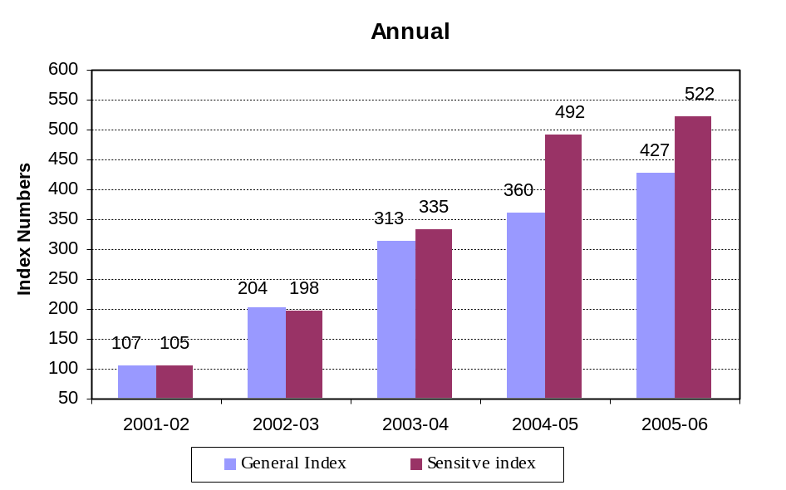

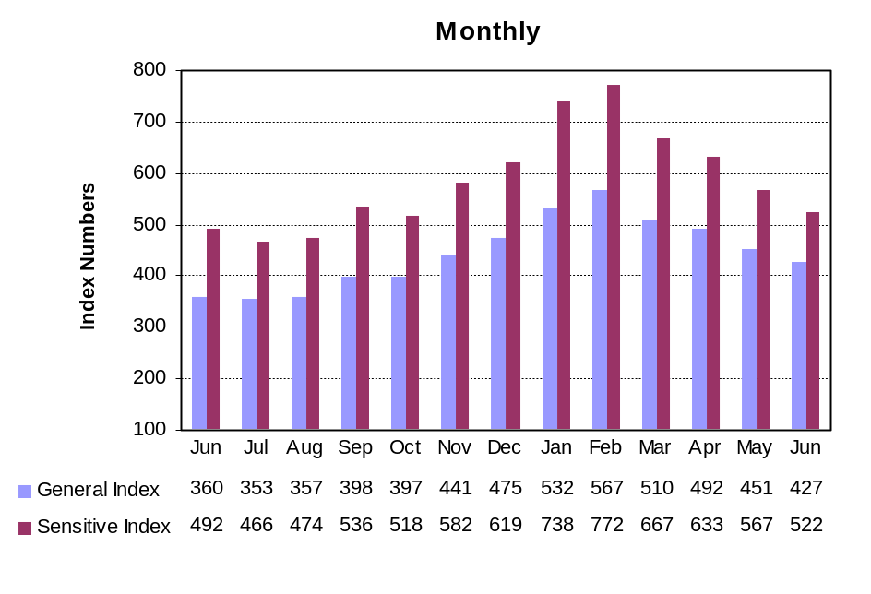

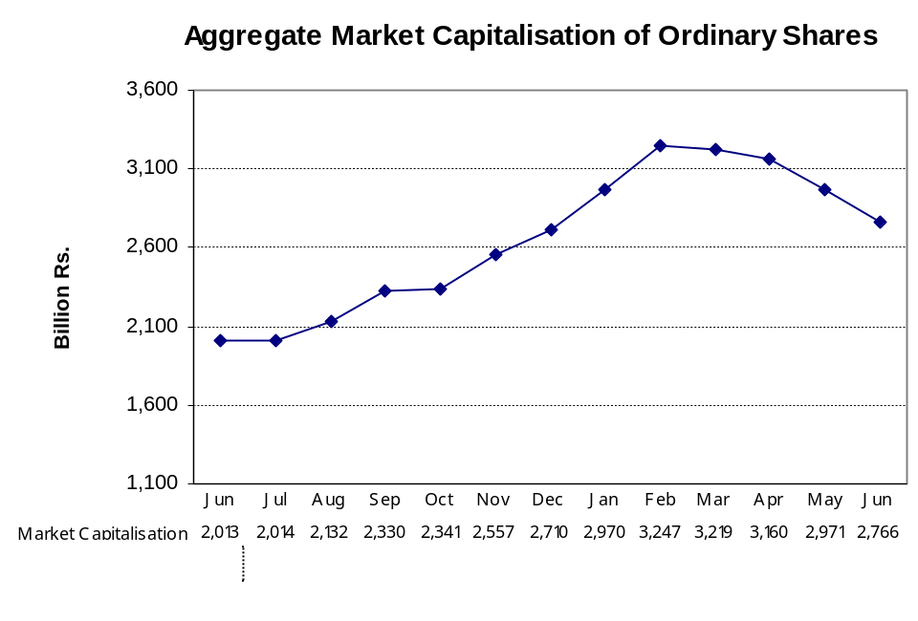

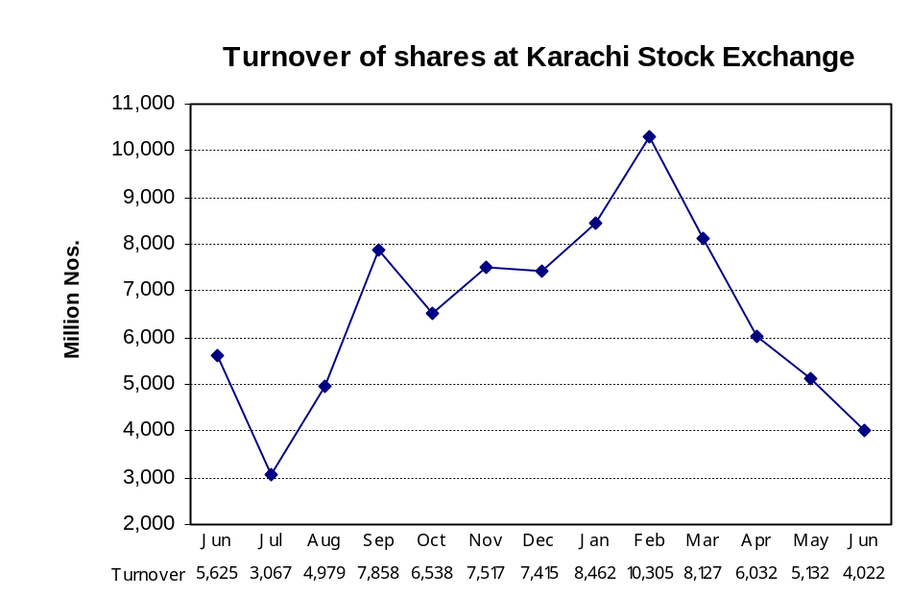

7.5 Balance Sheet Analysis- Overall (Non-Financial)
(Million Rupees)
ITEMS | 2000 | 2001 | 2002 | 2003 | 2004

A. CAPITAL STRUCTURE
1. Ordinary share capital | 191,623 | 189,761 | 228,070 | 246,857 | 305,608
2. Surplus | 126,645 | 128,977 | 204,867 | 200,607 | 289,230
3. Shareholders' equity (A1+A2) | 318,268 | 318,738 | 432,937 | 447,464 | 594,838
4. Preference shares | 194 | 187 | 890 | 1,083 | 1,083
5. Debentures | 41,441 | 53,364 | 43,882 | 40,128 | 23,474
6. Other fixed liabilities | 194,033 | 172,799 | 138,313 | 154,612 | 196,727
7. Total fixed liabilities (A4+A5+A6) | 235,668 | 226,350 | 183,085 | 195,824 | 221,284
8. Total capital employed (A3+A7) | 553,936 | 545,088 | 616,021 | 643,287 | 816,121
9. Gearing (A7 as % of A8) | 43 | 42 | 30 | 30 | 27
10. Shareholders' equity as % of ordinary share capital (A3 as % of A1) | 166 | 168 | 190 | 181 | 195
11. Break-up value of ordinary shares (in Rs.) | 17 | 17 | 19 | 18 | 20
B. LIQUIDITY:
1. Liquid Assets: | 93,649 | 107,564 | 119,968 | 162,465 | 241,184
(i) Cash | 60,934 | 70,642 | 74,347 | 97,228 | 160,857
(ii) Investments | 32,715 | 36,921 | 45,621 | 65,237 | 80,328
2. Other current assets | 309,237 | 344,592 | 344,221 | 234,268 | 267,963
3. Current assets (B1+B2) | 402,886 | 452,155 | 464,189 | 509,330 | 692,687
4. Current liabilities | 432,862 | 498,536 | 453,948 | 485,825 | 596,893
5. Total liabilities (A7+B4) | 668,530 | 724,886 | 637,033 | 681,649 | 818,176
6. Net current assets (B3-B4) | -29,976 | -46,380 | 10,240 | 23,505 | 95,793
7. Contractual liabilities | 0 | 419,627 | 331,725 | 341,082 | 373,562
8. Current liabilities as % of current assets (B4 as % of B3) | 93 | 91 | 102 | 105 | 116
9. Net liquid assets (B1-B4) | -339,213 | -390,972 | -333,981 | -323,360 | -355,709
C. FIXED ASSETS:
1. Fixed assets at cost | 897,625 | 955,846 | 1,018,106 | 1,070,185 | 1,150,211
2. Fixed assets after deducting accumulated depreciation | 583,912 | 591,469 | 605,781 | 619,782 | 720,328
3. Depreciation for the year | 44,452 | 50,578 | 58,697 | 54,992 | 60,445
4. Average annual % depreciation on written down fixed assets | 8 | 9 | 10 | 9 | 9
5. Total assets (B3+C2) | 986,798 | 1,043,624 | 1,069,970 | 1,129,113 | 1,413,015
D. OPERATION:
1. Gross sales | 1,003,217 | 1,177,503 | 1,222,526 | 1,382,479 | 1,632,834
i. Local sales | 0 | 1,062,582 | 1,114,222 | 1,266,940 | 1,507,135
ii. Export sales | 0 | 114,920 | 108,304 | 115,540 | 125,699
2. Gross profit | 149,919 | 151,819 | 186,783 | 210,041 | 272,673
3. Overhead and other expenses | 0 | 1,091,767 | 1,124,121 | 1,277,734 | 1,471,056
4. Operating profit | 0 | 108,926 | 117,714 | 130,931 | 199,205
5. Overhead and other expenses as % of gross sales (D3 as % of D1) | 0 | 93 | 92 | 92 | 90
6. Financial expenses | 0 | 54,377 | 47,999 | 32,030 | 23,752
7. Financial expenses as % of operating profit (D6 as % of D4) | 0 | 50 | 41 | 25 | 12
8. Financial expenses as % of gross sales(D6 as % of D1) | 0 | 5 | 4 | 2 | 2
9. Financial expenses as % of contractual liabilities (D6 as % of B7) | 0 | 13 | 15 | 9 | 6
10. Net profit before tax (D4-D6) | 37,660 | 54,549 | 69,714 | 98,902 | 175,454
11. Net profit as % of gross sales (D10/D1)*100 | 4 | 5 | 6 | 7 | 11
12. Tax provision | 21,015 | 23,956 | 25,405 | 36,046 | 49,604
13. Tax provision as % of net pre-tax profit (D12 as % D10) | 56 | 44 | 36 | 37 | 28
14. Sundry debtors as % of gross sales | 11 | 10 | 9 | 8 | 7
E. PROFIT VIS_A_VIS CAPITAL:
1. Earning per ordinary share:(in rupees)
-before tax provision (D10/No. of ordinary shares) | 2 | 3 | 3 | 4 | 6
-after tax provision [(D10-D12)/No. of ordinary shares] | 1 | 2 | 2 | 3 | 4
2. Net profit as % of shareholders' equity (D10 as % of A3) | 12 | 17 | 16 | 22 | 30
3. Total amount of dividend | 28,784 | 35,970 | 44,537 | 52,182 | 73,715
4. Dividend ratio to equity (E3 as % of A3) | 9 | 11 | 10 | 12 | 12
5. Dividend cover [(D10-D12)/E3] | 1 | 1 | 1 | 1 | 2
6. Total value of bonus shares issued | 3,792 | 3,258 | 1,879 | 1,240 | 2,263
F. SOURCES OF INCREASE IN CAPITAL EMPLOYED:
1. Increase/decrease in capital employed (A8-A8 of preceding year) | -6,740 | -8,848 | 70,933 | 27,266 | 172,834
2. Retention in business (D10-D12-E3) | -12,139 | -5,377 | -228 | 10,674 | 52,134
3. Self-financing ratio (F2 as % of F1) | 180 | 61 | 0 | 39 | 30
4. Finance from outside the company (F1-F2) | 5,398 | -3,472 | 71,161 | 16,592 | 120,700
G. CASH FLOW DATA:
1. Depreciation for the year plus retention in business: cash flow (C3+F2) | 32,313 | 45,201 | 58,469 | 65,666 | 112,580
2. Depreciation for the year plus changes in capital employed (C3+F1) | 37,711 | 41,730 | 129,630 | 82,258 | 233,279
3. Cash flow ratio (G1 as % of G2) | 86 | 108 | 45 | 80 | 48
H. No. OF COMPANIES | 520 | 506 | 481 | 463 | 451

7.6 Balance Sheet Analysis- Private Sector
(Million Rupees)
ITEMS | 2000 | 2001 | 2002 | 2003 | 2004

A. CAPITAL STRUCTURE
1. Ordinary share capital | 117,118 | 113,610 | 130,776 | 135,930 | 189,178
2. Surplus | 98,858 | 109,625 | 120,090 | 135,266 | 211,634
3. Shareholders' equity (A1+A2) | 215,976 | 223,236 | 250,865 | 271,196 | 400,812
4. Preference shares | 43 | 36 | 739 | 1,082 | 1,082
5. Debentures | 21,443 | 34,613 | 31,594 | 22,740 | 7,547
6. Other fixed liabilities | 123,334 | 109,052 | 120,416 | 112,765 | 131,239
7. Total fixed liabilities (A4+A5+A6) | 144,820 | 143,701 | 152,749 | 136,587 | 139,868
8. Total capital employed (A3+A7) | 360,796 | 366,936 | 403,614 | 407,829 | 540,680
9. Gearing (A7 as % of A8) | 40 | 39 | 38 | 33 | 26
10. Shareholders' equity as % of ordinary share capital (A3 as % of A1) | 184 | 197 | 192 | 200 | 212
11. Break-up value of ordinary shares (in Rs.) | 18 | 20 | 19 | 20 | 21
B. LIQUIDITY:
1. Liquid Assets: | 58,616 | 64,541 | 80,407 | 105,348 | 160,048
(i) Cash | 31,615 | 37,404 | 46,444 | 53,645 | 90,921
(ii) Investments | 27,002 | 27,137 | 33,963 | 51,703 | 69,127
2. Other current assets | 195,409 | 220,788 | 220,198 | 130,408 | 168,720
3. Current assets (B1+B2) | 254,025 | 285,329 | 300,605 | 334,966 | 473,465
4. Current liabilities | 248,884 | 285,711 | 277,108 | 314,100 | 393,111
5. Total liabilities (A7+B4) | 393,704 | 429,412 | 429,857 | 450,687 | 532,979
6. Net current assets (B3-B4) | 5,141 | -382 | 23,498 | 20,866 | 80,355
7. Contractual liabilities | 0 | 278,989 | 263,752 | 255,371 | 270,829
8. Current liabilities as % of current assets (B4 as % of B3) | 102 | 100 | 109 | 107 | 120
9. Net liquid assets (B1-B4) | -190,268 | -221,170 | -196,701 | -208,752 | -233,063
C. FIXED ASSETS:
1. Fixed assets at cost | 506,006 | 548,060 | 578,171 | 616,267 | 724,105
2. Fixed assets after deducting accumulated depreciation | 355,654 | 367,318 | 380,117 | 386,917 | 460,325
3. Depreciation for the year | 21,874 | 26,683 | 31,051 | 29,158 | 37,306
4. Average annual % depreciation on written down fixed assets | 7 | 8 | 9 | 8 | 9
5. Total assets (B3+C2) | 609,679 | 652,647 | 680,722 | 721,883 | 933,791
D. OPERATION:
1. Gross sales | 626,321 | 715,949 | 744,098 | 841,227 | 1,031,308
i. Local sales | 0 | 607,178 | 639,188 | 732,743 | 913,080
ii. Export sales | 0 | 108,771 | 104,910 | 108,484 | 118,228
2. Gross profit | 102,548 | 98,769 | 109,947 | 121,978 | 177,366
3. Overhead and other expenses | 0 | 661,119 | 683603 | 781,340 | 922,263
4. Operating profit | 0 | 69,948 | 70,508 | 71,312 | 126,206
5. Overhead and other expenses as % of gross sales (D3 as % of D1) | 0 | 92 | 92 | 93 | 89
6. Financial expenses | 0 | 38,659 | 32,094 | 23,339 | 18,046
7. Financial expenses as % of operating profit (D6 as % of D4) | 0 | 55 | 46 | 33 | 14
8. Financial expenses as % of gross sales(D6 as % of D1) | 0 | 5 | 4 | 3 | 2
9. Financial expenses as % of contractual liabilities (D6 as % of B7) | 0 | 14 | 12 | 9 | 7
10. Net profit before tax (D4-D6) | 24,897 | 31,289 | 38,414 | 47,972 | 108,160
11. Net profit as % of gross sales (D10/D1)*100 | 4 | 4 | 5 | 6 | 11
12. Tax provision | 9,885 | 10,491 | 10,924 | 14,716 | 26,731
13. Tax provision as % of net pre-tax profit (D12 as % D10) | 40 | 34 | 28 | 31 | 25
14. Sundry debtors as % of gross sales | 8 | 8 | 7 | 6 | 7
E. PROFIT VIS_A_VIS CAPITAL:
1. Earning per ordinary share:(in rupees)
-before tax provision (D10/No. of ordinary shares) | 2 | 3 | 3 | 4 | 6
-after tax provision [(D10-D12)/No. of ordinary shares] | 1 | 2 | 2 | 3 | 4
2. Net profit as % of shareholders' equity (D10 as % of A3) | 12 | 14 | 15 | 18 | 27
3. Total amount of dividend | 14,904 | 18,811 | 24,450 | 25,469 | 39,909
4. Dividend ratio to equity (E3 as % of A3) | 7 | 8 | 10 | 9 | 10
5. Dividend cover [(D10-D12)/E3] | 1 | 1 | 1 | 1 | 2
6. Total value of bonus shares issued | 2,129 | 1,688 | 1,593 | 747 | 2,206
F. SOURCES OF INCREASE IN CAPITAL EMPLOYED:
1. Increase/decrease in capital employed (A8-A8 of preceding year) | 13,106 | 6,141 | 36,678 | 4,169 | 133,840
2. Retention in business (D10-D12-E3) | 108 | 1,987 | 3,039 | 7,787 | 41,520
3. Self-financing ratio (F2 as % of F1) | 1 | 32 | 8 | 187 | 31
4. Finance from outside the company (F1-F2) | 12,998 | 4,154 | 33,639 | -3,619 | 92,321
G. CASH FLOW DATA:
1. Depreciation for the year plus retention in business: cash flow (C3+F2) | 21,982 | 28,670 | 34,090 | 36,945 | 78,826
2. Depreciation for the year plus changes in capital employed (C3+F1) | 34,980 | 32,824 | 67,729 | 33,327 | 171,146
3. Cash flow ratio (G1 as % of G2) | 63 | 87 | 50 | 111 | 46
H. No. OF COMPANIES | 495 | 481 | 457 | 441 | 426

7.7 Balance Sheet Analysis- Public Sector
(Million Rupees)
ITEMS | 2000 | 2001 | 2002 | 2003 | 2004

A. CAPITAL STRUCTURE
1. Ordinary share capital | 74,505 | 76,150 | 97,294 | 110,927 | 116,430
2. Surplus | 27,787 | 19,352 | 84,778 | 65,341 | 77,596
3. Shareholders' equity (A1+A2) | 102,292 | 95,502 | 182,071 | 176,268 | 194,026
4. Preference shares | 151 | 151 | 151 | 1 | 1
5. Debentures | 19,998 | 18,751 | 12,288 | 17,388 | 15,927
6. Other fixed liabilities | 70,699 | 63,747 | 17,897 | 41,848 | 65,488
7. Total fixed liabilities (A4+A5+A6) | 90,848 | 82,650 | 30,336 | 59,237 | 81,416
8. Total capital employed (A3+A7) | 193,141 | 178,152 | 212,407 | 235,504 | 275,442
9. Gearing (A7 as % of A8) | 47 | 46 | 14 | 25 | 30
10. Shareholders' equity as % of ordinary share capital (A3 as % of A1) | 137 | 125 | 187 | 159 | 167
11. Break-up value of ordinary shares (in Rs.) | 14 | 13 | 19 | 16 | 17
B. LIQUIDITY:
1. Liquid Assets: | 35,033 | 43,023 | 39,561 | 57,117 | 81,136
(i) Cash | 29,319 | 33,238 | 27,903 | 43,583 | 69,935
(ii) Investments | 5,714 | 9,784 | 11,658 | 13,535 | 11,201
2. Other current assets | 113,828 | 123,804 | 124,022 | 103,860 | 99,242
3. Current assets (B1+B2) | 148,861 | 166,826 | 163,583 | 174,364 | 219,221
4. Current liabilities | 183,978 | 212,825 | 176,841 | 171,725 | 203,783
5. Total liabilities (A7+B4) | 274,826 | 295,475 | 207,176 | 230,962 | 285,199
6. Net current assets (B3-B4) | -35,117 | -45,999 | -13,257 | 2,639 | 15,438
7. Contractual liabilities | 0 | 140,638 | 67,973 | 85,711 | 102,734
8. Current liabilities as % of current assets (B4 as % of B3) | 81 | 78 | 93 | 102 | 108
9. Net liquid assets (B1-B4) | -148,945 | -169,803 | -137,280 | -114,608 | -122,647
C. FIXED ASSETS:
1. Fixed assets at cost | 391,619 | 407,787 | 439,935 | 453,917 | 426,107
2. Fixed assets after deducting accumulated depreciation | 228,258 | 224,151 | 225,665 | 232,865 | 260,003
3. Depreciation for the year | 22,578 | 23,895 | 27,645 | 25,834 | 23,139
4. Average annual % depreciation on written down fixed assets | 10 | 11 | 12 | 12 | 10
5. Total assets (B3+C2) | 377,119 | 390,977 | 389,248 | 407,229 | 479,224
D. OPERATION:
1. Gross sales | 376,897 | 461,554 | 478,428 | 541,253 | 601,526
i. Local sales | 0 | 455,404 | 475,034 | 534,197 | 594,055
ii. Export sales | 0 | 6,150 | 3,394 | 7,056 | 7,470
2. Gross profit | 47,371 | 53,050 | 76,836 | 88,063 | 95,307
3. Overhead and other expenses | 0 | 430,648 | 440,518 | 496,394 | 548,793
4. Operating profit | 0 | 38,978 | 47,206 | 59,620 | 72,999
5. Overhead and other expenses as % of gross sales (D3 as % of D1) | 0 | 93 | 92 | 92 | 91
6. Financial expenses | 0 | 15,718 | 15,905 | 8,690 | 5,705
7. Financial expenses as % of operating profit (D6 as % of D4) | 0 | 40 | 34 | 15 | 8
8. Financial expenses as % of gross sales(D6 as % of D1) | 0 | 3 | 3 | 2 | 1
9. Financial expenses as % of contractual liabilities (D6 as % of B7) | 0 | 11 | 23 | 10 | 6
10. Net profit before tax (D4-D6) | 12,763 | 23,260 | 31,301 | 50,929 | 67,294
11. Net profit as % of gross sales (D10/D1)*100 | 3 | 5 | 7 | 9 | 11
12. Tax provision | 11,130 | 13,465 | 14,481 | 21,329 | 22,873
13. Tax provision as % of net pre-tax profit (D12 as % D10) | 87 | 58 | 46 | 42 | .34
14. Sundry debtors as % of gross sales | 16 | 14 | 14 | 11 | 7
E. PROFIT VIS_A_VIS CAPITAL:
1. Earning per ordinary share:(in rupees)
-before tax provision (D10/No. of ordinary shares) | 2 | 3 | 3 | 5 | 6
-after tax provision [(D10-D12)/No. of ordinary shares] | 0 | 1 | 2 | 3 | 4
2. Net profit as % of shareholders' equity (D10 as % of A3) | 13 | 24 | 17 | 29 | 35
3. Total amount of dividend | 13,880 | 17,159 | 20,087 | 26,714 | 33,806
4. Dividend ratio to equity (E3 as % of A3) | 14 | 18 | 11 | 15 | 17
5. Dividend cover [(D10-D12)/E3] | 0 | 1 | 1 | 1 | 1
6. Total value of bonus shares issued | 1,663 | 1,571 | 286 | 493 | 57
F. SOURCES OF INCREASE IN CAPITAL EMPLOYED:
1. Increase/decrease in capital employed (A8-A8 of preceding year) | -19,846 | -14,989 | 34,255 | 23,097 | 39,937
2. Retention in business (D10-D12-E3) | -12,247 | -7,364 | -3,267 | 2,887 | 10,615
3. Self-financing ratio (F2 as % of F1) | 62 | 49 | -10 | 13 | 27
4. Finance from outside the company (F1-F2) | -7,600 | -7,625 | 37,522 | 20,211 | 29,322
G. CASH FLOW DATA:
1. Depreciation for the year plus retention in business: cash flow (C3+F2) | 10,331 | 16,531 | 24,378 | 28,721 | 33,754
2. Depreciation for the year plus changes in capital employed (C3+F1) | 2,732 | 8,906 | 61,901 | 48,932 | 63,076
3. Cash flow ratio (G1 as % of G2) | 378 | 186 | 39 | 59 | 54
H. No. OF COMPANIES | 25 | 25 | 24 | 22 | 25

