###### Review of Pakistan’s Balance of Payments

###### July 2009- June 2010



Current account deficit dropped to $3,946 million during 2009-10, posting a significant decrease of $5,315 million from the massive deficit of $9,261 million recorded in the previous year. Exports (fob) fetched $19,673 million for the national exchequer, with an increase of $552 million over the last year. Imports, however, slashed by $538 million to $31,209 million from $31,747 million in FY09. Services account deficit was halved during the review period to $1,690 million from $3,381 million in the preceding year. Income account deficit also narrowed to $3,282 million from $4,407 million in the previous year reflecting a decrease of 26 percent. Net current transfers with a growth of 13 percent touched $12,562 million in 2009-10. Capital and financial accounts showed declines of $280 million and $535 million as compared with the last year. Overall surplus balances of $1,796 million and $774 million were witnessed during first and last quarter of 2009-10, however, overall deficit balance of $704 million and $600 million were registered during second and third quarter respectively. The overall balance, however, remained surplus with $1,266 million in fiscal year 2010.

**Merchandise Trade**

Increased exports compounded with low imports reduced the trade deficit by 9 percent to $11,536 million during 2009-10 compared to $12,627 million last year. Exports earned $19,673 million during 2009-10, expanded by $552 million (3%) from $19,121 million. Imports, however, contracted by $538 million (2%) reduced to $31,209 million from $31,747 million. Trade deficit, on quarterly basis, hovered around $3 billion. The general merchandise transactions reported through banks (export receipts) on a mixed fob and c&f basis amounted to $19,404 million as compared to $17,887 million during last fiscal year. The general merchandise exports at fob are arrived at by deducting freight amounting to $483 million, adding timing adjustments (outstanding export bills) of $247 million and other exports of $279 million not covered through banking channel.

The general merchandize imports (fob) recorded a fall of $464 million. Of the total imports payments against general merchandise (fob), $29,833 million or 96 per cent were reported by banks while those under foreign economic assistance, personal baggage & non-repatriable investment (NRI), sale of duty free shops and others taken together amounted to $1,113 million or 4 percent.



Major commodities groups constituting 86 percent of total export receipts during FY10 in descending order except others group are shown in table along with export receipts during FY09.

The commodity-wise analysis of export receipts revealed that cotton, clothing & textile and the cereal group remained the major export earners for the country. The traditional export sector comprising cotton, clothing and textile remained the mainstay, posting an increase of $403 million to $9,278 million from $8,875 million. Exports of cereals crossed $2,000 million mark touching $2,173 million from $1,785 million in the previous year, up by $388 million. Similarly, group comprising minerals fuels, oils and distillation products registered exports of $1,192 million up by 21 percent, from $983 million reported during the last year.

The country-wise comparison of export receipts by major countries during 2009-10 with 2008-09 is shown in Figure 1.

USA, UAE, China, Afghanistan and UK remained major destinations of country’s exports. It has been witnessed that exports worth $9,406 million, 48 percent of total exports were destined for USA, UAE, China, Afghanistan, UK and Germany during 2009-10. Same markets provided 47 percent of total export receipts in previous year. Exports to China took a leap in FY10, touching $1,211 million from $661 million in the previous year reflecting an increase of $550 million (83%).



Major commodities groups constituting 87 percent of total import payments reported by banks during 2009-10 in descending order except other groups are shown in table.

A total of $10,998 million, 35 percent of total import payments, were made to group comprising minerals fuels, oil and their distillation product. Import payments for fertilizers jumped up by $417 million (92%) to touch $868 million. Payments made for purchase of vehicles other than railway/tramway rolling witnessed a significant increase of 26 percent during 2009-10.

The country-wise comparison of import payments to major countries including freight during 2009-10 with that of last year is shown in Figure 2.



Country-wise analysis showed that more than half of the payments, were made to UAE, Saudi Arabia, China, Singapore, and Kuwait in 2009-10. The same group received 46 percent of total imports in last fiscal year. UAE, Saudi Arabia, and China maintained their position as top trade partners as they did in FY09. Singapore, however, replaced Kuwait to become the 4th major recipient of import payments.

**Services**

The deficit in services account substantially contracted by $1,691 million (50%) from $3,381 million in 2008-09 to $ 1,690 million in 2009-10. The aggregate receipts of services transactions during 2009-10 registered an increase of $1,123million, up by 27 percent as compared to last year. Decrease of $568 million in aggregate payments also contributed to slash services deficit. Government, transportation and other business services accounted for 48 percent, 24 percent and 10 percent of total receipts respectively. More than half of the total payments i.e. 52 percent were made to transportation, of which 38 percent were paid on the account of freight charges.

**Income**

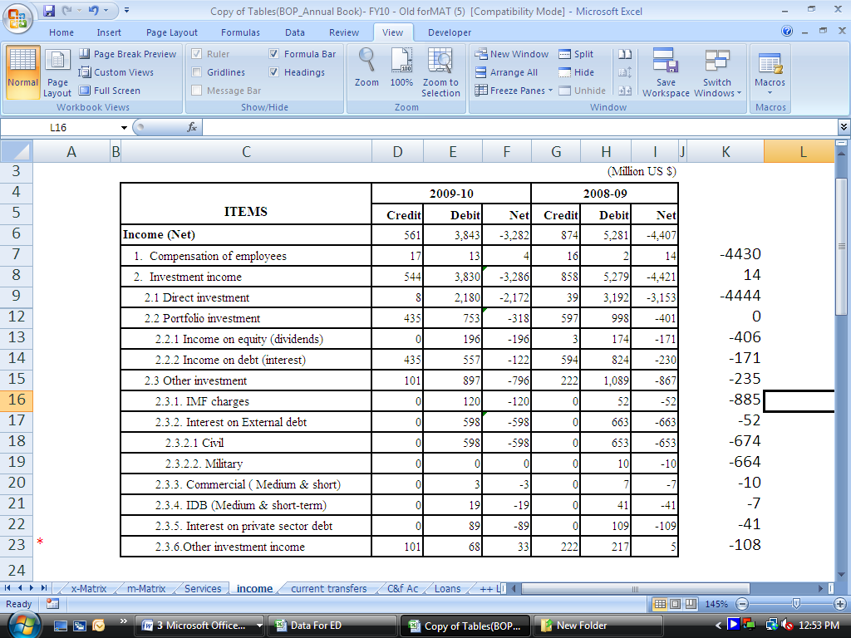

The income deficit of $3,282 million in 2009-10 was reduced by $1,125 million (26%) as compared to $ 4,407 million during 2008-09. The net outflow of direct investment income reduced to $2,172 million during 2009-10 as compared to $3,153 million in the last year. Portfolio investment income and other investment income posted an net outflows of $318 million and $796 million respectively. The receipt on other investment income dropped to $101 million during 2009-10 as compared to $222 million during the previous year.

#### Current Transfers



Considerable receipts of $12,672 million were recorded in current transfers during 2009-10, up by $1,416 million from $11,256 million in 2008-09.Capital remitted by Pakistani expatriates reached all-time high of $8,906 million. Current transfers payments of $50 million and $60 million were made by general government and other sectors respectively.

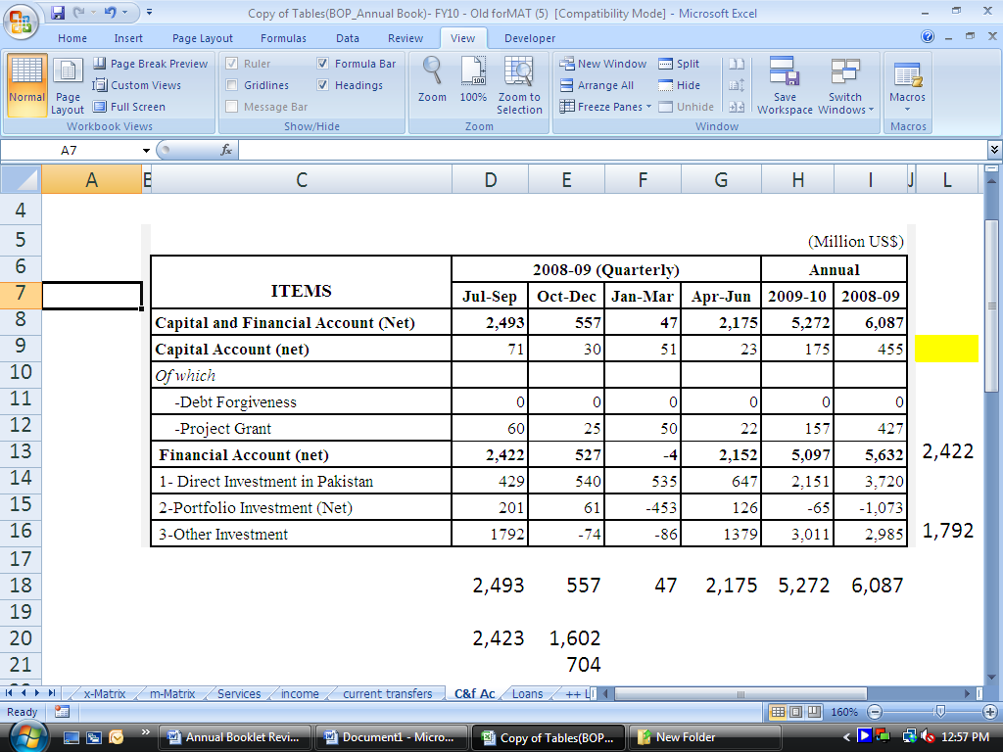

**Capital & Financial Account**

The net inflow in capital & financial account during 2009-10 stood at $5,272 million as against $6,087 million during previous year. The net capital inflow declined to $175 million in current period from $455 million during 2008-09. The project grant slashed by $270 million to $157 million in 2009-10 as compared with previous year. Financial account recorded a surplus of $5,097 million during FY10 slightly lower than last year’s flows of $5,632 million. Direct investment in Pakistan shrunk by 42 percent, to $2,151 million. The net outflow in portfolio investment, however, witnessed a massive reduction of $1,008 million to $65 million as compared to last year.

**Disbursement/Repayment of Loans/Credit**

The inflow of foreign loans/credits stood at $7,166 million as compared to $8,656 million in the last year. Of the total disbursement of long-term loans of $6,489 million, $2,413 million were received by the monetary authorities, $1,048 million were for financing of various projects while $2,516 million were non-projects loans. Short term loans came down to $677 million from $740 million a year ago.

The repayment of loans/credits reached $3,095 million during the current year as against $2,919 million in the previous year. $2,102 million, 68 percent of total repayments, were made against long term loans, of which $1,360 million were for official loans. The repayment of short-term loans/credits stood at $993 million during 2009-10 as against $857 million in 2008-09.

**Reserves and related items**

There has been considerable increase in net reserve assets of $4,063 million during 2009-10. This has mainly been due to Stand-By Arrangements, of which $455 million (SDR 291 million), $826 million (SDR 529 million), and $779 million (SDR 529 million) in first, second and fourth quarter of FY10 contributed towards balancing imbalances in balance of payments whereas a total of $1,465 million (SDR 951 million) was transferred to government for budgetary support. Allocation of SDR of $1,281 million (SDR 818.5 million) in the first quarter also caused increase in reserve assets. On the other hand, the repurchases/repayments of $239 million (SDR 155 million) were made to IMF during the year as against a repayment of $211 million (SDR138 million) in last year.

|  |  |  |  |  |  |  |  |  |  |  |
| --- | --- | --- | --- | --- | --- | --- | --- | --- | --- | --- |
| **Summary Balance of** | | | | | | | | | | |
|  | | | | | | | | | | |
|  |  | | | |  | | | | | |
| **ITEM** | **2009** | |  | **2010** | |  | | **Jul - Jun** | | |
| Jul – Sep | Oct - Dec |  | Jan - Mar | Apr – Jun | |  | | 2009-10 | 2008-09 |
|  |  |  |  | |  | |  | | |  |
| **Current Account Balance** | -981 | -1,589 | -536 | | -840 | | -3,946 | | | -9,261 |
| **Current Account Balance without off. transfers** | -977 | -1,714 | -764 | | -1,047 | | -4,502 | | | -9,424 |
| Goods: Exports fob | 4,635 | 4,681 | 5,032 | | 5,325 | | 19,673 | | | 19,121 |
| Goods: Imports fob | 7,485 | 7,691 | 7,367 | | 8,666 | | 31,209 | | | 31,747 |
| Trade Balance | -2,850 | -3,010 | -2,335 | | -3,341 | | -11,536 | | | -12,627 |
| Services: Credit | 881 | 1,070 | 1,166 | | 2,112 | | 5,229 | | | 4,106 |
| Services: Debit | 1,585 | 1,892 | 1,582 | | 1,860 | | 6,919 | | | 7,487 |
| Balance on Goods & Services | -3,554 | -3,832 | -2,751 | | -3,089 | | -13,226 | | | -16,008 |
| Income: Credit | 99 | 142 | 187 | | 133 | | 561 | | | 874 |
| Income: Debit | 798 | 1,035 | 881 | | 1,129 | | 3,843 | | | 5,281 |
| Of which : Interest payments | 267 | 446 | 356 | | 398 | | 1,467 | | | 1,915 |
| Profit & Dividend | 112 | 189 | 118 | | 242 | | 661 | | | 757 |
| Balance on Gds & Serv. & Inc | -4,253 | -4,725 | -3,445 | | -4,085 | | -16,508 | | | -20,415 |
| **Current Transfers.: Credit** | 3,311 | 3,150 | 2,924 | | 3,287 | | 12,672 | | | 11,256 |
| Of which: |  |  |  | |  | |  | | |  |
| Workers' Remittances | 2,331 | 2,199 | 2,021 | | 2,355 | | 8,906 | | | 7,811 |
| FCAs Residents | 199 | 177 | 150 | | 103 | | 629 | | | -271 |
| Current Transfers :Debit | 39 | 14 | 15 | | 42 | | 110 | | | 102 |
| **Capital Account,** | 71 | 30 | 51 | | 23 | | 175 | | | 455 |
| Capital Account, : Credit | 71 | 35 | 51 | | 23 | | 180 | | | 460 |
| Project Grants | 60 | 25 | 50 | | 22 | | 157 | | | 427 |
| Debt Forgiveness | 0 | 0 | 0 | | 0 | | 0 | | | 0 |
| Others | 11 | 10 | 1 | | 1 | | 23 | | | 33 |
| Capital Account... Debit | 0 | 5 | 0 | | 0 | | 5 | | | 5 |
| **Financial Account** | 2,422 | 527 | -4 | | 2,152 | | 5,097 | | | 5,632 |
| Direct Investment Abroad | -49 | -5 | -15 | | -7 | | -76 | | | -25 |
| Dir. Invest. In Rep. Econ. | 429 | 540 | 535 | | 647 | | 2,151 | | | 3,720 |
| Portfolio Investment Assets | -7 | -3 | 1 | | 8 | | -1 | | | -41 |
| Equity Securities | -7 | -3 | 1 | | 8 | | -1 | | | -41 |
| Debt Securities | 0 | 0 | 0 | | 0 | | 0 | | | 0 |
| Portfolio Investment Liab. | 208 | 64 | -454 | | 118 | | -64 | | | -1,032 |
| Equity Securities | 248 | 62 | 146 | | 132 | | 588 | | | -511 |
| Debt Securities | -40 | 2 | -600 | | -14 | | -652 | | | -521 |
| Financial Derivatives Assets | 0 | 0 | 0 | | 0 | | 0 | | | 0 |
|  |  |  |  | |  | |  | | |  |

|  |  |  |  |  |  |  |  |  |  |  |  |  |  |
| --- | --- | --- | --- | --- | --- | --- | --- | --- | --- | --- | --- | --- | --- |
| **Payments –Overall** | | | | | | | | | | | | | |
|  | | | | | | | | | | | | | |
|  | | | | |  | | | | | | | (Million US Dollars) | |
| **ITEM** | | **2009** | | | | |  | **2010** | |  | **Jul – Jun** | | |
| Jul – Sep | | Oct - Dec Dec | | |  | Jan-Mar | Apr – Jun |  | 2009-10 | | 2008-09 |
|  | |  | |  | | |  | |  |  | | |  |
| Financial Derivatives Liabilities | | 0 | | 0 | | | 0 | | 0 | 0 | | | 0 |
| Other Investment Assets | | -132 | | -13 | | | -109 | | 243 | -11 | | | 560 |
| Monetary Authorities | | 0 | | 0 | | | 0 | | 0 | 0 | | | 0 |
| General Government | | -3 | | -1 | | | 0 | | -2 | -6 | | | 8 |
| Banks | | 61 | | 94 | | | 1 | | 230 | 386 | | | 346 |
| Other Sector | | -190 | | -106 | | | -110 | | 15 | -391 | | | 206 |
| Other Investment Liab. | | 1,973 | | -56 | | | 38 | | 1,143 | 3,098 | | | 2,450 |
| Monetary Authorities | | 1,245 | | 0 | | | 0 | | 12 | 1,257 | | | -1 |
| General Government | | 839 | | 100 | | | 137 | | 885 | 1,961 | | | 1,948 |
| Disbursements | | 1,369 | | 890 | | | 559 | | 1,316 | 4,134 | | | 3,690 |
| Long-term | | 1,369 | | 890 | | | 237 | | 1,068 | 3,564 | | | 2,956 |
| Project loans | | 208 | | 296 | | | 220 | | 324 | 1,048 | | | 841 |
| Program loans | | 1,161 | | 594 | | | 17 | | 744 | 2,516 | | | 2,115 |
| Short-term | | 0 | | 0 | | | 322 | | 248 | 570 | | | 734 |
| Commercial loans | | 0 | | 0 | | | 0 | | 0 | 0 | | | 50 |
| IDB loans | | 0 | | 0 | | | 322 | | 248 | 570 | | | 684 |
| Amortization | | 507 | | 990 | | | 422 | | 331 | 2,250 | | | 2,246 |
| Long-term | | 323 | | 289 | | | 417 | | 331 | 1,360 | | | 1,389 |
| Short-term | | 184 | | 701 | | | 5 | | 0 | 890 | | | 857 |
| Other Liabilities | | -23 | | 200 | | | 0 | | -100 | 77 | | | 504 |
| Banks | | -51 | | -111 | | | -104 | | 40 | -226 | | | 291 |
| Other Sector | | -60 | | -45 | | | 5 | | 206 | 106 | | | 212 |
| Disbursements | | 165 | | 111 | | | 92 | | 251 | 619 | | | 1,064 |
| Amortization | | 160 | | 134 | | | 162 | | 150 | 606 | | | 462 |
| Other Liabilities | | -65 | | -22 | | | 75 | | 105 | 93 | | | -390 |
| Net Errors and Omissions | | 284 | | 328 | | | -111 | | -561 | -60 | | | 118 |
| **Overall Balance** | | 1,796 | | -704 | | | -600 | | 774 | 1,266 | | | -3,056 |
| Reserves and Related Items | | -1,796 | | 704 | | | 600 | | -774 | -1,266 | | | 3,056 |
| Reserve Assets | | -2,224 | | -363 | | | 653 | | -2,129 | -4,063 | | | -635 |
| Use of Fund Credit and Loans | | 428 | | 744 | | | -53 | | 1,055 | 2,174 | | | 3,691 |
| Purchases | | 455 | | 826 | | | 0 | | | 1,132 | 2,413 | | | 3,902 |
| Repurchases | | 27 | | 82 | | | 53 | | | 77 | 239 | | | 211 |
| **Exceptional Financing** | | 0 | | 323 | | | 0 | | 300 | 623 | | | 0 |
| **SBP Reserves** | | 12540 | | 12863 | | | 12033 | | 13953 | 13953 | | | 10257 |
|  | |  | |  | | |  | |  |  | | |  |